**Semester: EVEN 2020**

|  |  |
| --- | --- |
| Student Name : | Shivani Zele |
| Enrollment No | 1907069 |
| Course Name : | Web development using JavaScript |
| Course Code : | CM4106 |
| Semester | EVEN2020 |

**INDEX PAGE**

|  |  |  |
| --- | --- | --- |
| **Sr. No.** | **Practical Exercises**  (Learning Outcomes in Psychomotor Domain) | **Page No :** |
|  | Programs based on decision making statement | 3 |
|  | Programs based on looping statement | 18 |
|  | Programs based on arrays | 25 |
|  | Programs based on functions | 38 |
|  | Programs based on strings | 45 |
|  | Program using Form Objects and form elements | 53 |
|  | Program using Form Events | 61 |
|  | Program using Intrinsic Java Functions | 78 |
|  | Programs for Using cookies | 87 |
|  | Programs for placing the Window on the screen. | 93 |
|  | Programs for accessing child Window. | 110 |
|  | Programs for implementing Rollovers | 121 |
|  | Programs for implementing Banners, Slideshow | 129 |
|  | * Write a JavaScript program to display the current day and timein the following format.   Sample Output : Today is : Tuesday. Current time is : 10 PM : 30 : 38 | 140 |
|  | Writing code demonstrating  XMLHttpRequest | 146 |

**Assignment : 1**

**Aim :** Programs based on decision making statement

**Decision making :**

conditional statements are used to perform different actions based on various conditions. The conditional statement evaluates a condition before the execution of instructions.

When you write the code, you require to perform different actions for different decisions. You can easily perform it by using conditional statements.

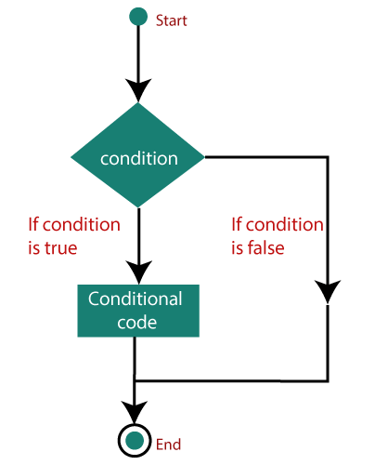

* Types of Conditional Statements

The conditional statements in JavaScript are listed below:

1. if statement
2. if….else statement
3. if….else if….statement
4. nested if statement
5. switch statement
6. **if statement**

It is one of the simplest decision-making statement which is used to decide whether a block of JavaScript code will execute if a certain condition is true.

Syntax :

if (condition) {

// block of code will execute if the condition is true

}

If the condition evaluates to true, the code within if statement will execute, but if the condition evaluates to false, then the code after the end of if statement (after the closing of curly braces) will execute.

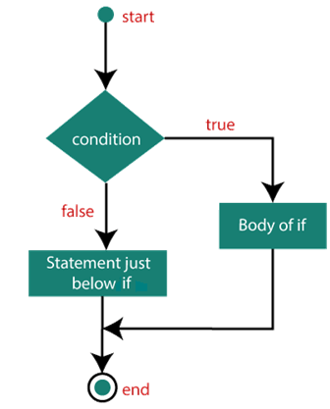

1. **The if….else statement**

An if….else statement includes two blocks that are if block and else block. It is the next form of the control statement, which allows the execution of JavaScript in a more controlled way. It is used when you require to check two different conditions and execute a different set of codes. The else statement is used for specifying the execution of a block of code if the condition is false.

Syntax :

if (condition)

{

// block of code will execute if the condition is true

}

else

{

// block of code will execute if the condition is false

}

If the condition is true, then the statements inside if block will be executed, but if the condition is false, then the statements of the else block will be executed.

**Flowchart :**

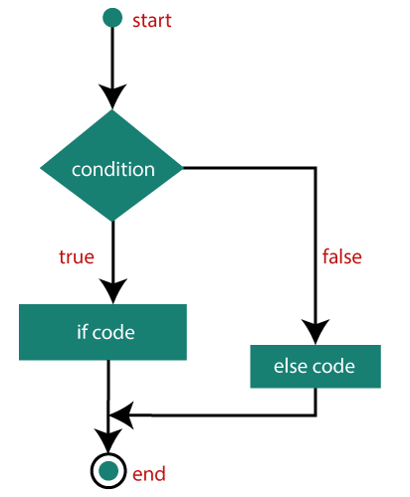

1. **The if….else if…..else statement**

It is used to test multiple conditions. The if statement can have multiple or zero else if statements and they must be used before using the else statement. You should always be kept in mind that the else statement must come after the else if statements.

**Syntax :**

if (condition1)

{

// block of code will execute if condition1 is true

}

else if (condition2)

{

// block of code will execute if the condition1 is false and condition2 is true

}

else

{

// block of code will execute if the condition1 is false and condition2 is false

}

1. **The nested if statement**

It is an if statement inside an if statement.

Syntax

if (condition1)

{

Statement 1; //It will execute when condition1 is true

if (condition2)

{

Statement 2; //It will execute when condition2 is true

}

else

{

Statement 3; //It will execute when condition2 is false

}

}

3. The switch statement

It is a multi-way branch statement that is also used for decision-making purposes. In some cases, the switch statement is more convenient than if-else statements. It is mainly used when all branches depend upon the value of a single variable. It executes a block of code depending upon the different cases.

**Syntax :**

switch(expression){

case value1:

//code to be executed;

break; //optional

case value2:

//code to be executed;

break; //optional

......

default:

code to be executed if all cases are not matched;

}

**Flowchart :**

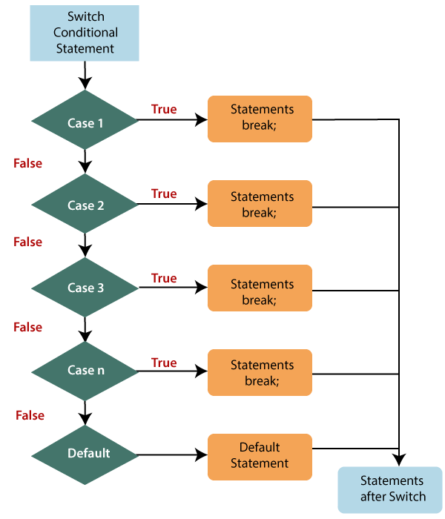

**Programs :**

1. **Program using if elseif.**

<html>

<body>

<script type='text/javascript'>

var subject = 'Physics';

if (subject == 'english') {

document.write('<b>This is English Subject</b>');

} else if (subject == 'Physics') {

document.write('<b>This is physics Subject</b>');

} else if (subject == 'Chemistry') {

document.write('<b>This is Chemistry Subject</b>');

} else {

document.write('<b>Unknown Subject</b>');

}

</script>

</body>

<html>

**Output :**

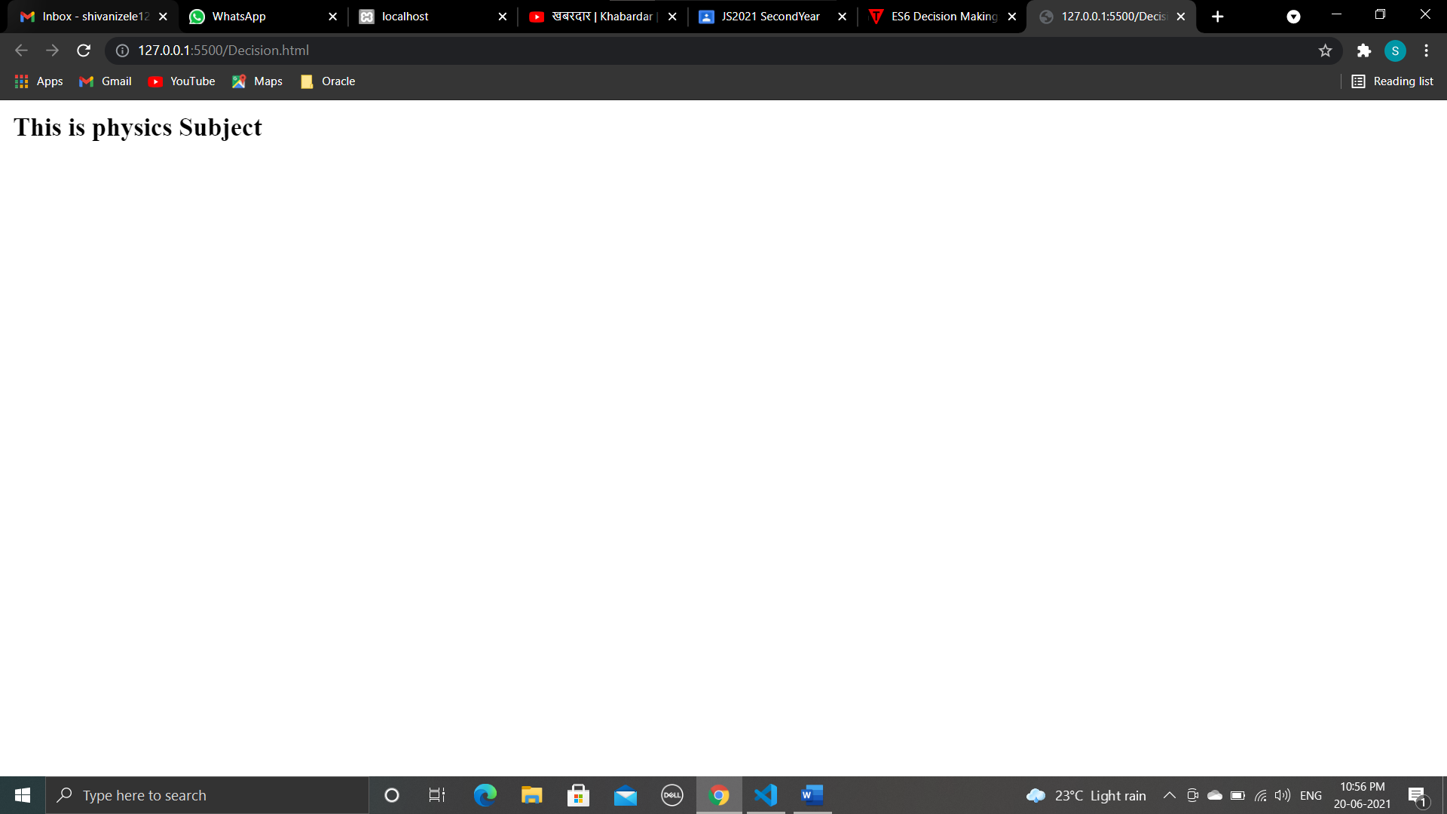

1. **Program using if statement .**

<html>

<body>

<script language="javascript" type="text/javascript">

var i = prompt("Enter Number : ")

if (i > 30) {

alert("The number is greater than 30")

}

</script>

</body>

</html>

**OUTPUT :**

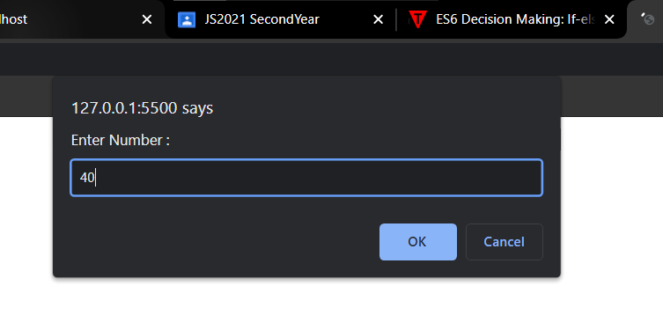

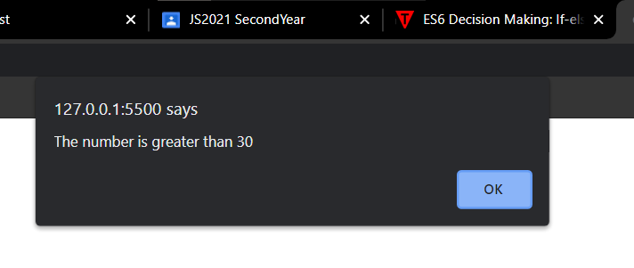

**3.Prgram using if… Else statement**

<html>

<body>

<script language="javascript" , type="text/javascript">

var age = prompt("Enter Age : ")

if (age >= 18) {

alert("You are eligible for voting ")

} else {

alert("you are not eligible for voting")

}

</script>

</body>

</html>

**OUTPUT :**

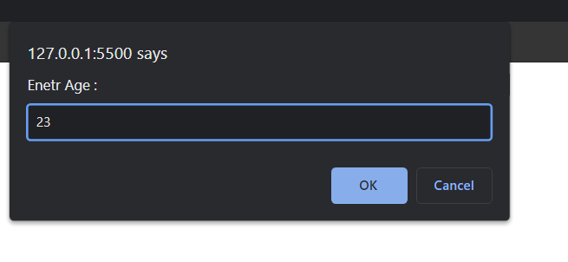

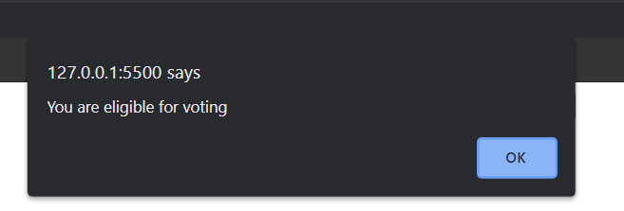

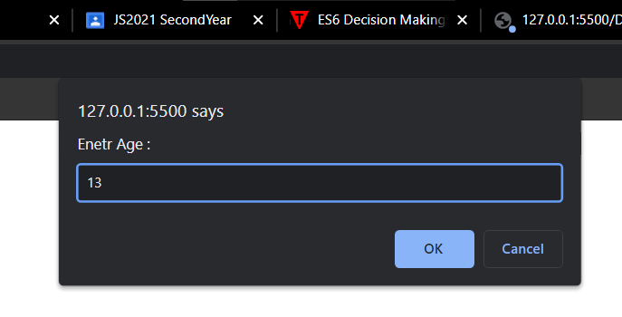

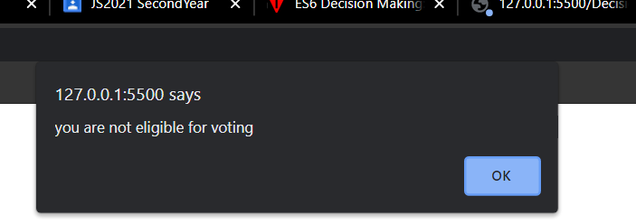

4 . Program to check whether a number is odd or even

<html>

<body>

<script language="javascript" type="text/javascript">

var num = prompt("Enter number you want to check : ")

if (num % 2 == 0) {

alert("The number is even number.")

} else {

alert("The number is odd.")

}

</script>

</body>

</html>

OUTPUT :

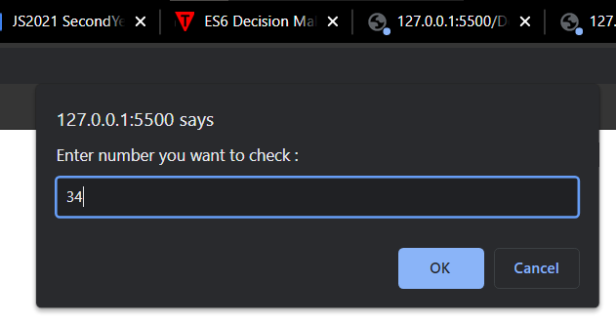

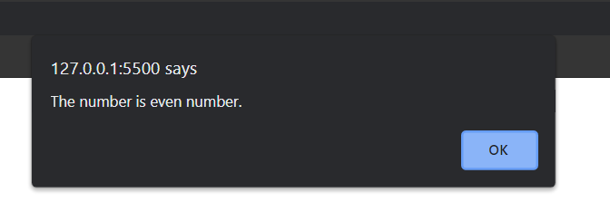

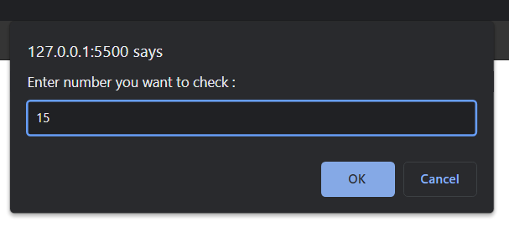

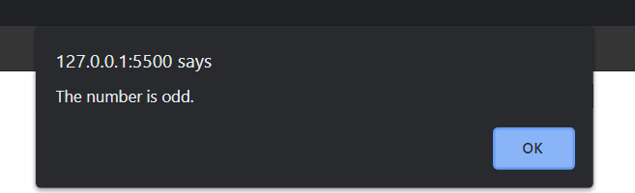

1. Program using if..elseif..else statement

<html>

<head>

<title>For Fun</title>

</head>

<body>

<script language="javascript" type="text/javascript">

var num = prompt("Enter number you want to check : ")

if (num >= 1) {

alert("The given number is positive number ")

} else if (num < 0) {

alert("The given number is Negative number")

} else {

alert("The number is Zero")

}

</script>

</body>

</html>

OUTPUT :

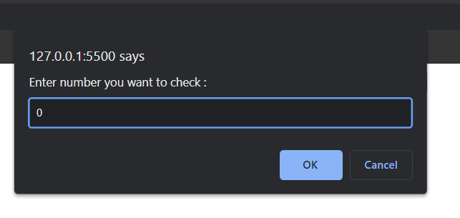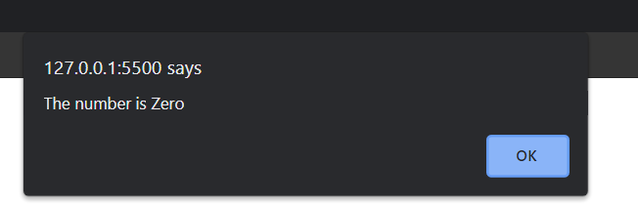

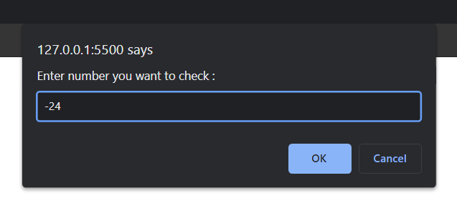

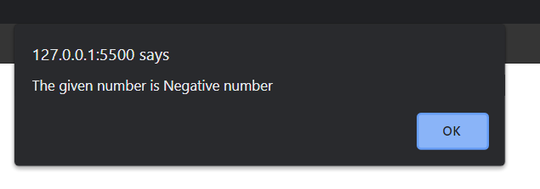

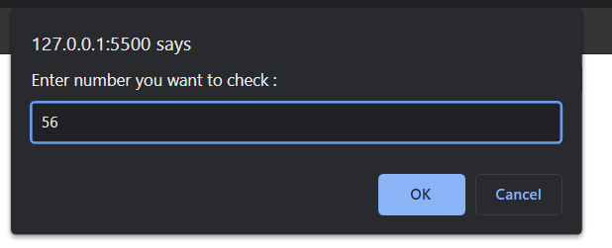

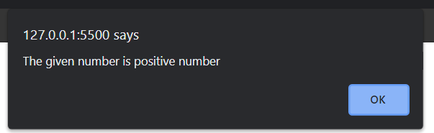

1. Program using switch statement

<!DOCTYPE html>

<html>

<body>

<p id="demo"></p>

<script>

var day;

switch (new Date().getDay()) {

case 1:

day = "Monday";

break;

case 2:

day = "Tuesday";

break;

case 3:

day = "Wednesday";

break;

case 4:

day = "Thursday";

break;

case 5:

day = "Friday";

break;

default:

day = " weekend"

}

var day = alert("Today is " + day);

</script>

</body>

</html>

OUTPUT :

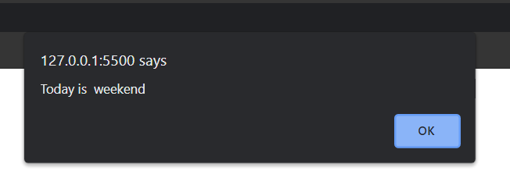

------------------------------------------------------------------------------------------------------------------------------------------------------------------------------------------------------------------

**Conclusion :**

**We have studies Programs based on decision making statement.**

------------------------------------------------------------------------------------------------------------------------------------------------------------------------------------------------------------------

**Assignment : 2**

**AIM : Programs based on looping statement.**

**Loops :** Looping in programming languages is a feature which facilitates the execution of a set of instructions/functions repeatedly while some condition evaluates to true.

Loops are used to execute the same block of code again and again, as long as a certain condition is met. The basic idea behind a loop is to automate the repetitive tasks within a program to save the time and effort. JavaScript now supports five different types of loops:

while — loops through a block of code as long as the condition specified evaluates to true.

do…while — loops through a block of code once; then the condition is evaluated. If the condition is true, the statement is repeated as long as the specified condition is true.

for — loops through a block of code until the counter reaches a specified number.

for…in — loops through the properties of an object.

for…of — loops over iterable objects such as arrays, strings, etc.

1. **The while Loop**

This is the simplest looping statement provided by JavaScript.

The while loop loops through a block of code as long as the specified condition evaluates to true. As soon as the condition fails, the loop is stopped. The generic syntax of the while loop is:

while(condition) {

// Code to be executed

}

1. **The do...while Loop :**

The do-while loop is a variant of the while loop, which evaluates the condition at the end of each loop iteration. With a do-while loop the block of code executed once, and then the condition is evaluated, if the condition is true, the statement is repeated as long as the specified condition evaluated to is true. The generic syntax of the do-while loop is:

do {

// Code to be executed

}

while(condition);

1. **The for Loop :**

The for loop repeats a block of code as long as a certain condition is met. It is typically used to execute a block of code for certain number of times. Its syntax is:

for(initialization; condition; increment) {

// Code to be executed

}

The parameters of the for loop statement have following meanings:

initialization — it is used to initialize the counter variables, and evaluated once unconditionally before the first execution of the body of the loop.

condition — it is evaluated at the beginning of each iteration. If it evaluates to true, the loop statements execute. If it evaluates to false, the execution of the loop ends.

increment — it updates the loop counter with a new value each time the loop runs.

**Programs :**

1. **Program using while loop**

<html>

<body>

<script language="javascript">

var i = welcome;

while (i <= 5) {

document.write("<p>The number is " + i + "</p>");

i++;

}

</script>

</body>

</html>

1. **Program using for loop.**

<html>

<body>

<script language="javascript">

var i = 1;

for (i = 1; i <= 5; i++) {

document.write("<p>The number is " + i + "</p>");

}

</script>

</body>

</html>

Output :

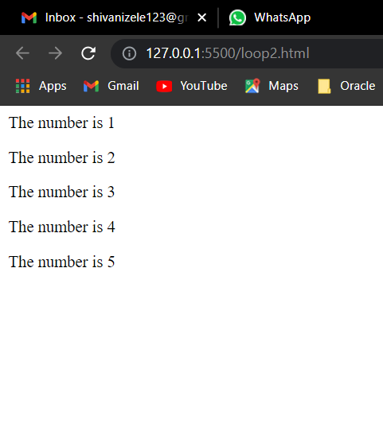

1. Program using do while loop.

<html>

<body>

<script language="javascript">

var i = 1;

do {

document.write("<p>The number is " + i + "</p>");

i++;

}

while (i <= 5)

</script>

</body>

</html>

Output :

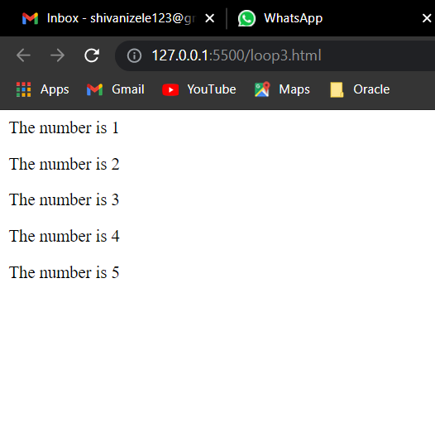

1. Program using for loop

<html>

<body>

<script language="javascript" type="text/javascript">

var i, j;

//outer loop

for (i = 1; i <= 5; i++) {

//inner loop

for (j = 1; j <= i; j++) {

document.write('*');

}

document.write('<br/>');

}

</script>

</body>

</html>

OUTPUT :

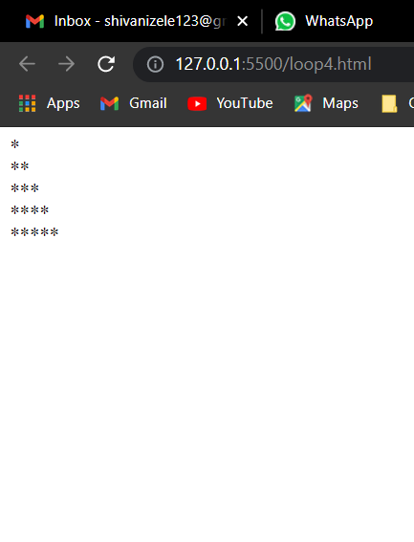

1. Program for printing star pattern.

<html>

<head>

<script type="text/javascript">

var i, j;

//outer loop

for (i = 5; i >= 1; i--) {

//inner loop

for (j = 1; j <= i; j++) {

document.write('*');

}

document.write('<br/>');

}

</script>

</head>

<body>

</body>

</html>

OUTPUT :

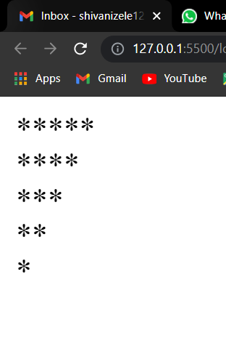

**Conclusion :**

**We have studied programs based on looping statement. Using for loop ,while loop, do while loop.**

**________________________________________________________**

**Assignment : 3**

**Aim : Programs based on arrays.**

* **Array :**

array is an object that represents a collection of similar type of elements.

There are 3 ways to construct array in JavaScript

1. By array literal
2. By creating instance of Array directly (using new keyword)
3. By using an Array constructor (using new keyword)

1) JavaScript array literal

- The syntax of creating array using array literal is given below:

var arrayname=[value1,value2.....valueN];

2) JavaScript Array directly (new keyword) :

The syntax of creating array directly is given below:

var arrayname=new Array();

Here, new keyword is used to create instance of array.

3) JavaScript array constructor (new keyword)

Here, you need to create instance of array by passing arguments in constructor so that we don't have to provide value explicitly.

**JavaScript Array Methods**

* array methods with their description.

|  |  |
| --- | --- |
| **Methods** | **Description** |
| [concat()](https://www.javatpoint.com/javascript-array-concat-method) | It returns a new array object that contains two or more merged arrays. |
| [copywithin()](https://www.javatpoint.com/javascript-array-copywithin-method) | It copies the part of the given array with its own elements and returns the modified array. |
| [entries()](https://www.javatpoint.com/javascript-array-entries-method) | It creates an iterator object and a loop that iterates over each key/value pair. |
| [every()](https://www.javatpoint.com/javascript-array-every-method) | It determines whether all the elements of an array are satisfying the provided function conditions. |
| [flat()](https://www.javatpoint.com/javascript-array-flat-method) | It creates a new array carrying sub-array elements concatenated recursively till the specified depth. |
| [flatMap()](https://www.javatpoint.com/javascript-array-flatmap-method) | It maps all array elements via mapping function, then flattens the result into a new array. |
| [fill()](https://www.javatpoint.com/javascript-array-fill-method) | It fills elements into an array with static values. |
| [from()](https://www.javatpoint.com/javascript-array-from-method) | It creates a new array carrying the exact copy of another array element. |
| [filter()](https://www.javatpoint.com/javascript-array-filter-method) | It returns the new array containing the elements that pass the provided function conditions. |
| [find()](https://www.javatpoint.com/javascript-array-find-method) | It returns the value of the first element in the given array that satisfies the specified condition. |
| [findIndex()](https://www.javatpoint.com/javascript-array-findindex-method) | It returns the index value of the first element in the given array that satisfies the specified condition. |
| [forEach()](https://www.javatpoint.com/javascript-array-foreach-method) | It invokes the provided function once for each element of an array. |
| [includes()](https://www.javatpoint.com/javascript-array-includes-method) | It checks whether the given array contains the specified element. |
| [indexOf()](https://www.javatpoint.com/javascript-array-indexof-method) | It searches the specified element in the given array and returns the index of the first match. |
| [isArray()](https://www.javatpoint.com/javascript-array-isarray-method) | It tests if the passed value ia an array. |
| [join()](https://www.javatpoint.com/javascript-array-join-method) | It joins the elements of an array as a string. |
| [keys()](https://www.javatpoint.com/javascript-array-keys-method) | It creates an iterator object that contains only the keys of the array, then loops through these keys. |
| [lastIndexOf()](https://www.javatpoint.com/javascript-array-lastindexof-method) | It searches the specified element in the given array and returns the index of the last match. |
| [map()](https://www.javatpoint.com/javascript-array-map-method) | It calls the specified function for every array element and returns the new array |
| [of()](https://www.javatpoint.com/javascript-array-of-method) | It creates a new array from a variable number of arguments, holding any type of argument. |
| [pop()](https://www.javatpoint.com/javascript-array-pop-method) | It removes and returns the last element of an array. |
| [push()](https://www.javatpoint.com/javascript-array-push-method) | It adds one or more elements to the end of an array. |
| [reverse()](https://www.javatpoint.com/javascript-array-reverse-method) | It reverses the elements of given array. |
| [reduce(function, initial)](https://www.javatpoint.com/javascript-array-reduce-method) | It executes a provided function for each value from left to right and reduces the array to a single value. |
| [reduceRight()](https://www.javatpoint.com/javascript-array-reduceright-method) | It executes a provided function for each value from right to left and reduces the array to a single value. |
| [some()](https://www.javatpoint.com/javascript-array-some-method) | It determines if any element of the array passes the test of the implemented function. |
| [shift()](https://www.javatpoint.com/javascript-array-shift-method) | It removes and returns the first element of an array. |
| [slice()](https://www.javatpoint.com/javascript-array-slice-method) | It returns a new array containing the copy of the part of the given array. |
| [sort()](https://www.javatpoint.com/javascript-array-sort-method) | It returns the element of the given array in a sorted order. |
| [splice()](https://www.javatpoint.com/javascript-array-splice-method) | It add/remove elements to/from the given array. |
| [toLocaleString()](https://www.javatpoint.com/javascript-array-tolocalestring-method) | It returns a string containing all the elements of a specified array. |
| [toString()](https://www.javatpoint.com/javascript-array-tostring-method) | It converts the elements of a specified array into string form, without affecting the original array. |
| [unshift()](https://www.javatpoint.com/javascript-array-unshift-method) | It adds one or more elements in the beginning of the given array. |
| [values()](https://www.javatpoint.com/javascript-array-values-method) | It creates a new iterator object carrying values for each index in the array. |

**Programs :**

1. **Programs for printing elements of array.**

<!DOCTYPE html>

<html>

<body>

<h3>Printing Elements Arrays</h3>

<p id="demo"></p>

<script>

var Name = ["Sneha ", " Shweta ", " Rani ", " Shanaya "];

document.getElementById("demo").innerHTML = Name;

</script>

<h3>Printing Elements of Array using New</h3>

<p id="demo1"></p>

<script>

var Names = new Array("Shivani", "Swara", "Sonali");

document.getElementById("demo1").innerHTML = Names;

</script>

</body>

</html>

Output :

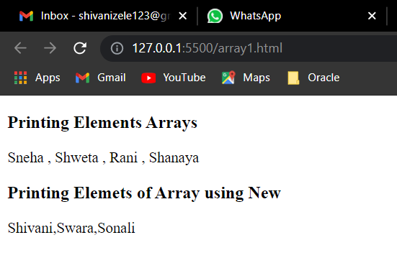

1. Program

<!DOCTYPE html>

<html>

<body>

<h3>Printing Elements Arrays using tostring</h3>

<p id="demo"></p>

<script>

var Name = ["Sneha ", " Shweta ", " Rani ", " Shanaya "];

document.getElementById("demo").innerHTML = Name.toString();

//document.getElementById("demo").innerHTML = Name.join("*");

</script>

<h3>Printing Elements of array using join()</h3>

<p id="demo1"></p>

<script>

var Name = ["Sneha ", " Shweta ", " Rani ", " Shanaya "];

document.getElementById("demo1").innerHTML = Name.join("*");

</script>

</body>

</html>

OUTPUT :

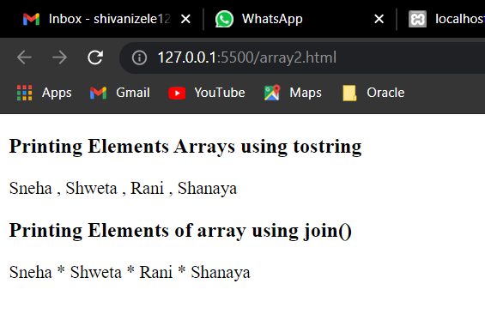

3 . Program

<body>

<h3> Arrays pop Method </h3>

<p id="demo"></p>

<script>

var Name = ["Sneha ", " Shweta ", " Rani ", " Shanaya "];

document.getElementById("demo").innerHTML = Name;

Name.pop();

document.getElementById("demo").innerHTML = Name;

</script>

</body>

</html>

Output :

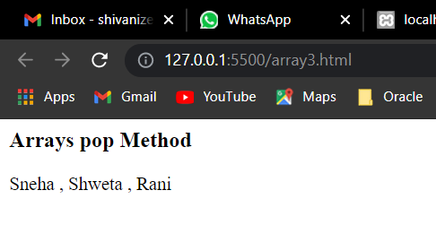

1. Program

<!DOCTYPE html>

<html>

<body>

<p>Elements Before Push Method : </p>

<p id="demo"></p>

<p>Elements After push method : </p>

<p id="demo1"></p>

<p>Elements After shift method : </p>

<p id="demo2"></p>

<script>

var Name = ["Siddhi", "Naina", "Anita", "Mona"];

document.getElementById("demo").innerHTML = Name;

Name.push("Swarupa");

document.getElementById("demo1").innerHTML = Name;

Name.shift();

document.getElementById("demo2").innerHTML = Name;

</script>

</body>

</html>

Output :

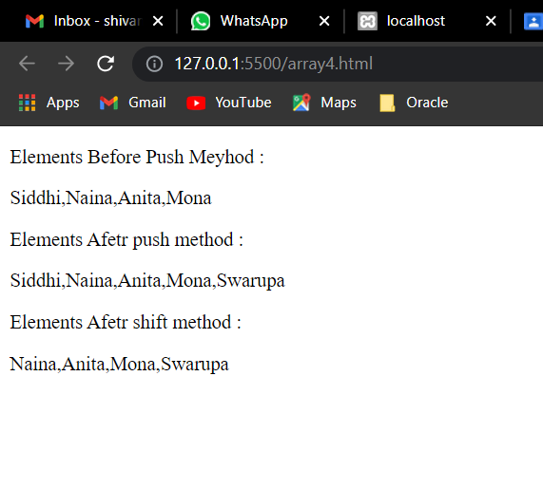

1. Program :

<!DOCTYPE html>

<html>

<body>

<p>Array elements are accessed using their index number : </p>

<p id="demo"></p>

<p id="demo1"></p>

<script>

var Name = ["Siddhi", "Naina", "Anita", "Mona"];

document.getElementById("demo").innerHTML = Name;

Name[0] = "Shweta";

document.getElementById("demo1").innerHTML = Name;

</script>

</body>

</html>

Output :

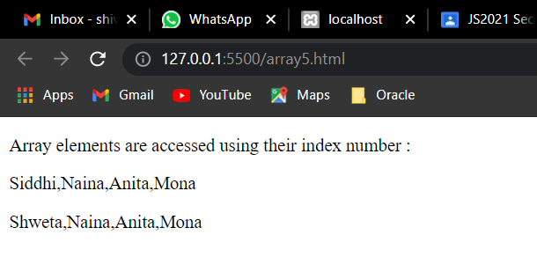

1. Program

<!DOCTYPE html>

<html>

<body>

<h2>concatinate array elements </h2>

<p>The concation of array method is used to merge/concatenate arrays:</p>

<p id="demo"></p>

<script>

var myGirls = ["Sid", "Raj"];

var myBoys = ["Vedika", "Shanaya", "Linisha"];

var child = ["sohan", "Geeta", "Jesus"]

var myChildren = myGirls.concat(myBoys, child);

document.getElementById("demo").innerHTML = myChildren;

</script>

</body>

</html>

Output :

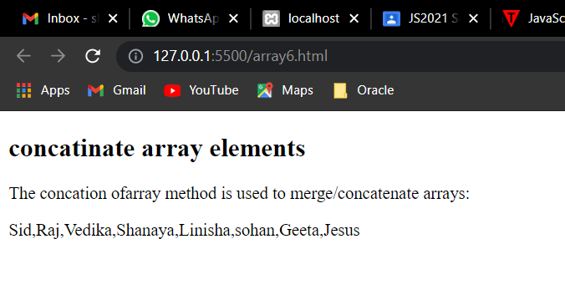

1. Program :

<!DOCTYPE html>

<html>

<body>

<h2>JavaScript Array Sort</h2>

<p>Click the button to sort the array in ascending order.</p>

<button onclick="myFunction()">Try it</button>

<p id="demo"></p>

<script>

var points = [40, 100, 1, 5, 25, 10];

document.getElementById("demo").innerHTML = points;

function myFunction() {

points.sort(function(a, b) {

return a - b

});

document.getElementById("demo").innerHTML = points;

}

</script>

</body>

</html>

Output :

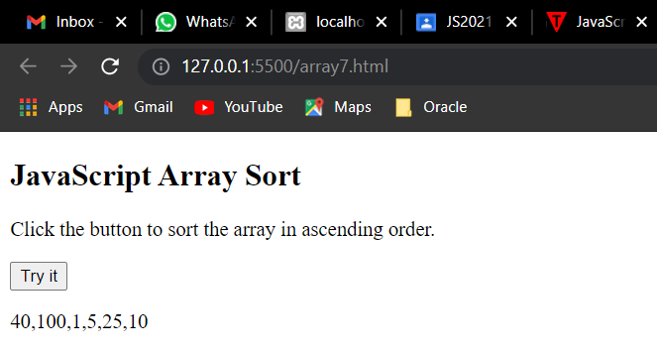

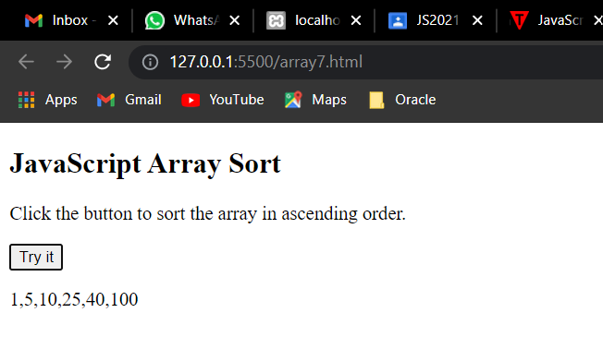

1. Program

<!DOCTYPE html>

<html>

<body>

<h2>JavaScript Array.forEach()</h2>

<p>Calls a function once for each array element.</p>

<p id="demo"></p>

<script>

var txt = "";

var numbers = [45, 4, 9, 16, 25];

numbers.forEach(myFunction);

document.getElementById("demo").innerHTML = txt;

function myFunction(value, index, array) {

txt = txt + value + "<br>";

}

</script>

</body>

</html>

Output :

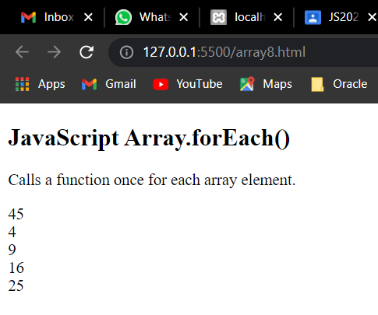

1. Program :

<html>

<h3>printing Elements of Array using for loop</h3>

<body>

<script>

var Subject = ["JavaScript", "Java_Programming", "PHP", "Data Structure"];

for (i = 0; i < Subject.length; i++) {

document.write(Subject[i] + "<br/>");

}

</script>

<script>

var arr = ["AngularJS", "Node.js", "JQuery", "Bootstrap"]

var result = arr.slice(1, 3);

document.write("Slice Method : ")

document.writeln(result);

</script>

<script>

document.write("<br>");

var arr2 = ["AngularJS", "Node.js", "JQuery", "Bootstrap"]

var result1 = arr2.slice(0, 3);

document.write("\n Slice Method : ")

document.writeln(result1);

</script>

</body>

</html>

Output :

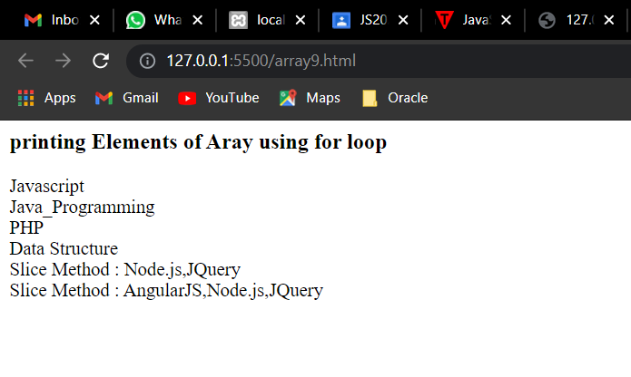

---------------------------------------------------------------------------------------------------------------------------------------------------------------------------------------------------------------

**Conclusion :**

We have studied Programs based on arrays using array methods and different functions of arrays.

------------------------------------------------------------------------------------------------------------------------------------------------------------------------------------------------------------------

**Assignment : 4**

**Aim : Programs based on functions.**

* **Functions :**
* In JavaScript, a function allows you to define a block of code, give it a name and then execute it as many times as you want.
* A JavaScript function can be defined using function keyword.
* **Syntax:**

//defining a function

function <function-name>()

{

// code to be executed

};

//calling a function

<function-name>();

* **Function Parameters :**

1. A function can have one or more parameters, which will be supplied by the calling code and can be used inside a function. JavaScript is a dynamic type scripting language, so a function parameter can have value of any data type.
2. You can pass less or more arguments while calling a function. If you pass less arguments then rest of the parameters will be undefined. If you pass more arguments then additional arguments will be ignored.

* **The Arguments Object :**
* The arguments object is an array like object. You can access its values using index similar to array. However, it does not support array methods.
* All the functions in JavaScript can use arguments object by default. An arguments object includes value of each parameter.
* An arguments object is still valid even if function does not include any parameters.
* An arguments object can be iterated using for loop.
* **Return Value :**

A function can return zero or one value using return keyword.

* **Function Expression**

JavaScript allows us to assign a function to a variable and then use that variable as a function. It is called function expression.

* **Anonymous Function**

Anonymous function is useful in passing callback function, creating closure or Immediately invoked function expression.

JavaScript allows us to define a function without any name. This unnamed function is called anonymous function. Anonymous function must be assigned to a variable.

* Nested Functions
* A function can have one or more inner functions.

These nested functions are in the scope of outer function.

- Inner function can access variables and parameters of outer function. However, outer function cannot access variables defined inside inner functions.

* **Functions :**

1. JavaScript a function allows you to define a block of code, give it a name and then execute it as many times as you want.
2. A function can be defined using function keyword and can be executed using () operator.
3. A function can include one or more parameters. It is optional to specify function parameter values while executing it.
4. JavaScript is a loosely-typed language. A function parameter can hold value of any data type.
5. You can specify less or more arguments while calling function.
6. All the functions can access arguments object by default instead of parameter names.
7. A function can return a literal value or another function.
8. A function can be assigned to a variable with different name.
9. JavaScript allows you to create anonymous functions that must be assigned to a variable.

**Programs :**

1. **Program using function .**

<html>

<body>

<script>

function Student() {

alert("Hello World !!");

}

Student();

</script>

</body>

</html>

**Output :**

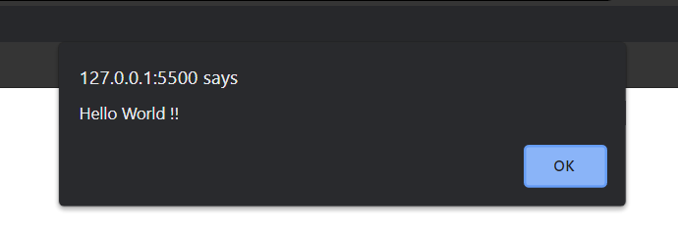

**2 . programs of function .**

<html>

<body>

<script>

function Student(Firstname, Enrollment_No) {

// document.write(" Welcome " + Firstname + " ", "En.N0" + Enrollment_No)

alert("Welcome to Government Polytechnic pune " + Firstname + " " + Enrollment_No)

}

Student("Shivani", 1907069);

Student("Sandhya", 1907070);

</script>

<script>

// Multiplication of Two Numbers

const Mul = (val1, val2) => val1 * val2;

alert("The Multiplication is :" + Mul(20, 81))

</script>

</body>

</html>

**Output :**

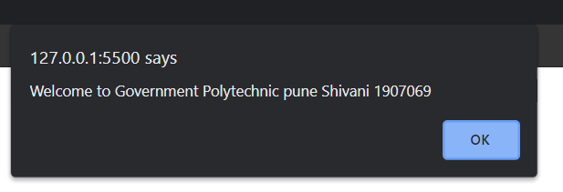

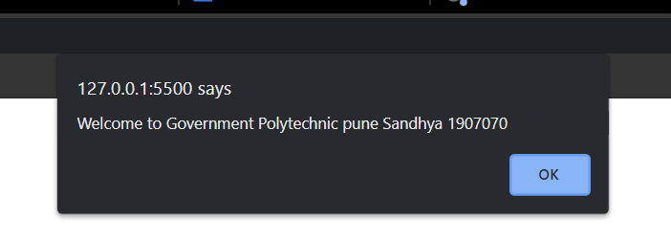

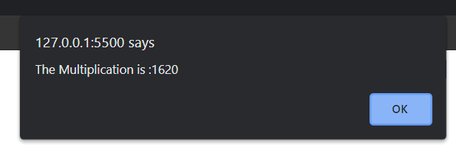

1. **Program using function argument**

<html>

<body>

<script>

var Add = function Addition(value1, value2) {

return value1 + value2;

}

var Res = Add(20, 81);

document.write("The Addition is :" + Res)

document.write("<br> ")

var Mul = function multiplication(value1, value2) {

return value1 * value2;

}

var Result = Mul(20, 81);

document.write("The Multiplication is :" + Result)

document.write("<br> ")

</script>

</body>

</html>

**Output :**

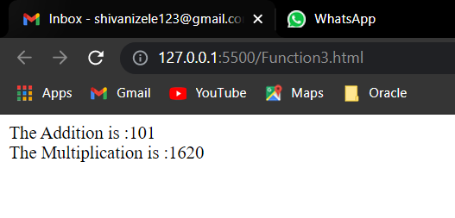

1. **Program using nested function.**

<!--Nested Function Program-->

<html>

<body>

<h3>Nested Function</h3>

<script>

var showMessage = function() {

document.write("Hello Welcome To Programming using Javascript!!");

document.write("<br>")

};

showMessage();

var sayHello = function(Student_Enroll_no) {

document.write("\n Hello " + Student_Enroll_no);

};

showMessage();

sayHello("Enrollment_No-1907069");

</script>

</body>

</html>

**Output :**

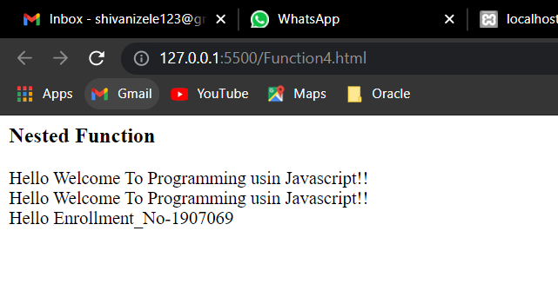

1. **Functions program to Convert Fahrenheit to Celsius .**

<!DOCTYPE html>

<!--Convert Fahrenheit to Celsius:-->

<html>

<body>

<h4>JavaScript Functions to Convert Fahrenheit to Celsius:</h4>

<p>This example calls a function to convert from Fahrenheit to Celsius:</p>

<p id="demo"></p>

<script>

function toCelsius(f) {

return (5 / 9) * (f - 32);

}

document.getElementById("demo").innerHTML = toCelsius(77);

</script>

</body>

</html>

**Output :**

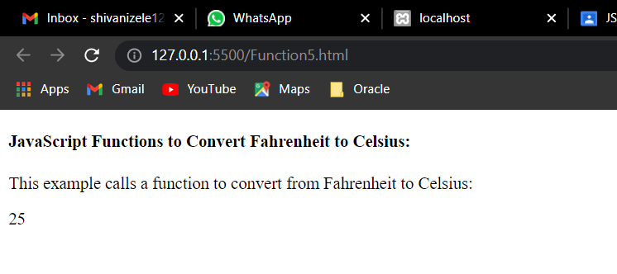

**---------------------------------------------------------------------------------------------------------**

**Conclusion :**

**We have studied Programs based on functions.**

**--------------------------------------------------------------------------------------------------------------------------**

**Assignment : 5**

**AIM : Programs based on strings.**

* **String :**

The JavaScript string is an object that represents a sequence of characters.

There are 2 ways to create string in JavaScript

1. By string literal
2. By string object (using new keyword).

1) By string literal

- The string literal is created using double quotes. The syntax of creating string using string literal is given below:

Syntax :

var stringname="string value";

2) By string object (using new keyword)

The syntax of creating string object using new keyword is given below:

* Syntax :

var stringname=new String("string literal");

Here, new keyword is used to create instance of string.

**JavaScript String Methods :**

* list of JavaScript string methods.

|  |  |
| --- | --- |
| **Methods** | **Description** |
| [charAt()](https://www.javatpoint.com/javascript-string-charat-method) | It provides the char value present at the specified index. |
| [charCodeAt()](https://www.javatpoint.com/javascript-string-charcodeat-method) | It provides the Unicode value of a character present at the specified index. |
| [concat()](https://www.javatpoint.com/javascript-string-concat-method) | It provides a combination of two or more strings. |
| [indexOf()](https://www.javatpoint.com/javascript-string-indexof-method) | It provides the position of a char value present in the given string. |
| [lastIndexOf()](https://www.javatpoint.com/javascript-string-lastindexof-method) | It provides the position of a char value present in the given string by searching a character from the last position. |
| [search()](https://www.javatpoint.com/javascript-string-search-method) | It searches a specified regular expression in a given string and returns its position if a match occurs. |
| [match()](https://www.javatpoint.com/javascript-string-match-method) | It searches a specified regular expression in a given string and returns that regular expression if a match occurs. |
| [replace()](https://www.javatpoint.com/javascript-string-replace-method) | It replaces a given string with the specified replacement. |
| [substr()](https://www.javatpoint.com/javascript-string-substr-method) | It is used to fetch the part of the given string on the basis of the specified starting position and length. |
| [substring()](https://www.javatpoint.com/javascript-string-substring-method) | It is used to fetch the part of the given string on the basis of the specified index. |
| [slice()](https://www.javatpoint.com/javascript-string-slice-method) | It is used to fetch the part of the given string. It allows us to assign positive as well negative index. |
| [toLowerCase()](https://www.javatpoint.com/javascript-string-tolowercase-method) | It converts the given string into lowercase letter. |
| [toLocaleLowerCase()](https://www.javatpoint.com/javascript-string-tolocalelowercase-method) | It converts the given string into lowercase letter on the basis of host?s current locale. |
| [toUpperCase()](https://www.javatpoint.com/javascript-string-touppercase-method) | It converts the given string into uppercase letter. |
| [toLocaleUpperCase()](https://www.javatpoint.com/javascript-string-tolocaleuppercase-method) | It converts the given string into uppercase letter on the basis of host?s current locale. |
| [toString()](https://www.javatpoint.com/javascript-string-tostring-method) | It provides a string representing the particular object. |
| [valueOf()](https://www.javatpoint.com/javascript-string-valueof-method) | It provides the primitive value of string object. |
| split() | It splits a string into substring array, then returns that newly created array. |
| trim() | It trims the white space from the left and right side of the string. |

**Programs :**

1. **Program using string methods.**

<html>

<body>

<p id="demo"></p>

<p id="demo1"></p>

<p id="demo3"></p>

<script>

var fruitname = "Mangeo is \"Very best fruit and sweet \\ best fruit";

var fruitname2 = "Pineapple";

var fruitname3 = "Coconut"

var slength = fruitname.length;

document.getElementById("demo1").innerHTML = "The Length of fruitname : " + slength;

document.write("<hr>");

document.getElementById("demo").innerHTML = fruitname + " <br>" + fruitname2 + "<br>" + fruitname3;

var pos = fruitname.indexOf("Mangeo");

</script>

<script>

var student = "The Student Enrollment number is sixty nine";

var pos = student.indexOf("Enrollment");

document.write("The index is : " + pos);

</script>

</body>

</html>

**Output :**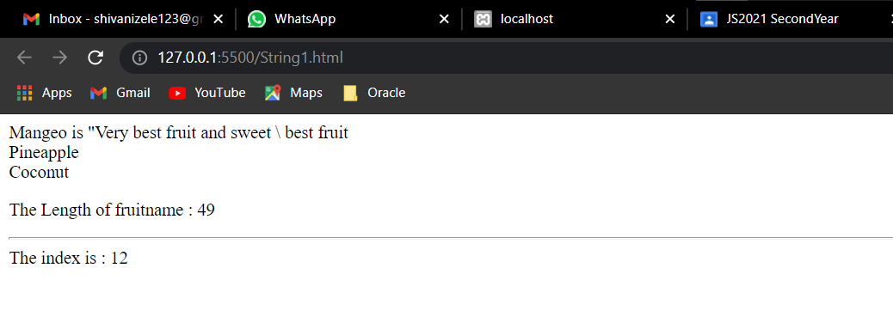

1. **Program**

<!DOCTYPE html>

<html>

<body>

<h2>JavaScript String Methods</h2>

<p>The search() method returns the position of the first occurrence of a specified text in a string:</p>

<p id="demo"></p>

<script>

var str = "This is javascript!";

var pos = str.search("is");

document.getElementById("demo").innerHTML = pos;

</script>

</body>

</html>

**Output :**

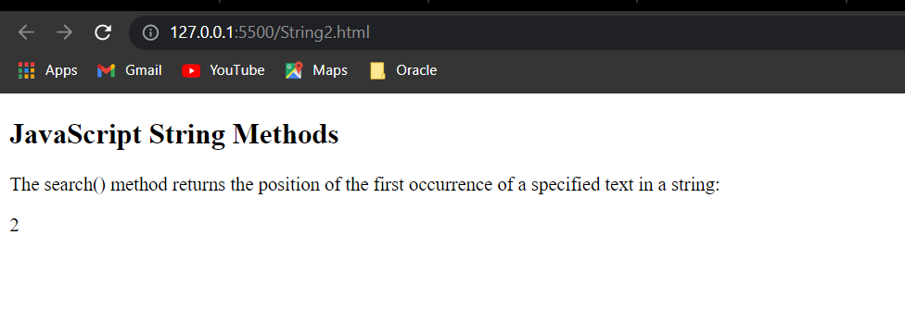

1. **Program**

<!--Slice method-->

<html>

<body>

<h3>Javascript slice method of string</h3>

<p id="demo"></p>

<script>

var str = "StudentTeacherEmploye engineers are part of our society";

var res = str.slice(5, 10);

document.getElementById("demo").innerHTML = res;

</script>

<h3>Another program of slice method</h3>

<p id="demo1"></p>

<script>

var str1 = "Arohi, Sadhna, Rani";

var res1 = str1.slice(-12, -6);

document.getElementById("demo1").innerHTML = res1;

</script>

<h3>Program using substr() method of string </h3>

<p id="demo4"></p>

<p id="demo5"></p>

<script>

var str2 = "The substr() method extract a part of a string and returns the extracted parts in a new string."

var res3 = str2.substr(13, 27)

var res4 = str2.substr(17)

document.getElementById("demo4").innerHTML = res3;

document.getElementById("demo5").innerHTML = res4;

</script>

<p id=" demo"></p>

<script>

var name = "VIJAY SHILEKAR"

console.log(name.split(" ").reverse().join(" "))

var r = name.split(" ").reverse().join(" ")

// var res5 = name.slice(6, 15);

document.getElementById("demo5").innerHTML = r;

</script>

</body>

</html>

**Output :**

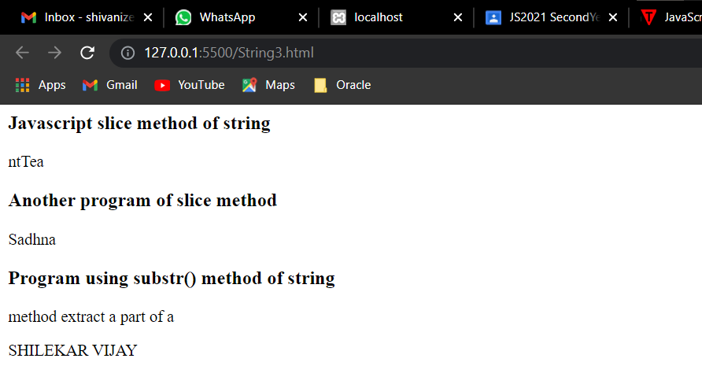

1. Program

<html>

<body>

<h3>String after replace : </h3>

<p id="demo"></p>

<p id="demo1"></p>

<p id="demo2"></p>

<script>

var str = " Welcome to JavaScript";

var r = str.replace(/Welcome/, "Welcomefriend")

document.getElementById("demo").innerHTML = r;

</script>

<script>

var str3 = " Welcome to JavaScript";

//var str2 = str3.toUpperCase(str3);

document.getElementById("demo1").innerHTML = str3.toUpperCase();

document.getElementById("demo2").innerHTML = str3.toLowerCase();

var ss = " Welcome Friends ";

alert(ss.trim());

</script>

</body>

</html>

**Output :**

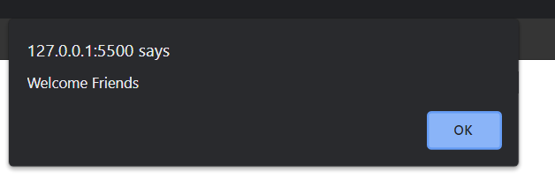

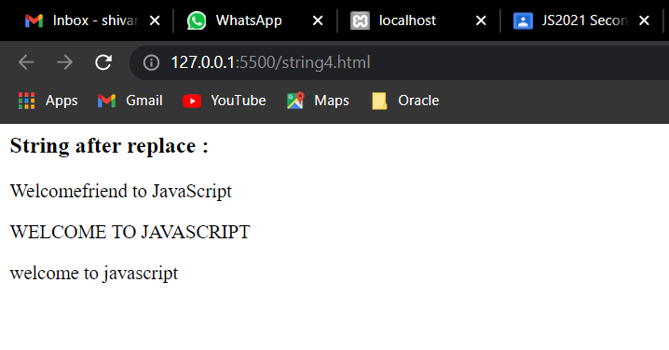

**Conclusion :**

**We have studied Programs based on strings using string methods.**

**Assignment : 6**

**AIM : Program using Form Objects and form elements.**

* **Creating the form**

Typical form control objects -- also called "widgets" -- include the following:

* Text box for entering a line of text
* Push button for selecting an action
* Radio buttons for making one selection among a group of options
* Check boxes for selecting or deselecting a single, independent option
* FORM NAME="myform" defines and names the form. Elsewhere in the JavaScript you can reference this form by the name myform. The name you give your form is up to you, but it should comply with JavaScript's standard variable/function naming rules (no spaces, no weird characters except the underscore, etc.).
* ACTION="" defines how you want the browser to handle the form when it is submitted to a CGI program running on the server. As this example is not designed to submit anything, the URL for the CGI program is omitted.
* METHOD="GET" defines the method data is passed to the server when the form is submitted. In this case the atttibute is puffer as the example form does not submit anything.
* INPUT TYPE="text" defines the text box object. This is standard HTML markup.
* INPUT TYPE="button" defines the button object. This is standard HTML markup except for the onClick handler.
* onClick="testResults(this.form)" is an event handler -- it handles an event, in this case clicking the button. When the button is clicked, JavaScript executes the expression within the quotes. The expression says to call the testResults function elsewhere on the page, and pass to it the current form object.
* Programs :

1. Programs

<HTML>

<HEAD>

<TITLE>Test Input</TITLE>

<SCRIPT LANGUAGE="JavaScript">

function testResults(form) {

var TestVar = form.inputbox.value;

alert("You typed: " + TestVar);

}

</SCRIPT>

</HEAD>

<BODY>

<FORM NAME="myform" ACTION="" METHOD="GET">Enter Your Full name :

<INPUT TYPE="text" NAME="inputbox" VALUE="">

<P>

<INPUT TYPE="button" NAME="button" Value="Click" onClick="testResults(this.form)">

</FORM>

</BODY>

</HTML>

Output :

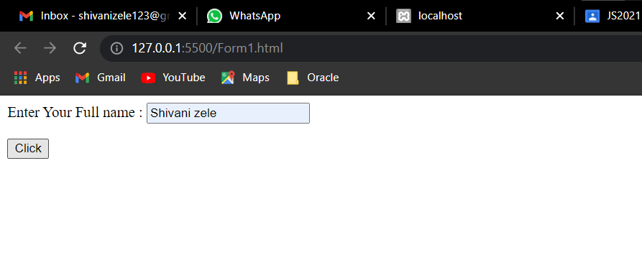

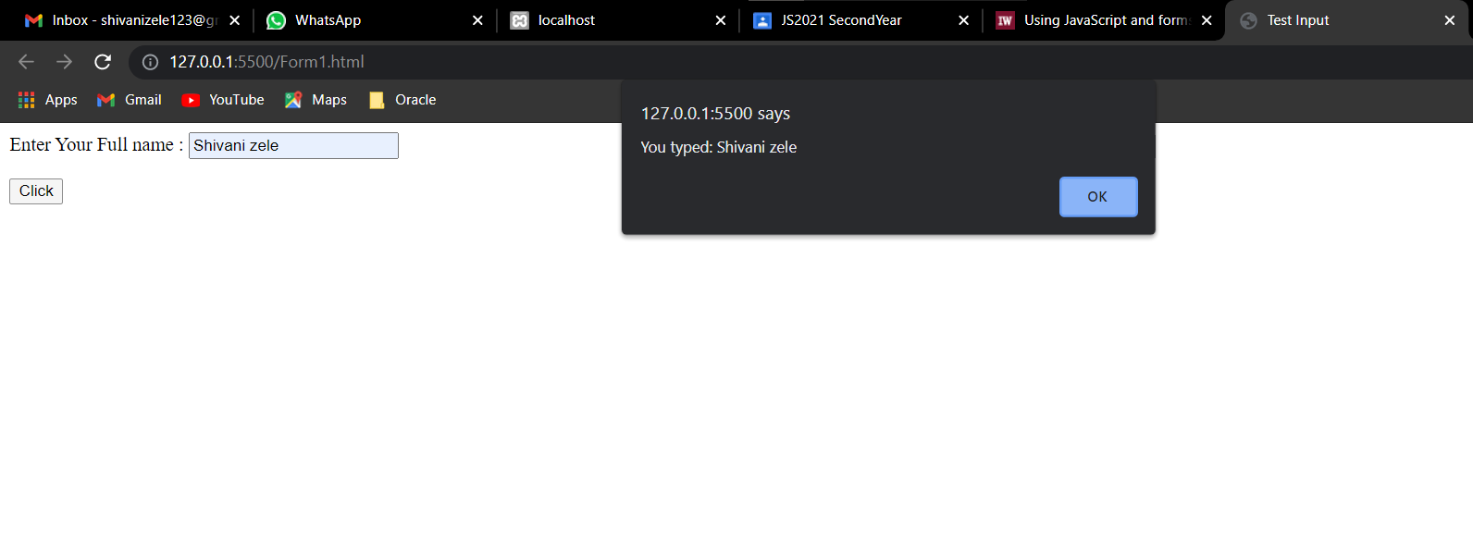

1. Program

<HTML>

<HEAD>

<TITLE>Test Input</TITLE>

<SCRIPT LANGUAGE="JavaScript">

function testResults(form) {

var TestVar = form.inputbox.value;

alert("You typed: " + TestVar);

}

</SCRIPT>

</HEAD>

<BODY>

<FORM NAME="myform" ACTION="" METHOD="GET">Enter Your Fullanme :

<INPUT TYPE="text" NAME="inputbox" VALUE="">

<P>

<INPUT TYPE="button" NAME="button" Value="Click" onClick="testResults(this.form)">

</FORM>

</BODY>

</HTML>

Output :

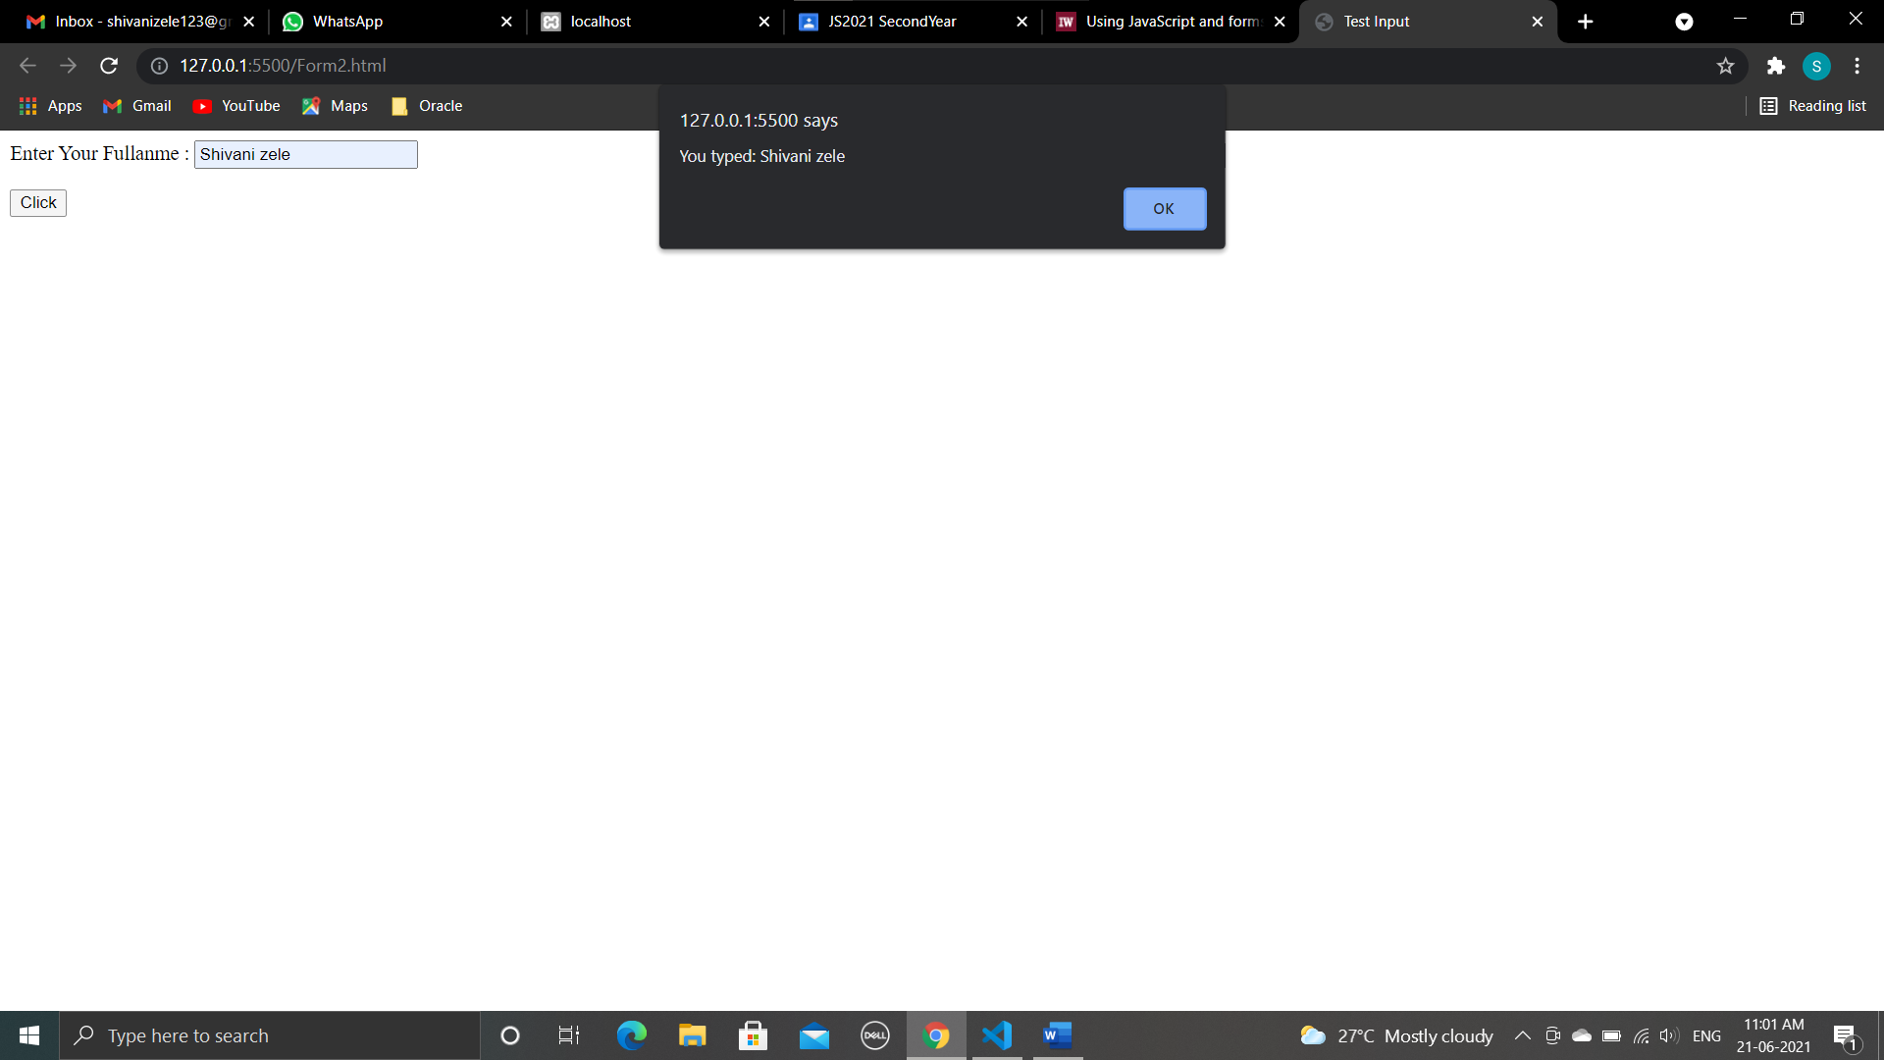

1. Program

<HTML>

<HEAD>

<TITLE>Test Input </TITLE>

<SCRIPT LANGUAGE="JavaScript">

function readText(form) {

TestVar = form.inputbox.value;

alert("You typed: " + TestVar);

}

function writeText(form) {

form.inputbox.value = "Have a nice day!"

}

</SCRIPT>

</HEAD>

<BODY>

<FORM NAME="myform" ACTION="" METHOD="GET">

Enter the text box:

<BR>

<INPUT TYPE="text" NAME="inputbox" VALUE="">

<P>

<INPUT TYPE="button" NAME="button1" Value="Read" onClick="readText(this.form)">

<INPUT TYPE="button" NAME="button2" Value="Write" onClick="writeText(this.form)">

</FORM>

</BODY>

</HTML>

Output :

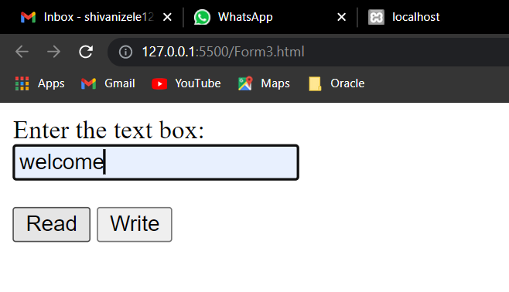

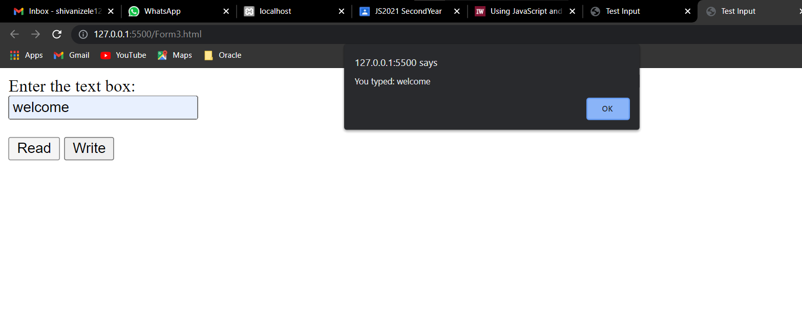

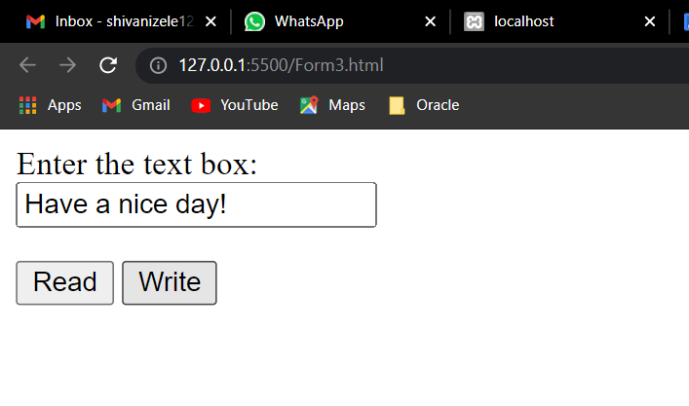

1. Program

<html>

<head> Javascript Events

<br> </head>

</br>

<body>

<script language="Javascript" type="text/Javascript">

<!--

function clickevent()

{

document.write("This is Javascript programming");

}

//-->

</script>

<form>

<input type="button" onclick="clickevent()" value="Who's this?" />

</form>

</body>

</html>

Output :

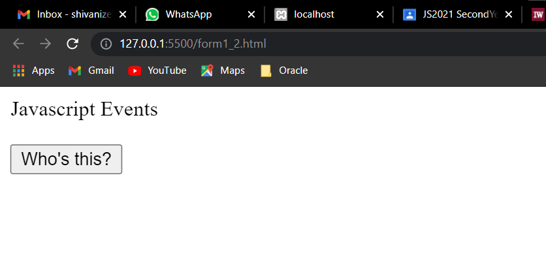

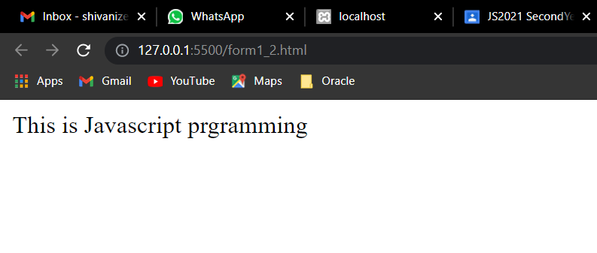

________________________________________________________________

**Conclusion :**

**We have studied Program using Form Objects and form elements.**

________________________________________________________________

**Assignment : 7**

**Aim : Program using Form Events.**

Form Events :

The **form** property within the document object contains an array of all forms defined within the document.

Each element within the array is a form object , the index number associated with the form object defines the order in which the form appears on the webpage.

The exits a number of events associated with the form element. The table below enumerates them in detail.

Table : Event handlers for Form Elements.

| Object | Event Handler |
| --- | --- |
| button | *onClick, onBlur, onFocus* |
| checkbox | *onClick, onBlur, onFocus.* |
| FileUpLoad | *onClick, onBlur, onFocus* |
| hidden | *none* |
| password | *onBlur, onFocus, onSelect.* |
| radio | *onClick, onBlur, onFocus* |
| reset | *onReset.* |
| select | *onFocus, onBlur, onChange.* |
| submit | *onSubmit* |
| text | *onClick, onBlur, onFocus , onChange* |
| textarea | *onClick, onBlur, onFocus , onChange* |

Javascript Form Events : Buttons

The main utility of a button object is to trigger an event, say an ***onClick()*** event, but a button object has no default action.

The are several types of buttons associated with a form:

* submit
* reset
* button

These events are fired when some click related activity is registered.

Table : The MouseEvent Object.

| Event Handler | Triggered When |
| --- | --- |
| onBlur | *The form's select, text, or textarea field loses focus.* |
| onChange | *A select , text ot textarea field has lost the focus and values are changed.* |
| onClick | *An object on a form gets clicked.* |
| onFocus | *a field gets input focus.* |
| onReset | *The form is reset* |
| onSelect | *text within the textarea field is selected* |
| onSubmit | *A form is submitted* |

Form Events : Using keyword *this*

* The current object is referred using the keyword ***this***, it is used quite frequently with form element.
* For forms with multiple input fields, it get easier to refer them using ***this*** keyword, than by using full name to call the event handler function.

## Form Events : Event handler *onClick*

Using the event handler **onClick** is the most frequently used in form, or elsewhere to trigger event handler function on click events.

A click event is set to take place when the button within a form, radio or checkbox is pressed or when a selection is made.

## Form Events: *onFocus* and *onBlur* event handlers

The event handler ***onFocus*** is fired when a form element gets the focus.

Similarly, the **onblur** event handler is fired when the form element loses focus, i.e when the cursor moves away from form field.

**Programs:**

1. **Program**

<html>

<head> Javascript Events

<br> </head>

</br>

<body>

<script language="Javascript" type="text/Javascript">

<!--

function clickevent()

{

document.write("This is Javascript prgramming");

}

//-->

</script>

<form>

<input type="button" onclick="clickevent()" value="Who's this?" />

</form>

</body>

</html>

**Output :**

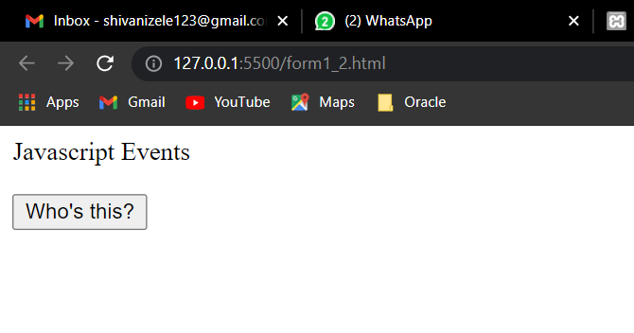

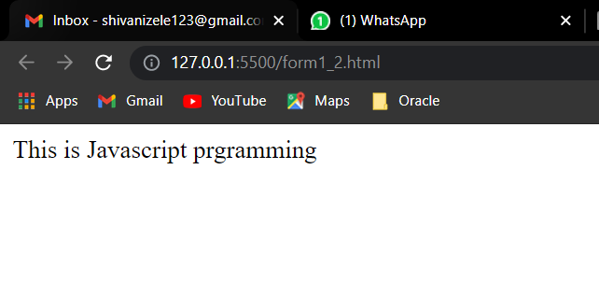

2. **program**

<!DOCTYPE html>

<html>

<head>

<title>Javascript Form Events : onClick Event</title>

<script>

function Pune() {

alert("I Like Pune city");

}

function Aurangabad() {

alert("Aurangabad is very famous city");

}

function Mumbai() {

alert(" Mumbai is capital of maharashtra");

}

</script>

</head>

<body>

<p>City names and description</p>

<form>

<input type="button" value="Pune" onclick="Pune()" />

<input type="button" value="Aurangabad" onclick="Aurangabad()" />

<input type="button" value="Mumbai" onclick="Mumbai()" />

</form>

</body>

</html>

**Output :**

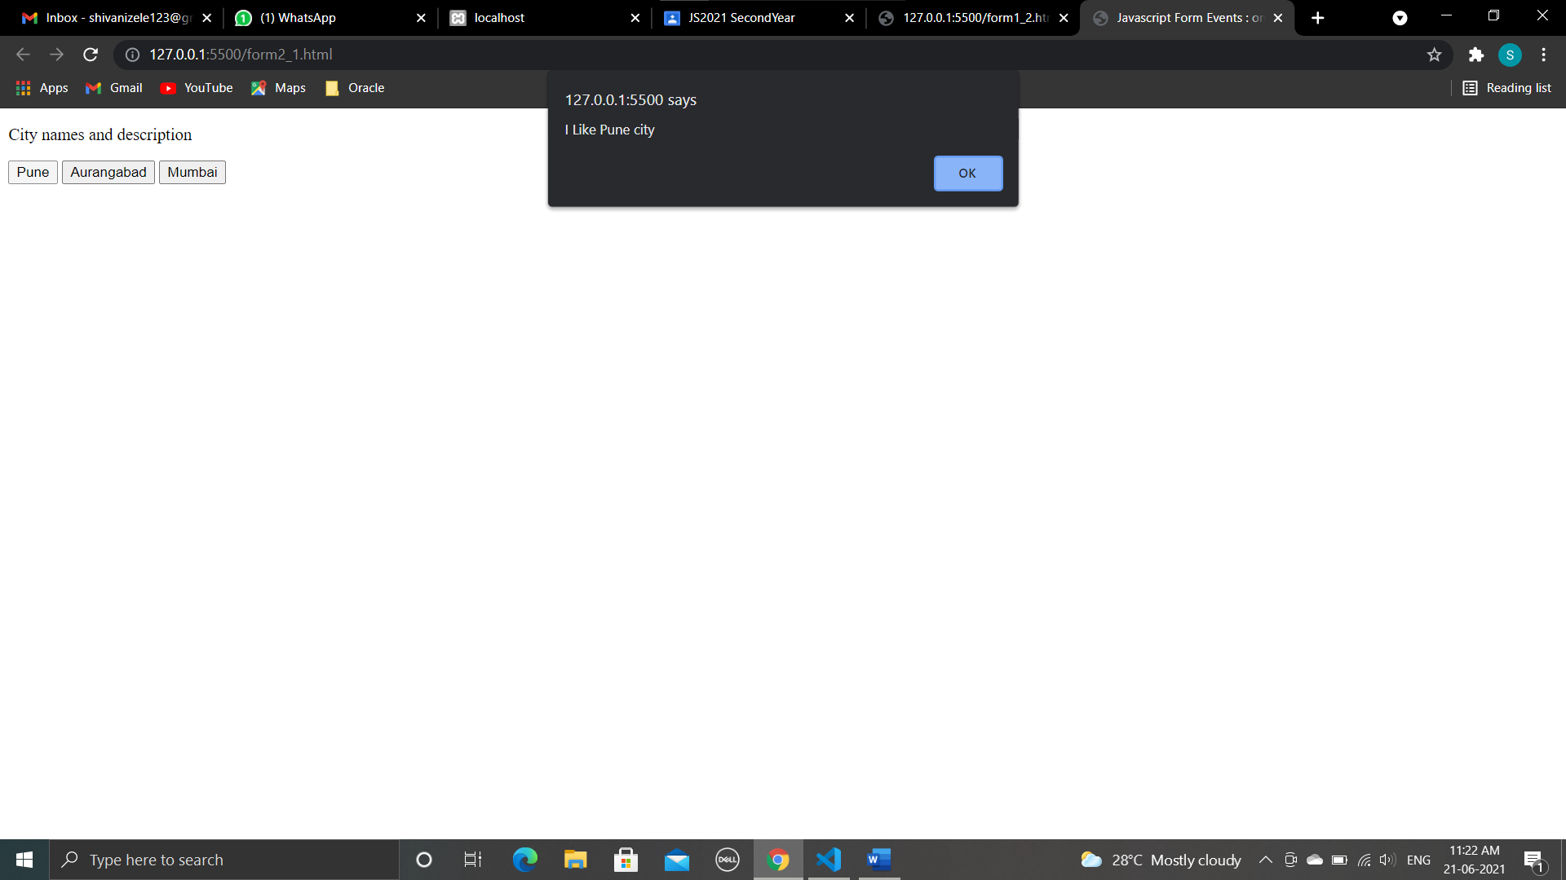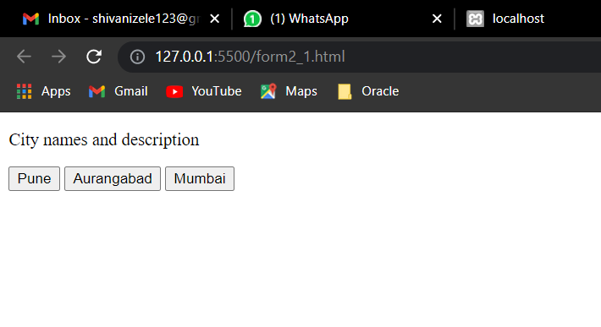

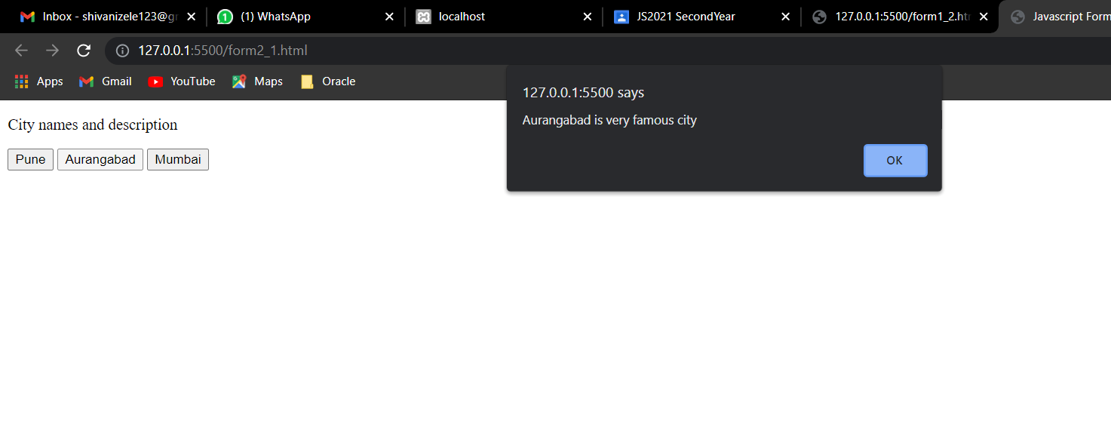

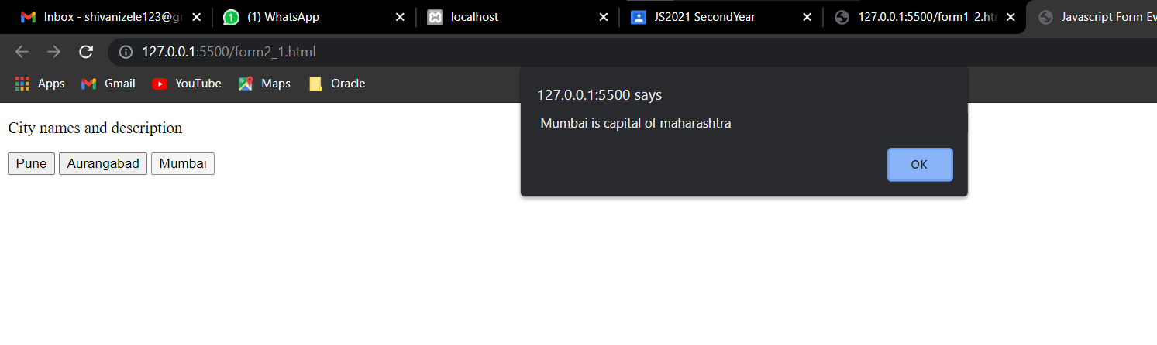

**3. program**

<html>

<head> Javascript Events</head>

<body>

<h2> Enter something here</h2>

<input type="text" id="input1" onfocus="focusevent()" />

<script>

function focusevent() {

document.getElementById("input1").style.background = " aqua";

}

//-->

</script>

</body>

</html>

**Output :**

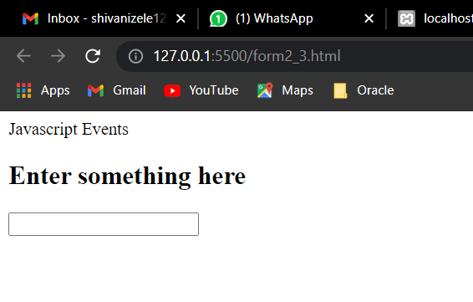

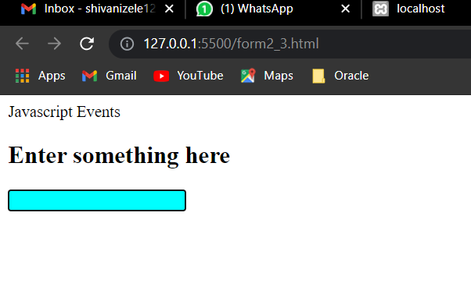

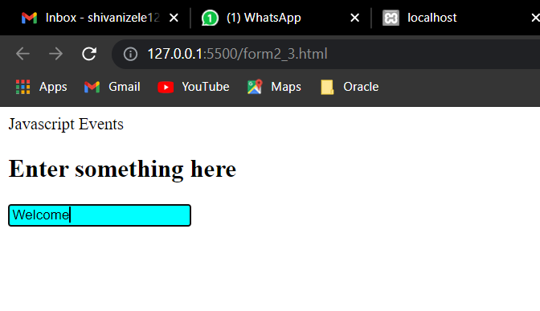

**4. Program :**

<!DOCTYPE html>

<html>

<style>

body {

font-family: Arial, Helvetica, sans-serif;

}

* {

box-sizing: border-box;

}

/* Full-width input fields */

input[type=text],

input[type=password] {

width: 100%;

padding: 15px;

margin: 5px 0 22px 0;

display: inline-block;

border: none;

background: #f1f1f1;

}

/* Add a background color when the inputs get focus */

input[type=text]:focus,

input[type=password]:focus {

background-color: #ddd;

outline: none;

}

/* Set a style for all buttons */

button {

background-color: #04AA6D;

color: white;

padding: 14px 20px;

margin: 8px 0;

border: none;

cursor: pointer;

width: 100%;

opacity: 0.9;

}

button:hover {

opacity: 1;

}

/* Extra styles for the cancel button */

.cancelbtn {

padding: 14px 20px;

background-color: #f44336;

}

/* Float cancel and signup buttons and add an equal width */

.cancelbtn,

.signupbtn {

float: left;

width: 50%;

}

/* Add padding to container elements */

.container {

padding: 16px;

}

/* The Modal (background) */

.modal {

display: none;

/* Hidden by default */

position: fixed;

/* Stay in place */

z-index: 1;

/* Sit on top */

left: 0;

top: 0;

width: 100%;

/* Full width */

height: 100%;

/* Full height */

overflow: auto;

/* Enable scroll if needed */

background-color: #474e5d;

padding-top: 50px;

}

/* Modal Content/Box */

.modal-content {

background-color: #fefefe;

margin: 5% auto 15% auto;

/* 5% from the top, 15% from the bottom and centered */

border: 1px solid #888;

width: 80%;

/* Could be more or less, depending on screen size */

}

/* Style the horizontal ruler */

hr {

border: 1px solid #f1f1f1;

margin-bottom: 25px;

}

/* The Close Button (x) */

.close {

position: absolute;

right: 35px;

top: 15px;

font-size: 40px;

font-weight: bold;

color: #f1f1f1;

}

.close:hover,

.close:focus {

color: #f44336;

cursor: pointer;

}

/* Clear floats */

.clearfix::after {

content: "";

clear: both;

display: table;

}

/* Change styles for cancel button and signup button on extra small screens */

@media screen and (max-width: 300px) {

.cancelbtn,

.signupbtn {

width: 100%;

}

}

</style>

<body>

<h2>Modal Signup Form</h2>

<button onclick="document.getElementById('id01').style.display='block'" style="width:auto;">Sign Up</button>

<div id="id01" class="modal">

<span onclick="document.getElementById('id01').style.display='none'" class="close" title="Close Modal">&times;</span>

<form class="modal-content" action="/action.html">

<div class="container">

<h1>Sign Up</h1>

<p>Please fill in this form to create an account.</p>

<hr>

<label for="email"><b>Email</b></label>

<input type="text" placeholder="Enter Email" name="email" required>

<label for="psw"><b>Password</b></label>

<input type="password" placeholder="Enter Password" name="psw" required>

<label for="psw-repeat"><b>Repeat Password</b></label>

<input type="password" placeholder="Repeat Password" name="psw-repeat" required>

<label>

<input type="checkbox" checked="checked" name="remember" style="margin-bottom:15px"> Remember me

</label>

<p>By creating an account you agree to our <a href="#" style="color:dodgerblue">Terms & Privacy</a>.</p>

<div class="clearfix">

<button type="button" onclick="document.getElementById('id01').style.display='none'" class="cancelbtn">Cancel</button>

<button type="submit" class="signupbtn">Sign Up</button>

</div>

</div>

</form>

</div>

<script>

// Get the modal

var modal = document.getElementById('id01');

// When the user clicks anywhere outside of the modal, close it

window.onclick = function(event) {

if (event.target == modal) {

modal.style.display = "none";

}

}

</script>

</body>

</html>

**Output :**

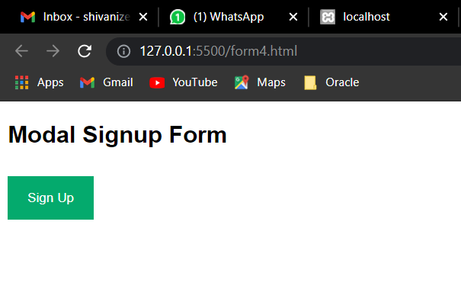

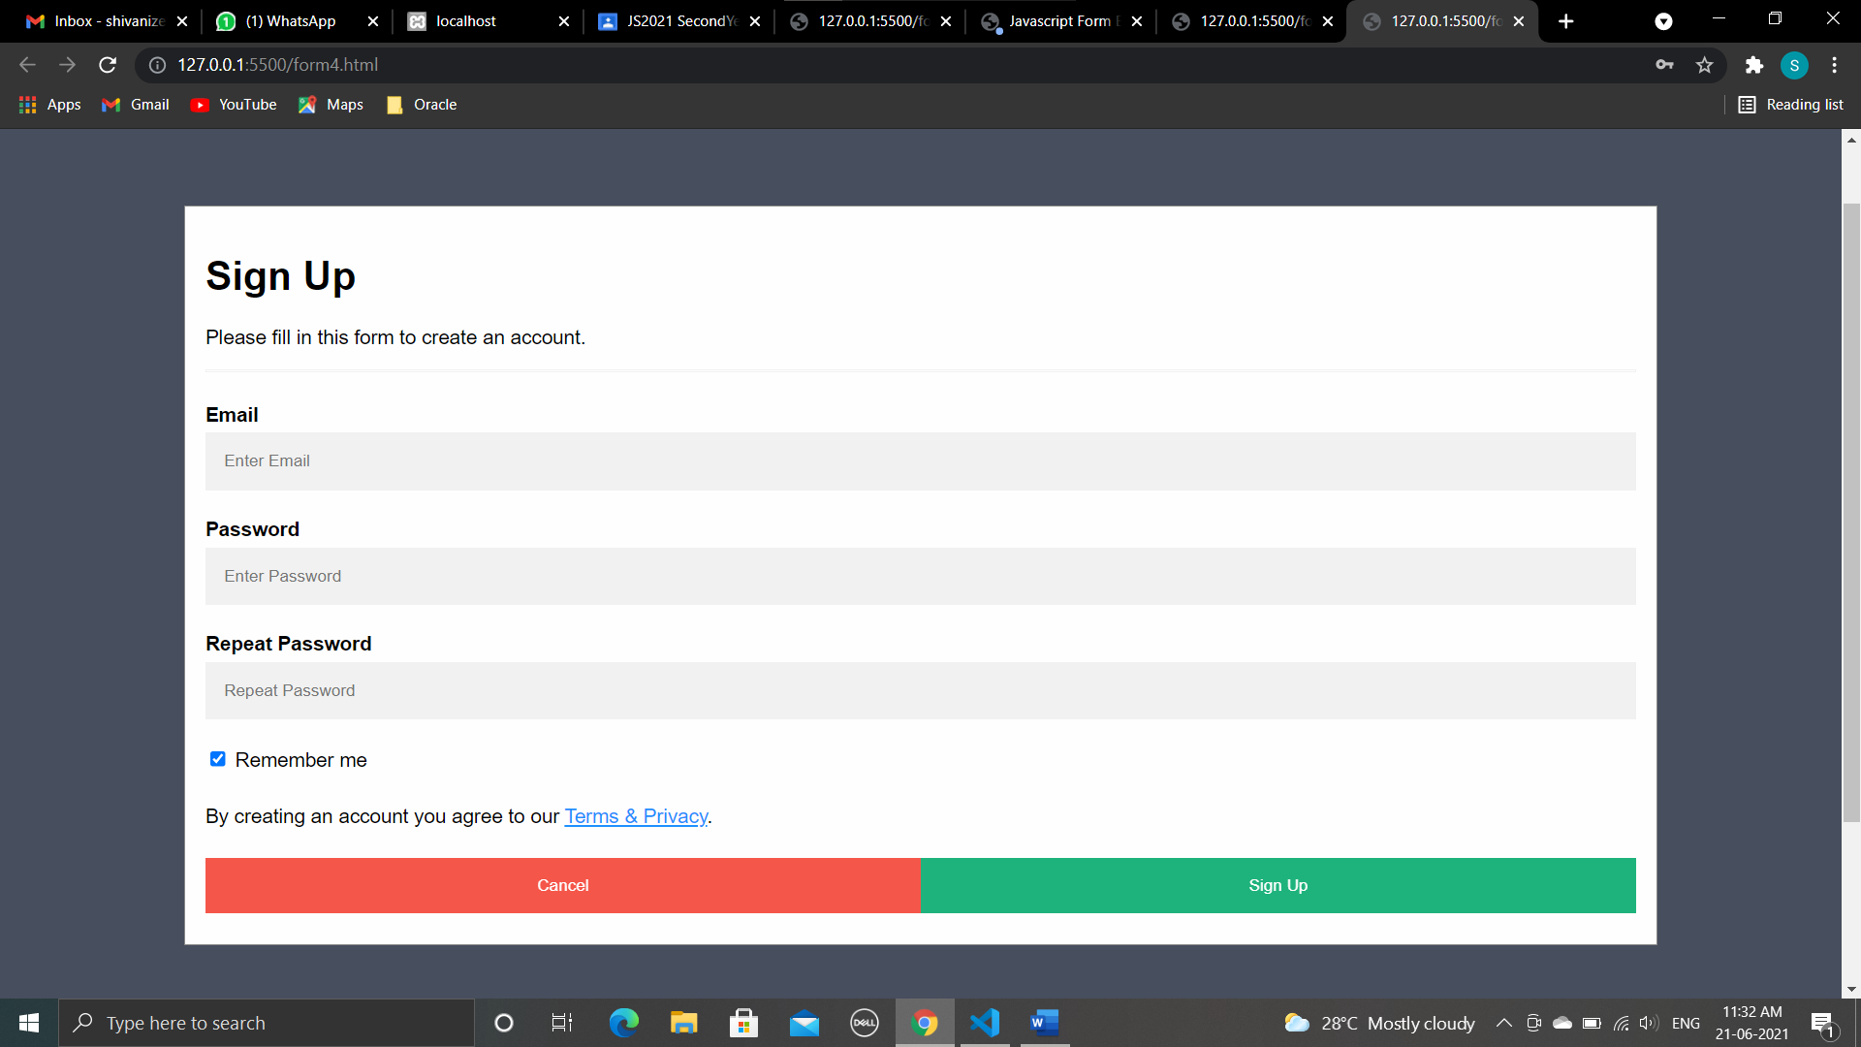

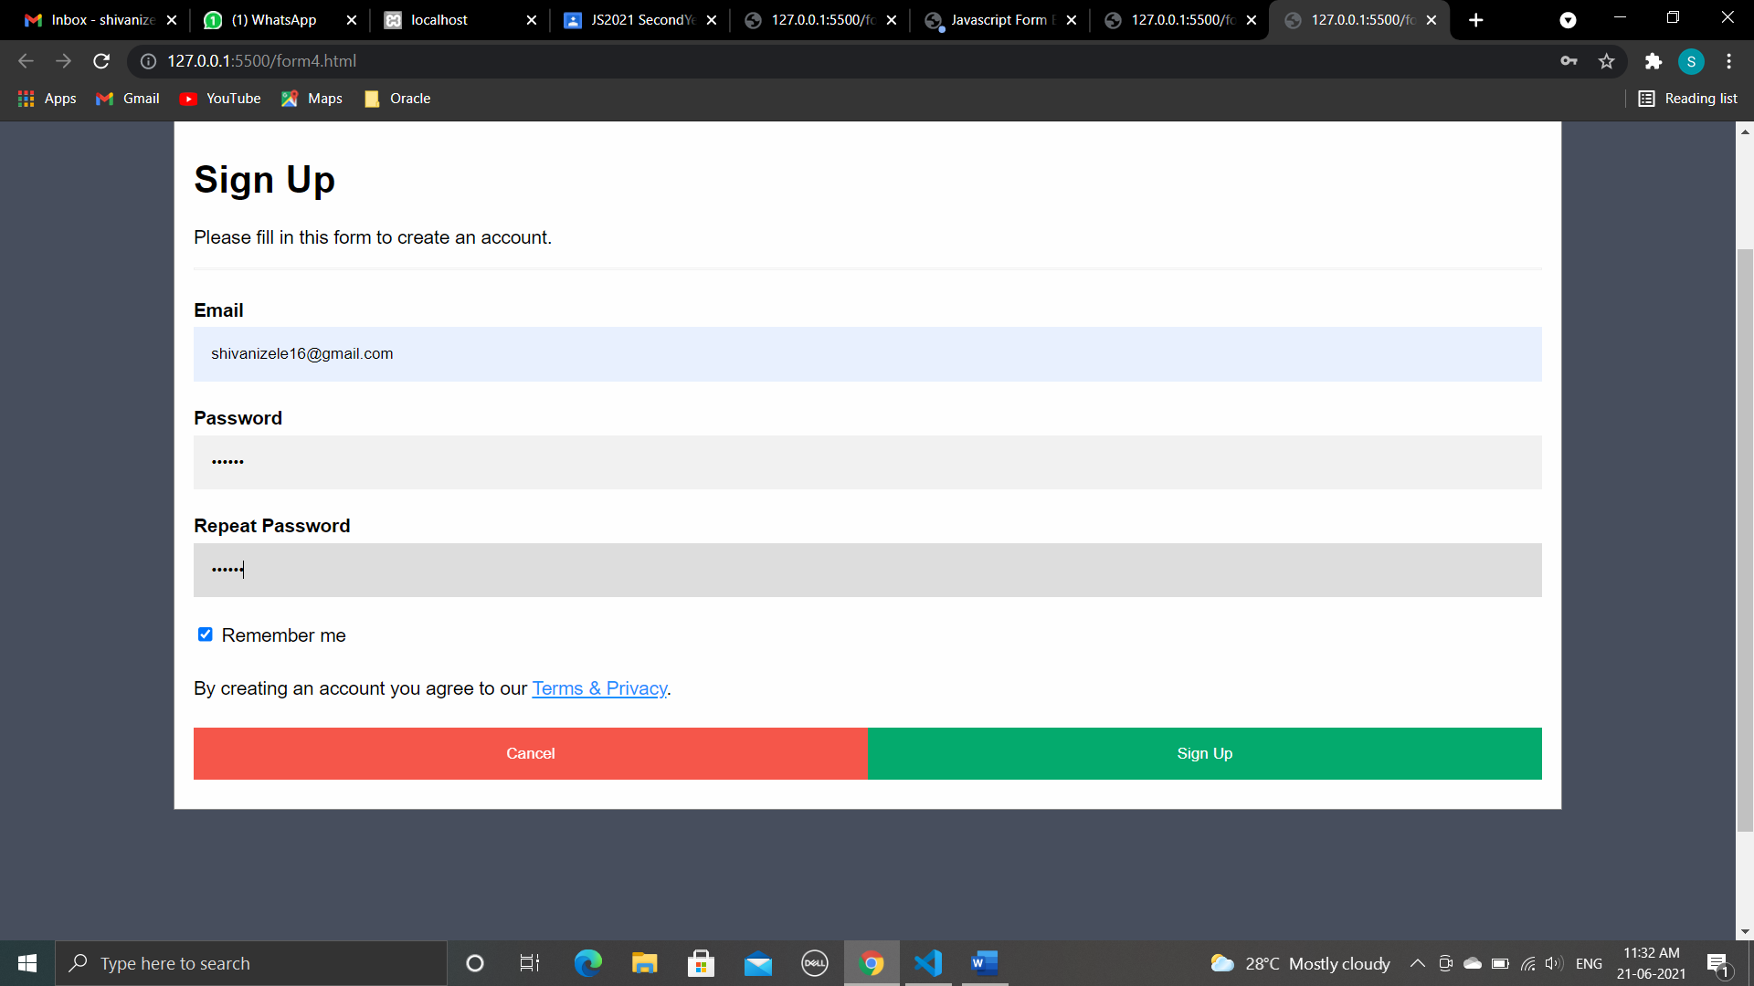

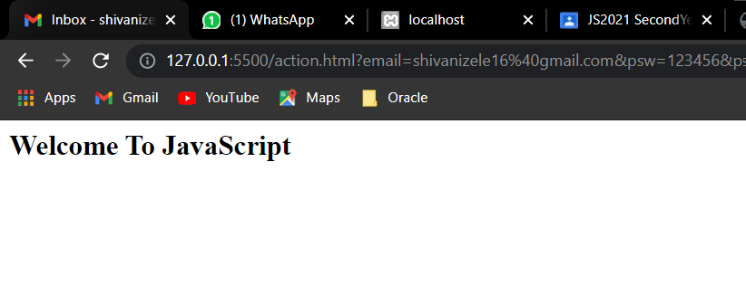

**Conclusion :**

**We have studied Program using Form Events.**

**________________________________________________________________**

**Assignment : 8**

**Aim :** Program using Intrinsic Java Functions.

**Intrinsic JavaScript Functions**

* An intrinsic function (or built-in function) is a function (subroutine) available for use in a given programming language whose implementation is handled specially by the compiler.
* “Intrinsic” is the way some authors refer to what other authors call “built-in”.
* Those data types/objects/classes are always there regardless of what environment you’re running in.
* JavaScript provides intrinsic (or “built-in”) objects. They are the Array, Boolean, Date, Error, Function, Global, JSON, Math, Number, Object, RegExp, and String objects.
* As you know JavaScript is an object oriented programming language, it supports the concept of objects in the form of attributes.
* If an object attribute consists of function, then it is a method of that object, or if an object attribute consists of values, then it is a property of that object.
* For example,

var status = document.readyState;

* readyState is a property of the document object which can contain values such as “unintialized”, ”loading”, ”interactive”, ”complete” whereas,

document.write("Hello World");

* write() is a method of the document object that writes the content “Hello World” on the web page.
* JavaScript Built-in objects such as

1. Number
2. String
3. RegExp
4. Array
5. Math
6. Date
7. Boolean

* Each of the above objects hold several built-in functions to perform object related functionality.

### isNaN()

* [isNaN()](https://www.programming-free.com/2012/07/javascript-built-in-functions-with.html) method determines whether value of a variable is a legal number or not.
* For example

document.write(isNan(0));              // false

document.write(isNan('JavaScript'));   // true

### eval()

* [eval()](https://www.programming-free.com/2012/07/javascript-built-in-functions-with.html) is used to execute Javascript source code.
* It evaluates or executes the argument passed to it and generates output.
* For example

eval("var number=2;number=number+2;document.write(number)");   //4

### Number()

* [Number()](https://www.programming-free.com/2012/07/javascript-built-in-functions-with.html) method takes an object as an argument and converts it to the corresponding number value.
* Return Nan (Not a Number) if the object passed cannot be converted to a number
* For example

var obj1=new String("123");

var obj2=new Boolean("false");

var obj3=new Boolean("true");

var obj4=new Date();

var obj5=new String("9191 9999");

document.write(Number(obj1));     // 123

document.write(Number(obj2));     // 0

document.write(Number(obj3));     // 1

document.write(Number(obj4));     // 1342720050291

document.write(Number(obj5));     // NaN

### String()

* [String()](https://www.programming-free.com/2012/07/javascript-built-in-functions-with.html) function converts the object argument passed to it to a string value.
* For example

document.write(new Boolean(0)); // false

document.write(new Boolean(1)); // true

document.write(new Date());     // Tue Jan 05 2021 13:28:00 GMT+0530

### parseInt()

* [parseInt()](https://www.programming-free.com/2012/07/javascript-built-in-functions-with.html) function takes string as a parameter and converts it to integer.
* For example

document.write(parseInt("45"));         // 45

document.write(parseInt("85 days"));    // 85

document.write(parseInt("this is 9"));  // NaN

* An optional radix parameter can also be used to specify the number system to be used to parse the string argument.
* For example,

document.write(parseInt(“10”,16)); //16

### parseFloat()

* [parseFloat()](https://www.programming-free.com/2012/07/javascript-built-in-functions-with.html) function takes a string as parameter and parses it to a floating point number.

An intrinsic function is often used to replace the Submit button and the Reset button with your own graphical images, which are displayed on a form in place of these buttons.

Programs :

1. Program :

<html>

<head>

<title>Using Intrinsic JavaScript Functions</title>

</head>

<body>

<script>

var obj1 = new String("123");

var obj2 = new Boolean("false");

var obj3 = new Boolean("true");

var obj4 = new Date();

var obj5 = new String("9191 9999");

document.write("The string value is :", Number(obj1), "<br>"); // 123

document.write("The boolean is :", Number(obj2), "<br>"); // 0

document.write("The boolean is :", Number(obj3), "<br>"); // 1

document.write("The date is :", Number(obj4), "<br>"); // 1342720050291

document.write("The value is : ", Number(obj5)); // NaN

</script>

</body>

</html>

Output :

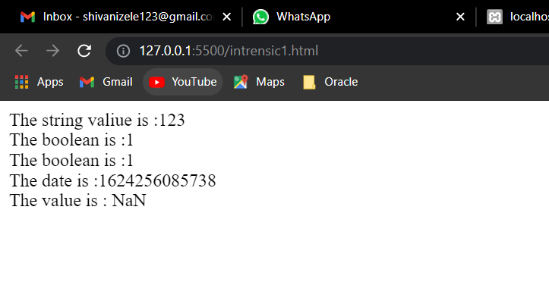

1. Program

<script>

// function is being called with radius 5 as a parameter.

function area_of_circle(radius_of_the_circle) {

return Math.PI * radius_of_the_circle * radius_of_the_circle;

}

// Here area of the circle is 5 unit.

document.write(area_of_circle(5));

</script>

<br> Current Date and Time: <span id="txt"></span>

<script>

var today = new Date();

document.getElementById('txt').innerHTML = today;

</script>

Output :

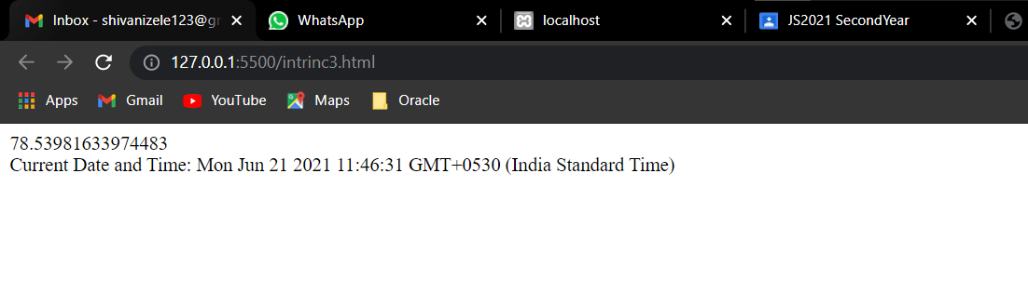

1. Program :

<script>

document.writeln(Math.log(1) + "<br>");

document.writeln(Math.log(5) + "<br>");

document.writeln(Math.log(10));

</script>

Output :

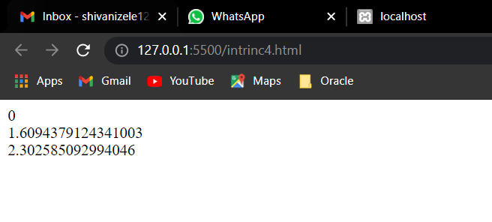

1. Program :

<html>

<head>

<title>Insert a string within a specific position in another string</title>

</head>

<body>

<script>

function insert(main_string, ins_string, pos) {

if (typeof(pos) == "undefined") {

pos = 0;

}

if (typeof(ins_string) == "undefined") {

ins_string = '';

}

return main_string.slice(0, pos) + ins_string +

main_string.slice(pos);

}

var main_string = "Welcome to JavaScript";

var ins_string = " the world of ";

var pos = 10;

var final_string = insert(main_string, ins_string, pos);

document.write("Main String: <b>" + main_string + "</b><br/>");

document.write("String to insert: <b>" + ins_string + "</b><br/>");

document.write("Position of string: <b>" + pos + "</b><br/>");

document.write("Final string: <b>" + final_string + "</b>");

</script>

</body>

</html>

Output :

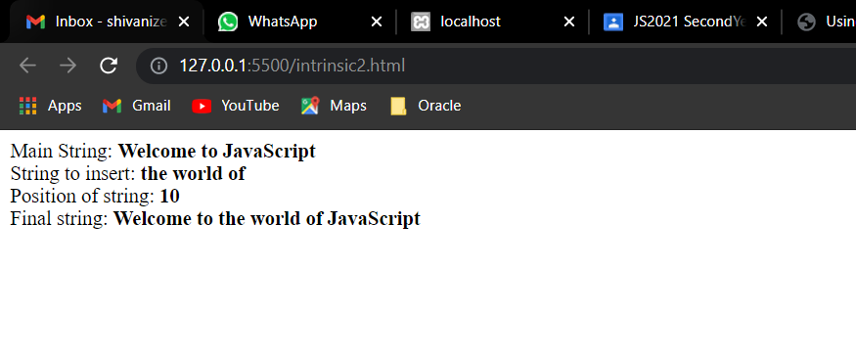

_________________________________________________________________________

**Conclusion :**

**We have studied Program using Intrinsic Java Functions.**

**­­­­­­­­­­­­­­­­­­­­­­­­­­________________________________________________________________**

**Assignment : 9**

**Aim : Programs for Using and Personalizing cookies.**

1. **Program using cookies.**

<!DOCTYPE html>

<html>

<head>

<script>

function setCookie(cname, cvalue, exdays) {

var d = new Date();

d.setTime(d.getTime() + (exdays * 24 * 60 * 60 * 1000));

var expires = "expires=" + d.toGMTString();

document.cookie = cname + "=" + cvalue + ";" + expires + ";path=/";

}

function getCookie(cname) {

var name = cname + "=";

var decodedCookie = decodeURIComponent(document.cookie);

var ca = decodedCookie.split(';');

for (var i = 0; i < ca.length; i++) {

var c = ca[i];

while (c.charAt(0) == ' ') {

c = c.substring(1);

}

if (c.indexOf(name) == 0) {

return c.substring(name.length, c.length);

}

}

return "";

}

function checkCookie() {

var user = getCookie("username");

if (user != "") {

alert("Welcome again " + user);

} else {

user = prompt("Please enter your name:", "");

if (user != "" && user != null) {

setCookie("username", user, 30);

}

}

}

</script>

</head>

<body onload="checkCookie()"></body>

</html>

Output :

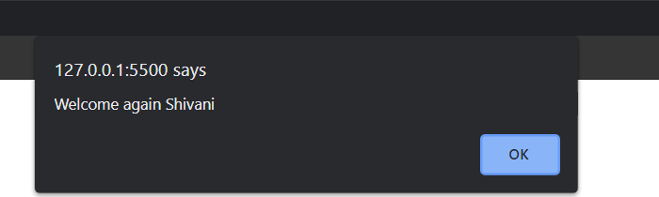

1. Program using cookies.

<html>

<head>

<script type="text/javascript">

//Reading cookie

function ReadCookie() {

var allcookies = document.cookie;

document.write("All Cookies : " + allcookies);

// Get all the cookies pairs in an array

cookiearray = allcookies.split(';');

// Now take key value pair out of this array

for (var i = 0; i < cookiearray.length; i++) {

name = cookiearray[i].split('=')[0];

value = cookiearray[i].split('=')[1];

document.write("Key is : " + name + " and Value is : " + value);

}

}

</script>

</head>

<body>

<form name="myform" action="">

<p> click the following button and see the result:</p>

<input type="button" value="Get Cookie" onclick="ReadCookie()" />

</form>

</body>

</html>

Output :

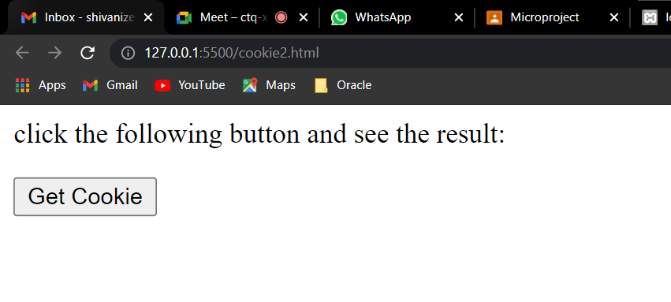

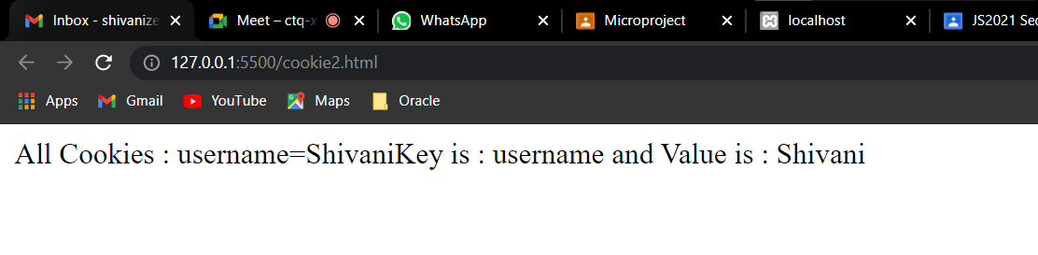

1. Program

<html>

<head>

<script type="text/javascript">

function WriteCookie() {

var now = new Date();

now.setMonth(now.getMonth() + 1);

cookievalue = escape(document.myform.customer.value) + ";"

document.cookie = "name=" + cookievalue;

document.cookie = "expires=" + now.toUTCString() + ";"

document.write("Setting Cookies : " + "name=" + cookievalue);

}

</script>

</head>

<body>

<form name="myform" action="">

Enter name: <input type="text" name="customer" />

<input type="button" value="Set Cookie" onclick="WriteCookie()" />

</form>

</body>

</html>

Output :

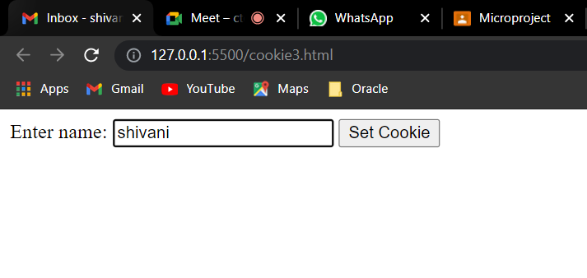

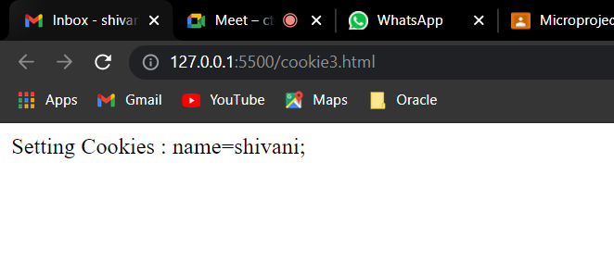

1. Program

<!DOCTYPE html>

<html>

<head>

<meta http-equiv="content-type" content="text/html; charset=iso-8859-1" />

<title>JavaScript creating cookies - receive real data. example1</title>

</head>

<body>

<h4 style="color: rgb(7, 26, 13)">JavaScript creating cookies, receive real data.!!!</h4>

<hr />

<script type="text/javascript">

//This is done to make the following JavaScript code compatible to XHTML. <![CDATA[

var visitor_name = prompt("What's your name?", "");

var curdate = new Date();

curdate.setMonth(curdate.getMonth() + 6);

var cookie_date = curdate.toUTCString();

final_cookie = "my_cookie=" + encodeURIComponent(visitor_name) + ";expires_on = " + cookie_date;

document.cookie = final_cookie;

alert(final_cookie);

//]]>

</script>

</body>

</html>

Output :

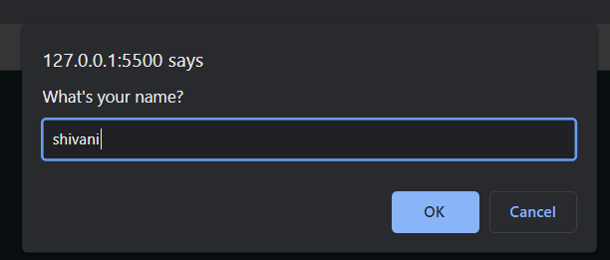

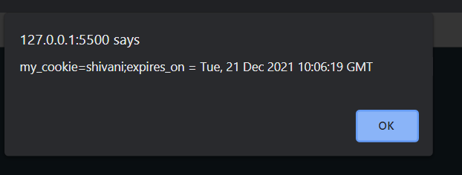

___________________________________________________________

**Conclusion :**

We have studied Programs for Using and Personalizing cookies..

___________________________________________________________

**Assignment : 10**

**Aim : Programs for placing the Window on the screen.**

1. **Program for displaying all properties of windows.**

<html>

<body>

<h3>shows properties of window</h3>

<hr>

<script language="javascript" type="text/javascript">

for (Property in window) {

document.write(Property + '<br>')

}

</script>

</body>

</html>

Output :

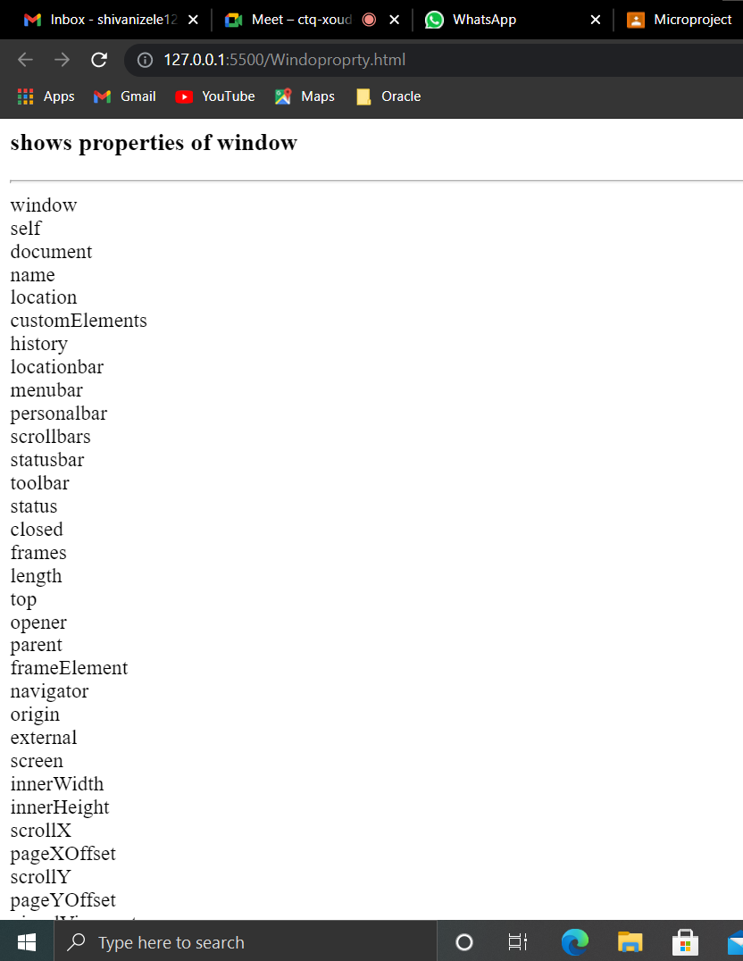

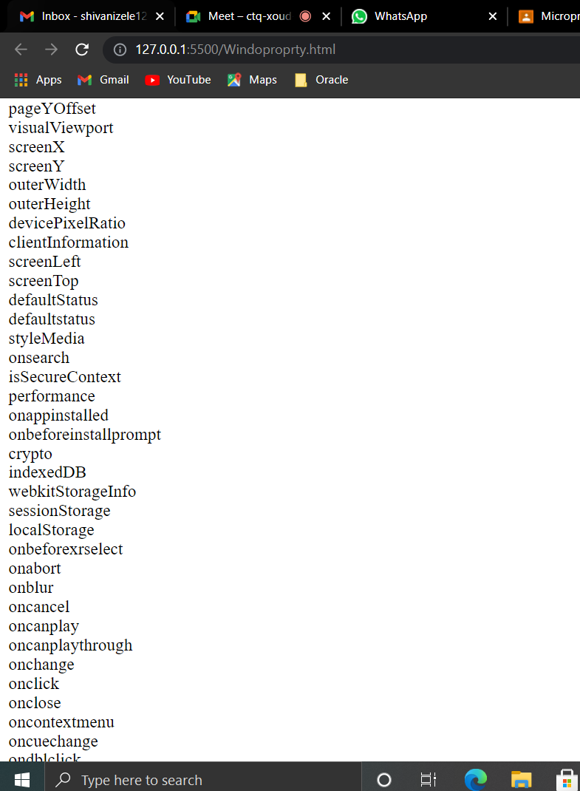

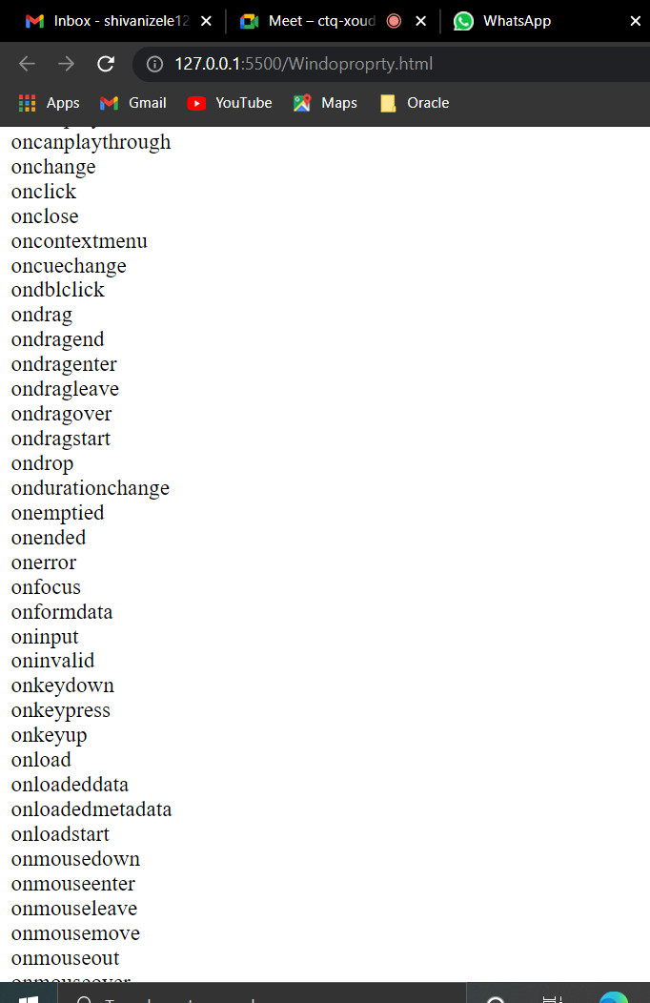

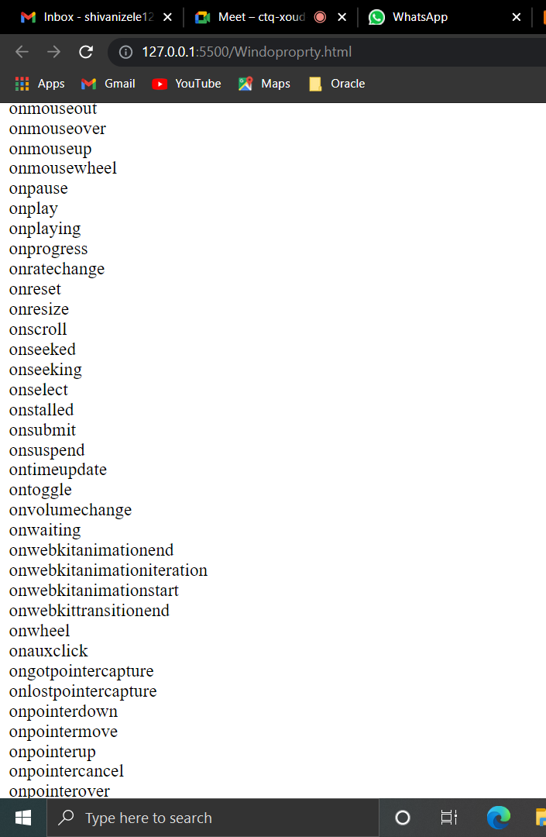

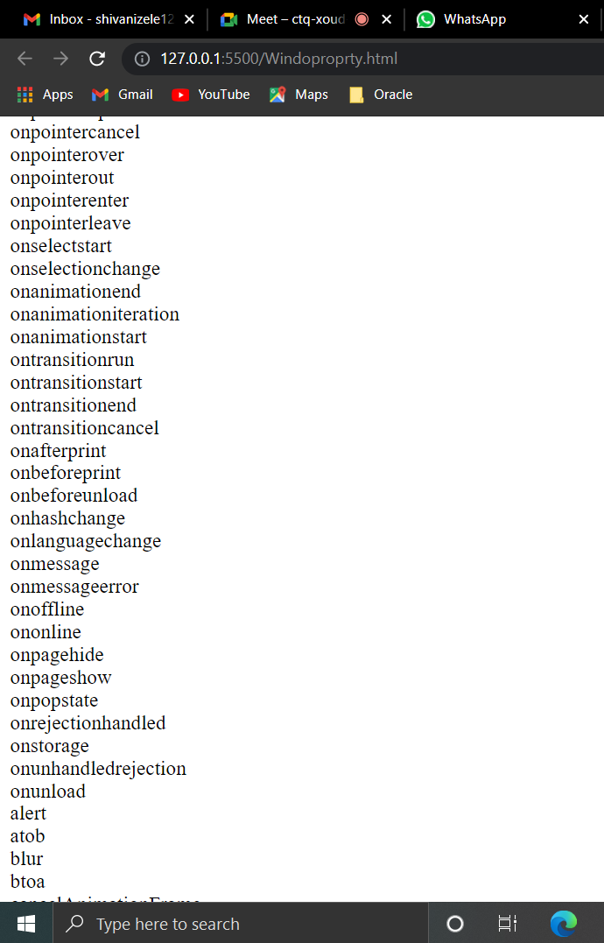

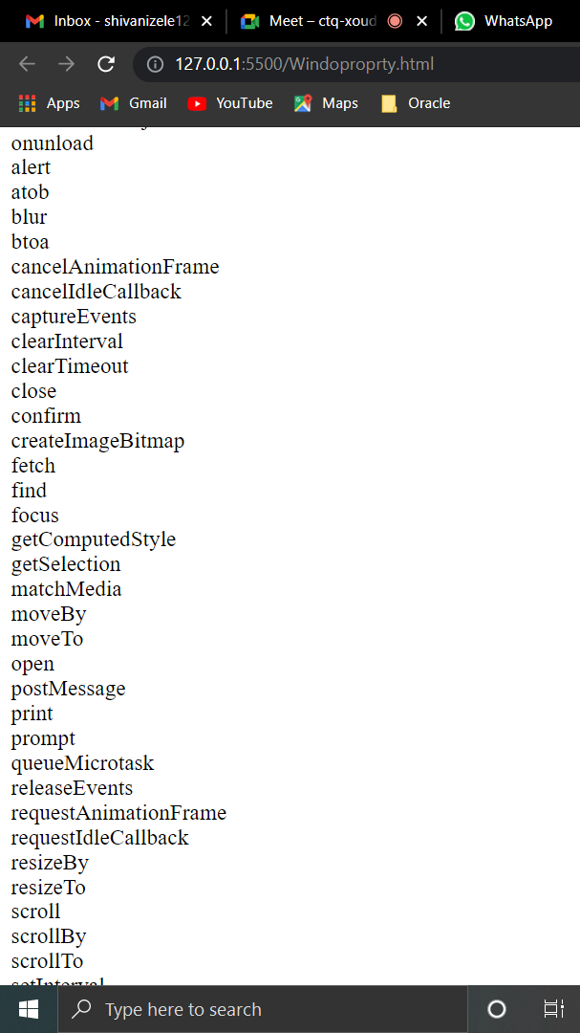

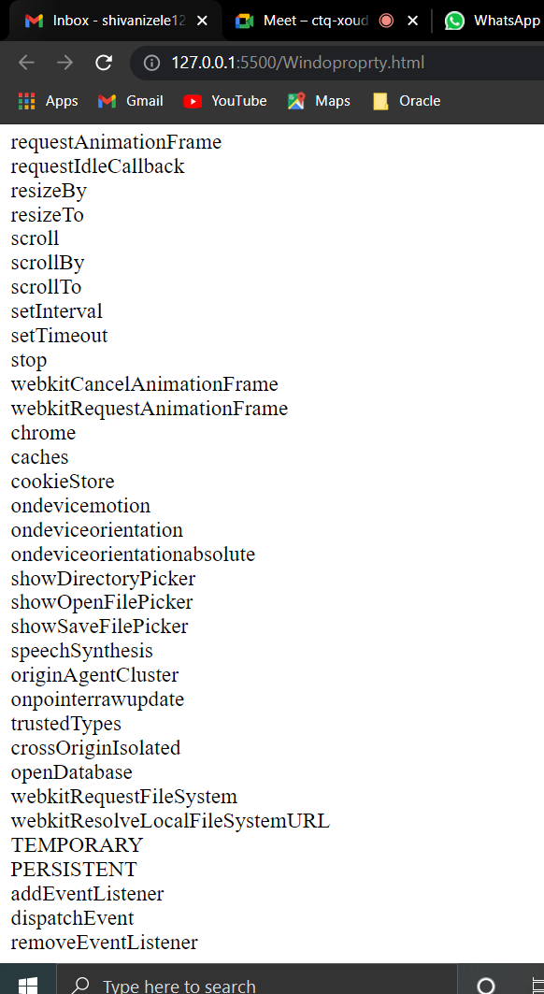

1. Program

<html>

<script>

function openwindow() {

window.open('https://classroom.google.com/u/0/c/MzI2NzE3MDMzODU4', '_parent');

}

</script>

<body>

<b> Click on the button to open window in the same tab </b>

<br>

<br>

<button onclick="openwindow()">Open window</button>

</body>

</html>

Output:

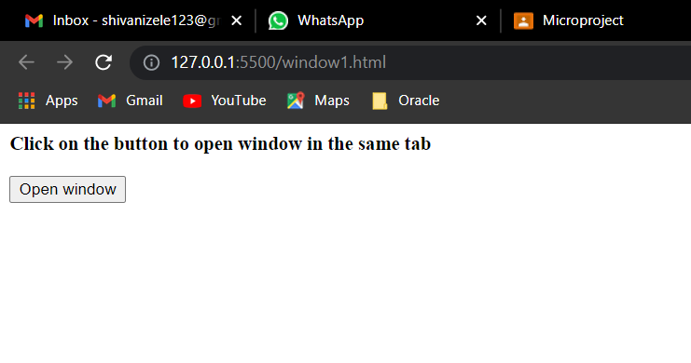

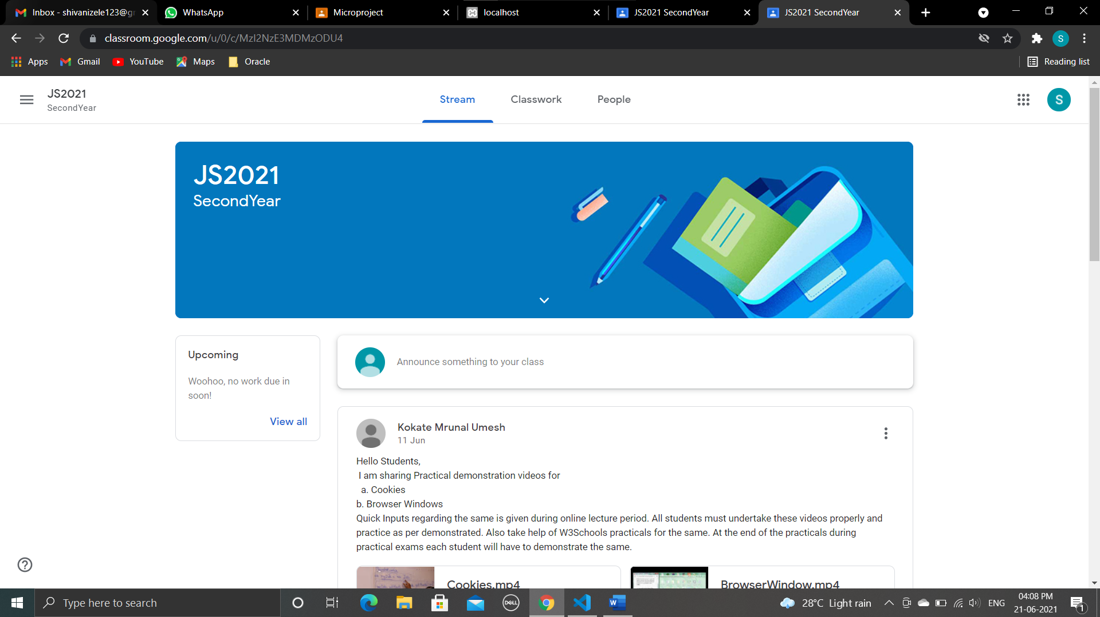

1. Program

<html>

<script>

function openwindow() {

window.open(" ", " ", "width=250,height=250");

}

</script>

<body>

<b> Welcome to javascript programming </b>

<br>

<br>

<button onclick="openwindow()">Open window</button>

</body>

</html>

Output :

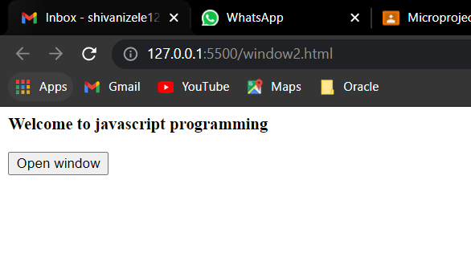

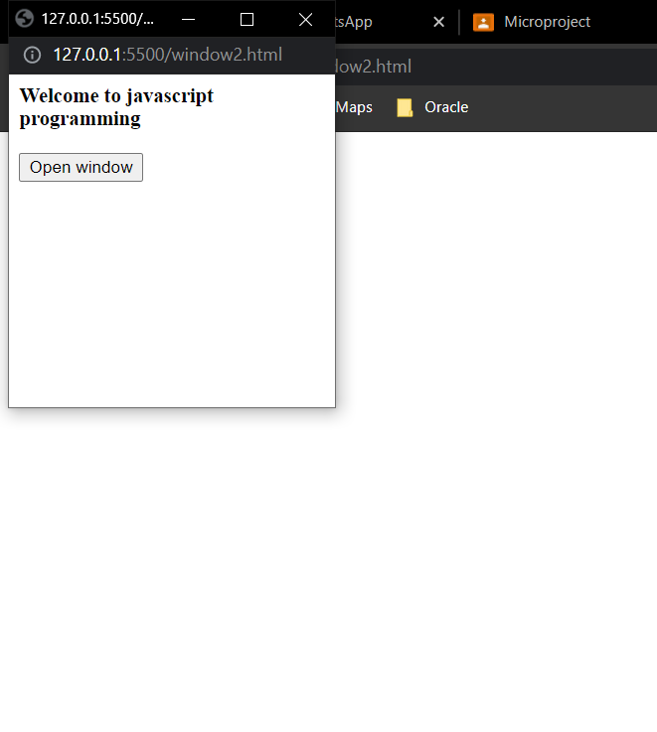

1. Program

<!DOCTYPE html>

<html>

<body>

<script>

function myPopup(myURL, title, myWidth, myHeight) {

var left = (screen.width - myWidth) / 2;

var top = (screen.height - myHeight) / 4;

var myWindow = window.open(myURL, title, 'toolbar=no, location=no, directories=no, status=no, menubar=no, scrollbars=no, resizable=no, copyhistory=no, width=' + myWidth + ', height=' + myHeight + ', top=' + top + ', left=' + left);

}

</script>

<button onclick=" myPopup ('https://mail.google.com/mail/u/0/#inbox', 'web', 1050, 550);">Open Gmail</button>

</body>

</html>

Output :

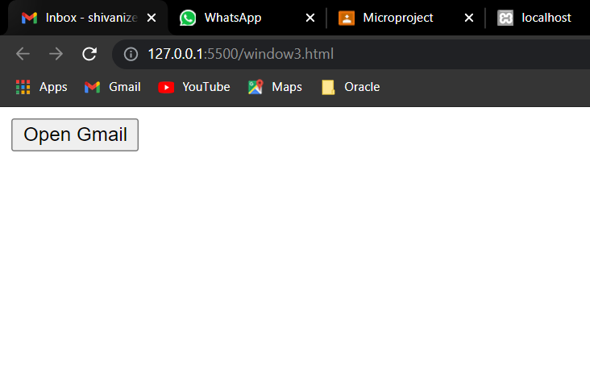

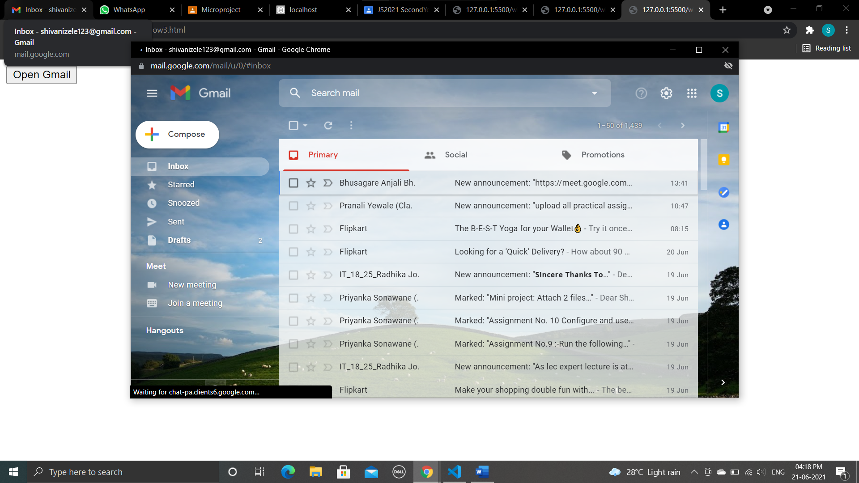

1. Program

<!DOCTYPE html>

<html>

<body>

<p>Click</p>

<button onclick="myFunction()">Alertwindow</button>

<script>

function myFunction() {

alert("Hello! This is alert window!");

}

</script>

</body>

</html>

Output :

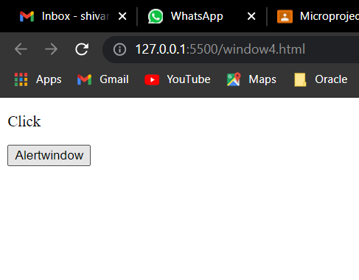

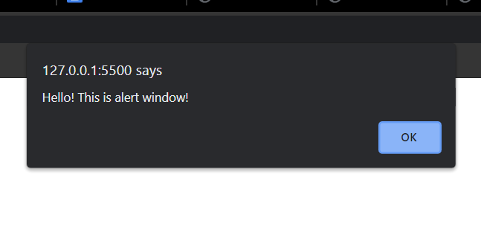

1. Program

<html>

<head>

<script>

function createWindows()

{

for (i = 0; i < 5; i++)

{

var mywin = window.open("", "win" + i, "width=200, height=200")

mywin.document.write("<h3>Hello World !!!!</h3>")

}

}

</script>

</head>

<body>

<form>

<input type="button" value="Create Multiple Windows" onclick="createWindows()" />

</form>

</body>

</html>

Output :

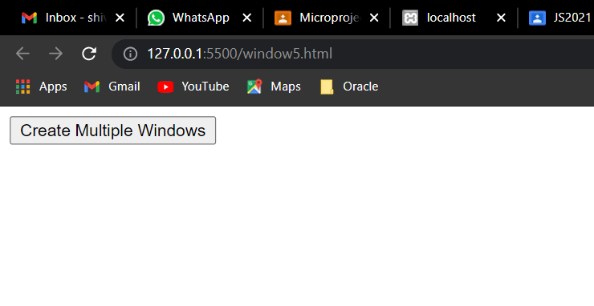

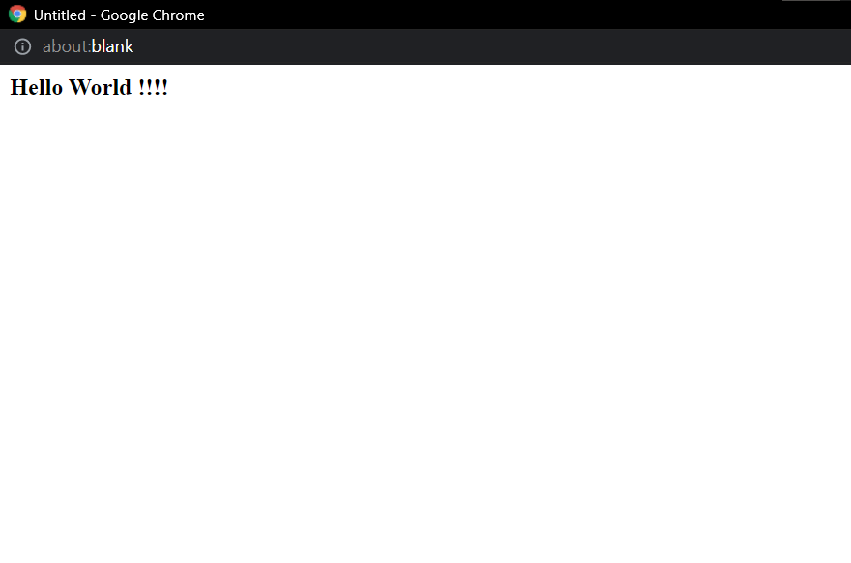









**Conclusion :**

We have studied Programs for placing the Window on the screen.

**Assignment 11**

**Aim : Programs for accessing child Window.**

1. **Program for accessing child window.**

<!--Program: Write a JavaScript program to create a new child window-->

<html>

<head>

<title>Open new window</title>

<script>

function openWindow()

{

myWindow = window.open('date.html', 'My Window', " top=200 , width = 300, height = 300 ")

}

</script>

</head>

<body>

<form action="#">

<input type="button" value="Open Window" onclick="openWindow()" />

</form>

</body>

</html>

Output :

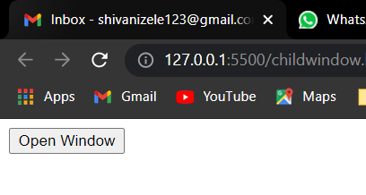

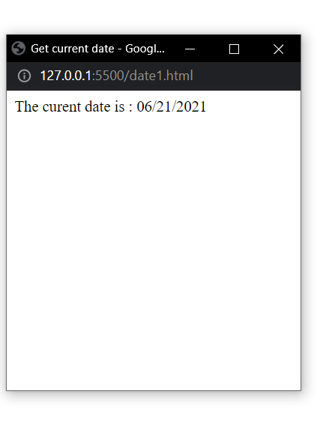

1. **Program**

Program: Write a JavaScript program to write content on child window

<html>

<head>

<script>

function init()

{

var win = window.open("", "MyWindow", "width=100, height=100")

win.document.write("<h3>Hello World!!!</h3>")

}

</script>

</head>

<body onload="init()">

</body>

</html>

**Output :**

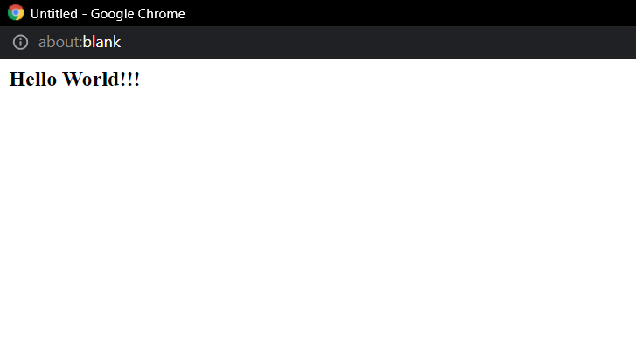

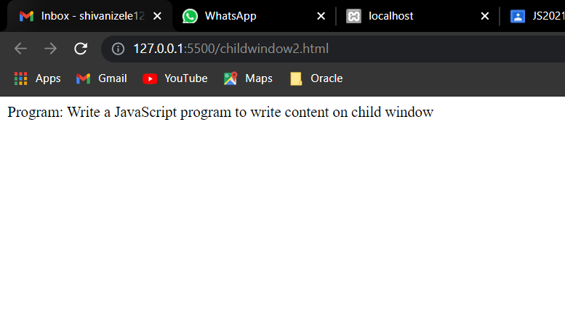

1. **Program**

<html>

<table border="0" cellpadding="0" cellspacing="0">

<tr>

<td>

First Name:&nbsp;

</td>

<td>

<input type="text" id="txtFirstName" value="" />

</td>

</tr>

<tr>

<td>

Last Name:&nbsp;

</td>

<td>

<input type="text" id="txtLastName" value="" />

</td>

</tr>

<tr>

<td>

<input type="button" value="Open Popup" onclick="OpenPopup()" />

</td>

<td>

<input type="button" value="Send" onclick="SendToPopup()" />

</td>

</tr>

</table>

<script type="text/javascript">

var popup;

function OpenPopup() {

popup = window.open("childwindow3ref.html", "Popup", "width=300,height=100");

};

function SendToPopup() {

if (popup != null && !popup.closed) {

var lblFirstName = popup.document.getElementById("lblFirstName");

var lblLastName = popup.document.getElementById("lblLastName");

lblFirstName.innerHTML = document.getElementById("txtFirstName").value;

lblLastName.innerHTML = document.getElementById("txtLastName").value;

popup.focus();

} else {

alert("Popup has been closed.");

}

}

</script>

</html>

Ref file.html

<html>

<body>

<table border="0" cellpadding="0" cellspacing="0">

<tr>

<td>

First Name:&nbsp;

</td>

<td>

<span id="lblFirstName"></span>

</td>

</tr>

<tr>

<td>

Last Name:&nbsp;

</td>

<td>

<span id="lblLastName"></span>

</td>

</tr>

</table>

</body>

</html>

**Output :**

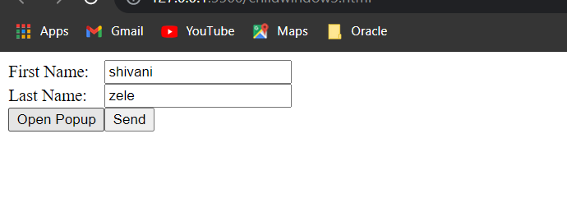

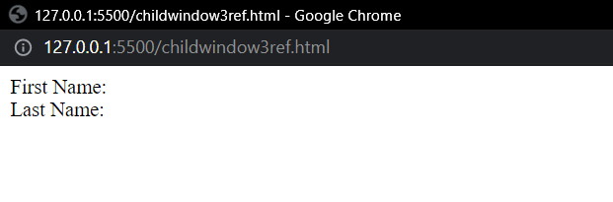

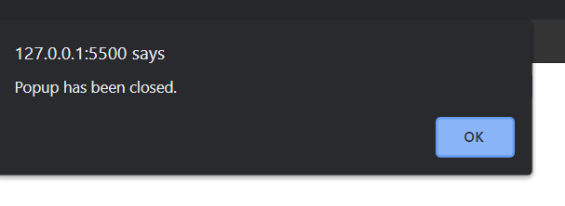

1. **Program**

<html>

<head>

<title>Parent</title>

<style>

div {

float: left;

cursor: pointer;

}

</style>

<script type="text/javascript">

var SubpopUpWin = "";

var testUrl = "";

function Opennew(passedURL) {

testUrl = passedURL;

SubpopUpWin = window.open("childwindow4ref.html", '_blank', 'toolbar=no,status=no,menubar=no,scrollbars=yes,resizable=yes,copyhistory=yes');

}

</script>

</head>

<body>

<div onclick="Opennew('https://msbte.org.in/')">

<b>MSBTE</b>

</div>

<br/>

<div onclick="Opennew('https://gppune.ac.in/userindex.php')">

<b>Government Polytechnic Pune</b>

</div>

</br>

<div onclick="Opennew('http://www.bing.com')">

<b> Bing</b>

</div>

</body>

Ref.html

<html>

<head>

<title>Child</title>

<style>

div {

float: left;

}

</style>

</head>

<body>

<div>

<div id="ifrm_title">

</div>

<div style="margin-top:20px">

<iframe id="ifrm" src="" width="470" height="270" frameborder="0" style="margin-top: 34px" scrolling="no">

</iframe>

<script type="text/javascript">

document.getElementById("ifrm").src = window.opener.testUrl;

</script>

</div>

</div>

</body>

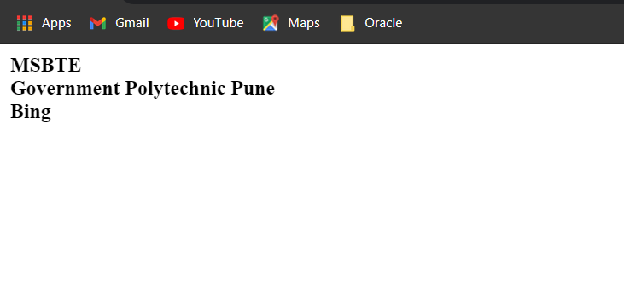

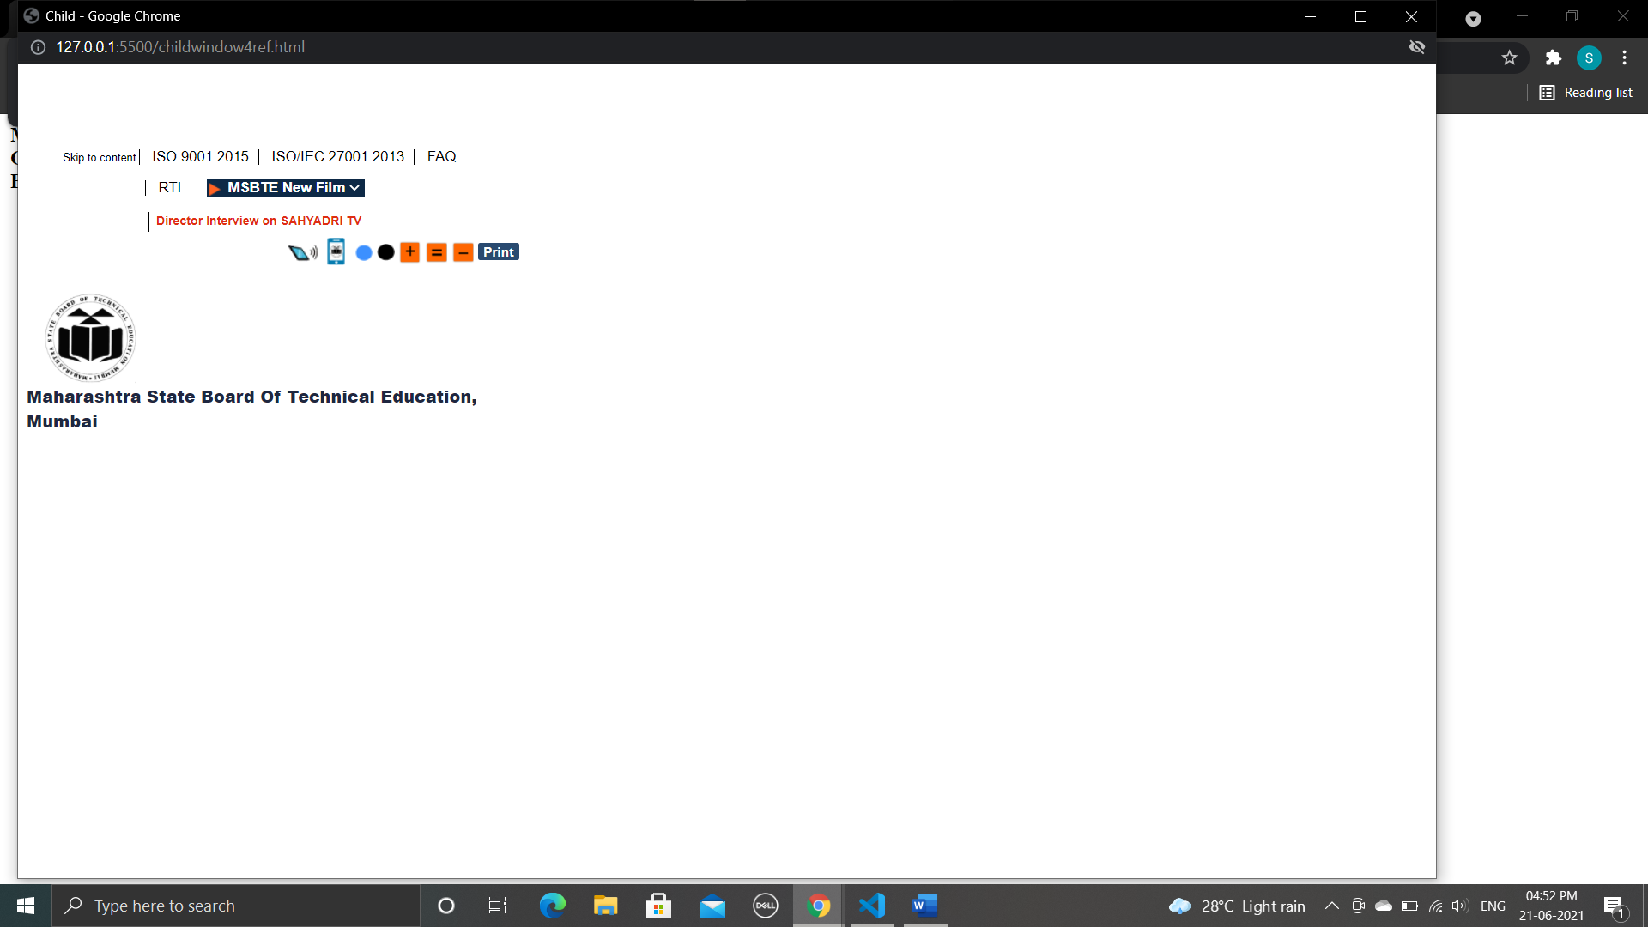

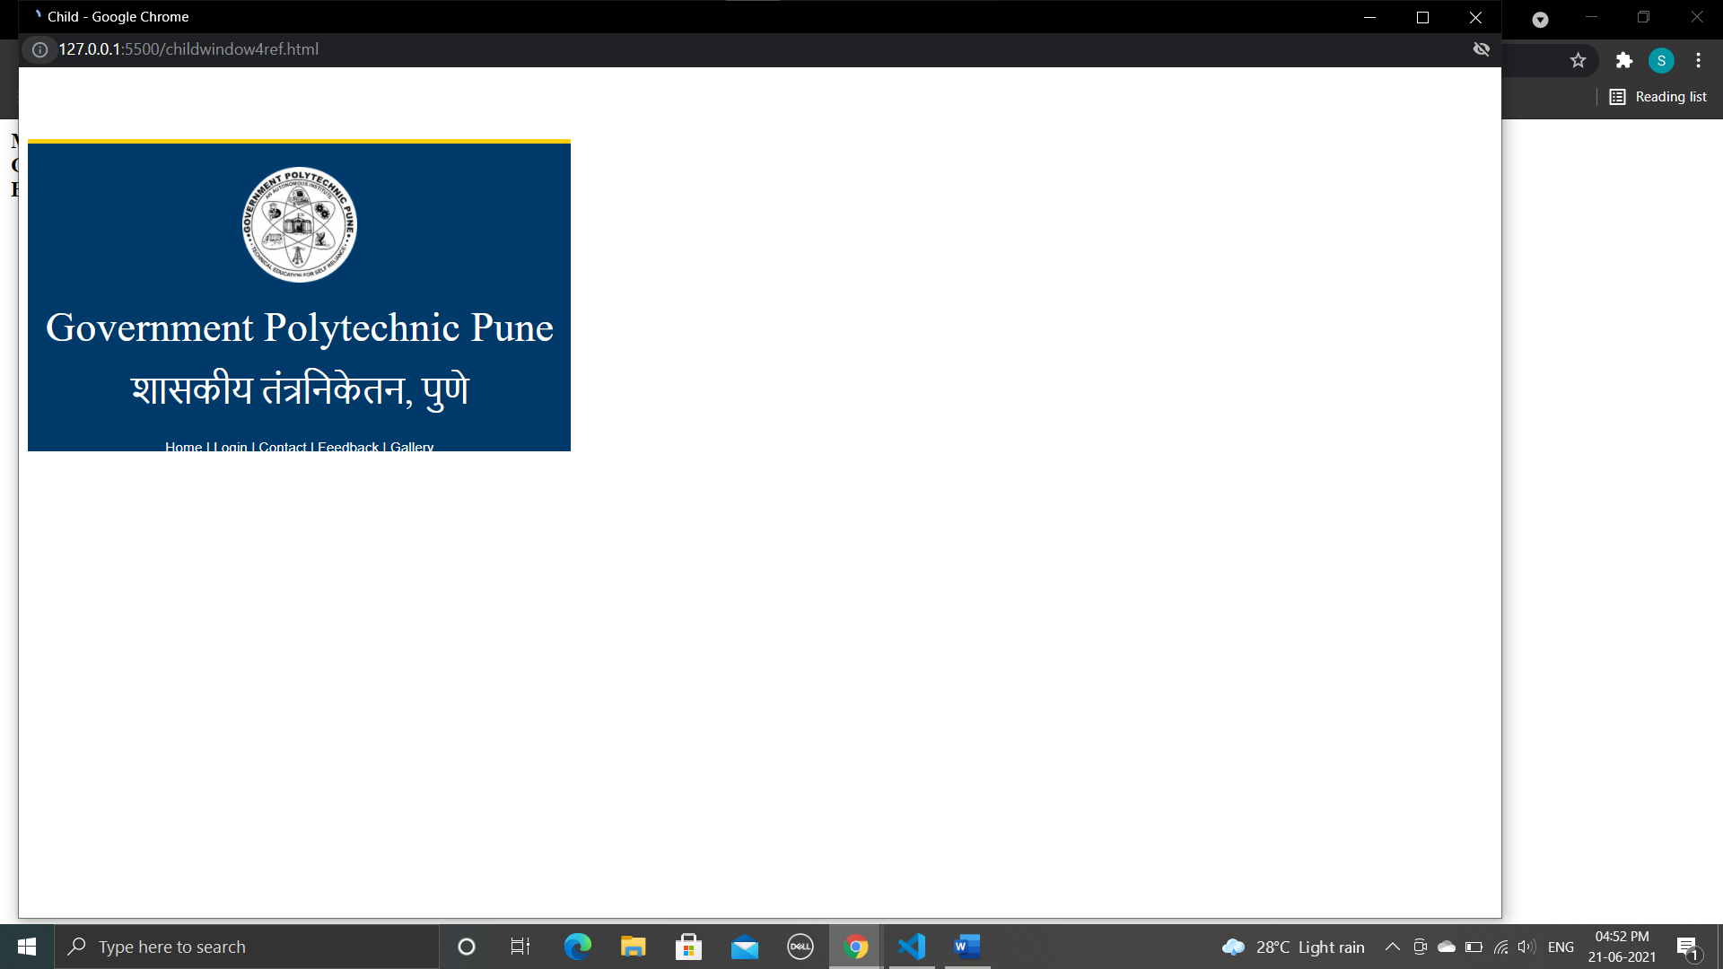

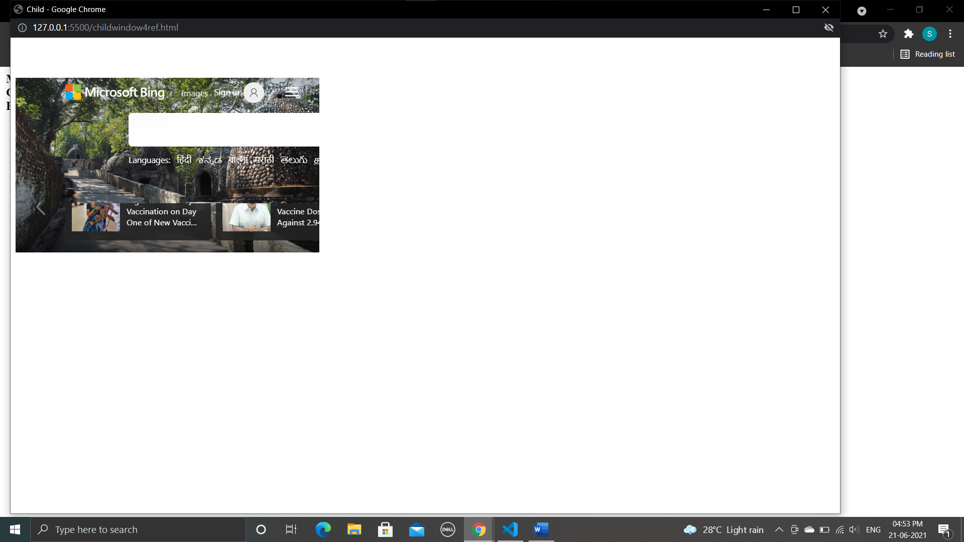

**Conclusion :**

We have studied Programs for accessing child Window.

________________________________________________________________

**Assignment 12**

**Aim : Programs for implementing Rollovers.**

* **Rollover :**

An image rollover is basically two different images. One is displayed after the page loaded up, the other one is displayed only when the user moves his mouse over the first one. Image rollovers are often used for a site’s interface. Currently this is the most popular JavaScript function.

1. Program

<html>

<body>

<table width="100%" border="0">

<tbody>

<tr valign="top">

<td width="50">

<a>

<img height="250" src="books.jpg" width="200" name="cover">

</a>

</td>

<td>

<img height="1" src="" width="10" border="0">

</td>

<td>

<a onmouseover="document.cover.src='js.jpg' ">

<b><u>Javascript book</u></b>

</a>

<br/>

<br>

<a onmouseover="document.cover.src='oop.jpg' ">

<b><u>Object Oriented book</u></b>

</a>

<br/>

<br>

<a onmouseover="document.cover.src='ds.jpg' ">

<b><u>Data Structure book</u></b>

</a>

<br/>

<br>

</td>

</tr>

</td>

</tr>

</tbody>

</table>

</body>

</html>

OUTPUT :

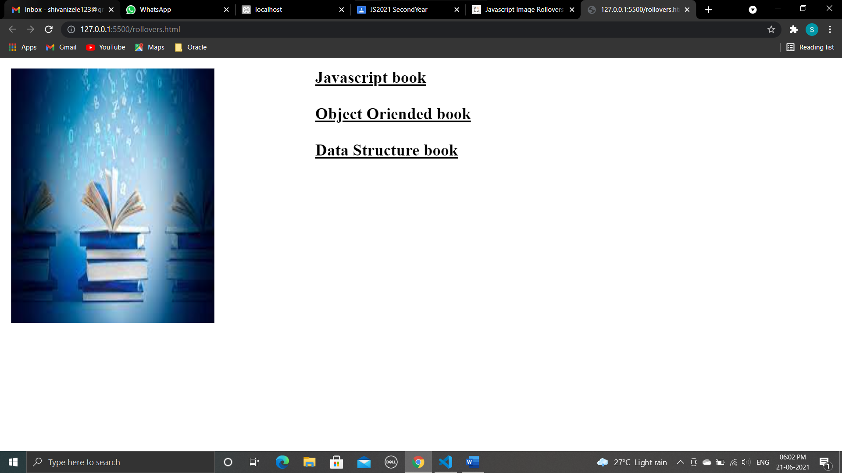

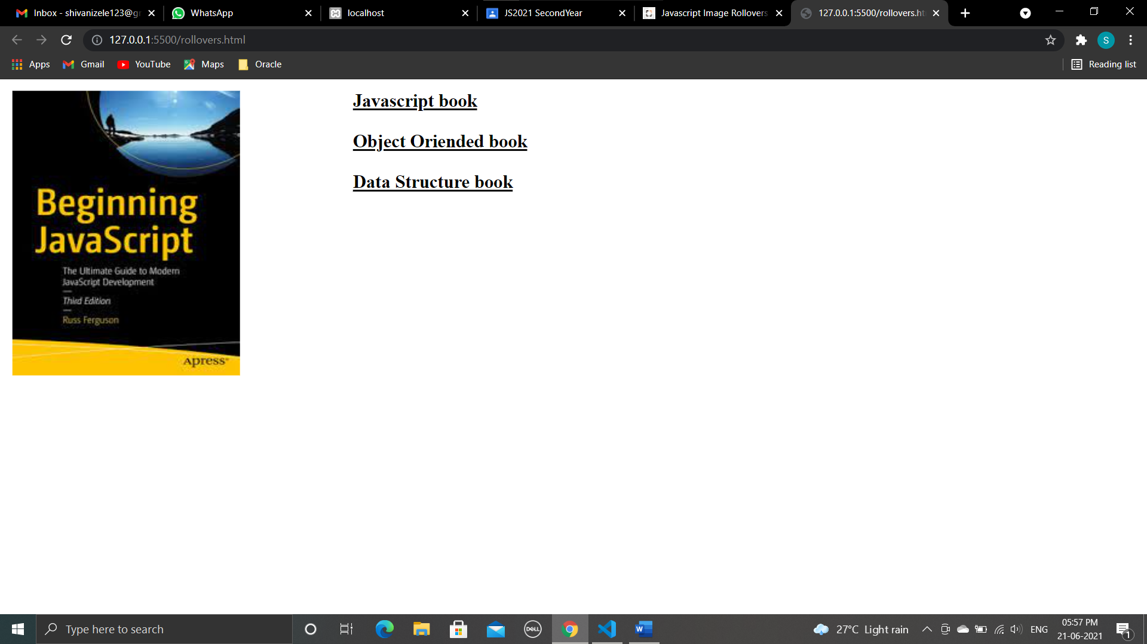

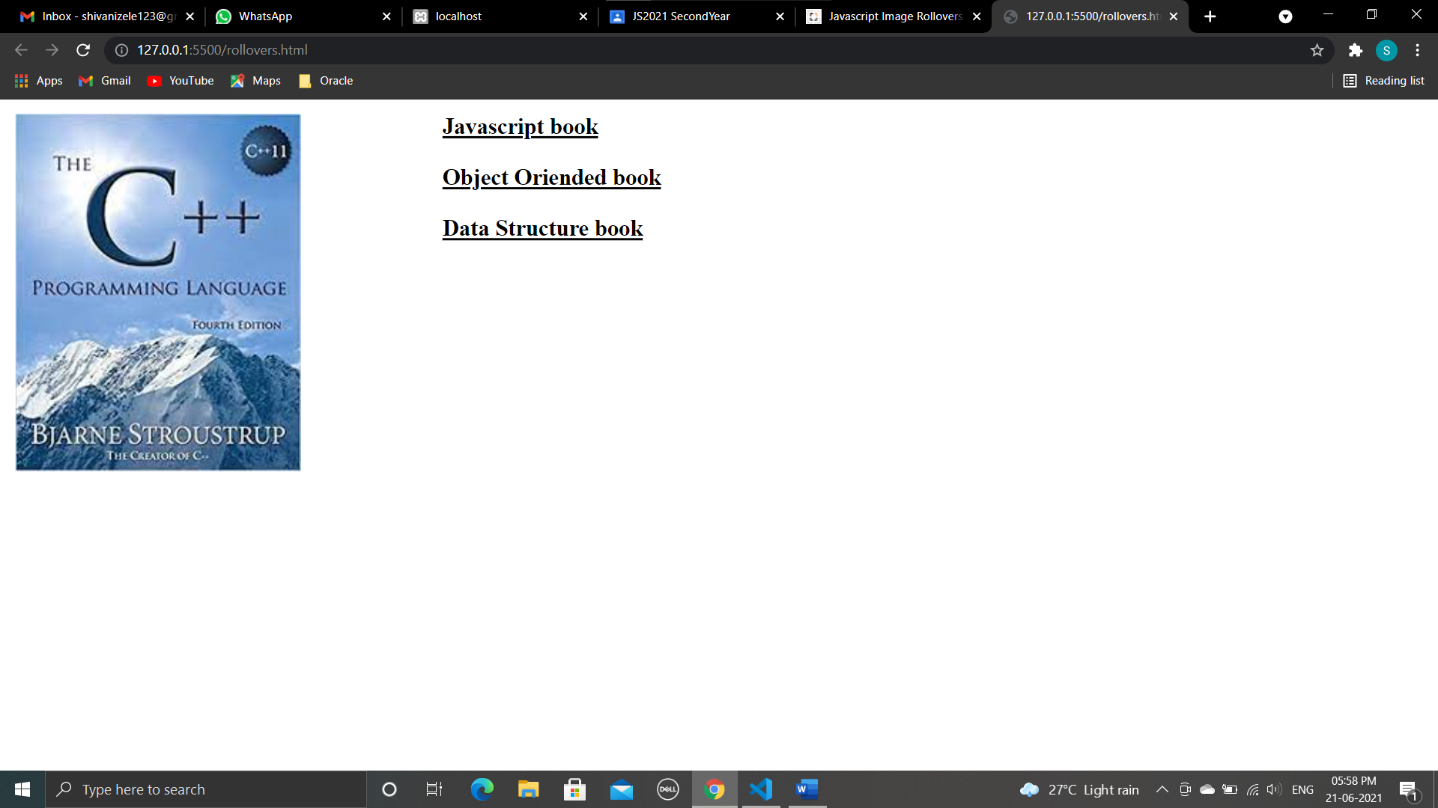

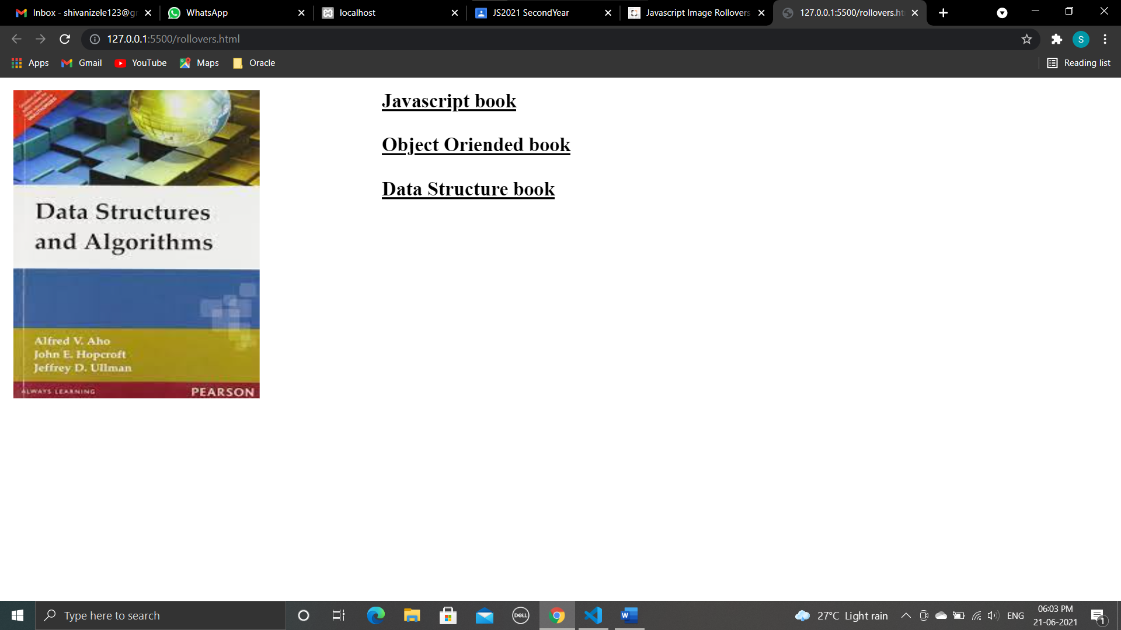

1. Program

<HTML>

<head></head>

<Body>

<textarea rows="5" cols="70" name="rollovertext" onmouseover="this.value='What is rollover?'" onmouseout="this.value='Rollover means a webpage changes when the user moves his or her mouse over an object on the page'"></textarea>

</body>

</html>

Output :

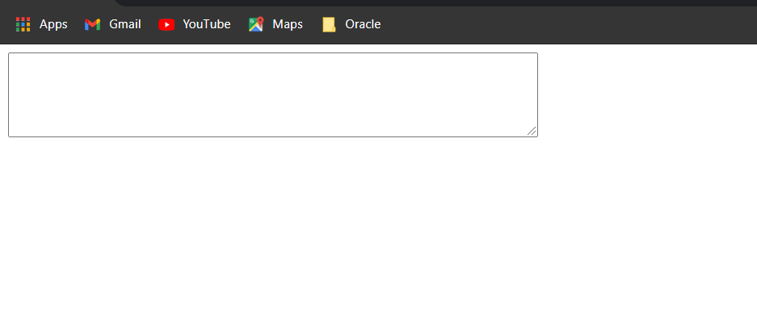

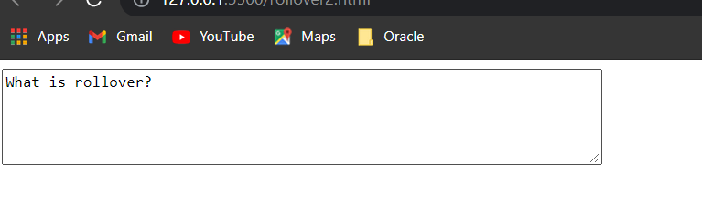

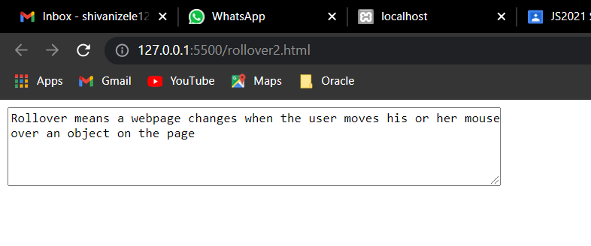

1. Program

<html>

<head>

<title> Rollover </title>

</head>

<script>

<body>

<h2 onmouseover="this.style.color='Gray'" onmouseout="this.style.color='orange'">Welcome to java script</h2>

<p onmouseover="this.style.color='red'" onmouseout="this.style.color='blue'"> Move the mouse over this text to change its color to red. Move the mouse away to change the text color to blue.

</p>

</script>

</body>

</html>

Output: 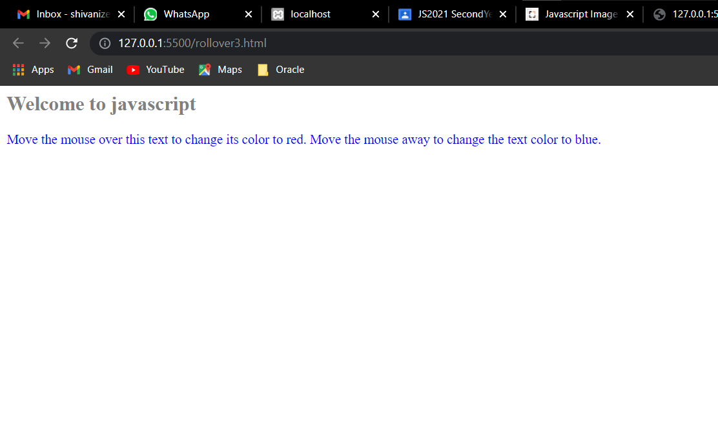

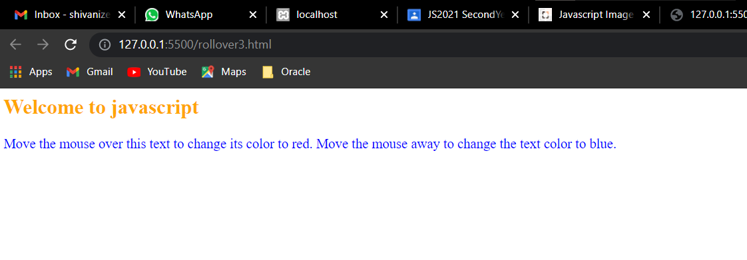

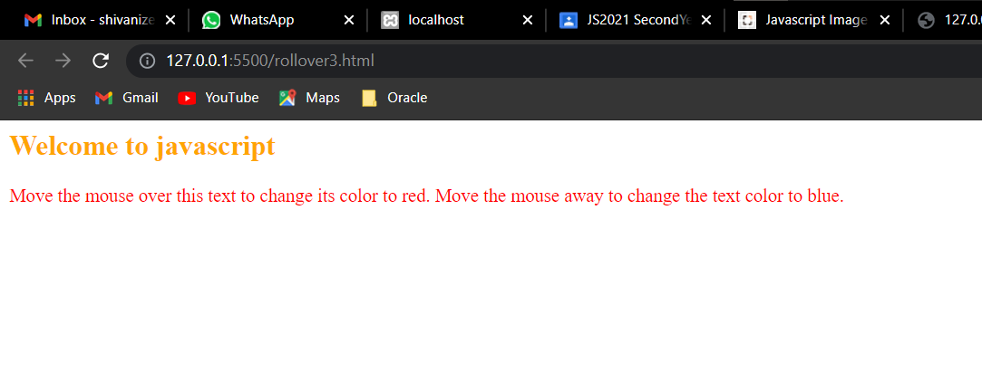

********************************************************************************

**Conclusion :**

**We have studied Programs for implementing Rollovers.**

**\*\*\*\*\*\*\*\*\*\*\*\*\*\*\*\*\*\*\*\*\*\*\*\*\*\*\*\*\*\*\*\*\*\*\*\*\*\*\*\*\*\*\*\*\*\*\*\*\*\*\*\*\*\*\*\*\*\*\*\*\*\*\*\***

**Assignment 13**

**AIM :** Programs for implementing Banners, Slideshow Programs for implementing Status bars and Webpage Protection.

1. **Program**

<!--Banner advertisement-->

<html>

<head>

<title>Banner Advertisements</title>

</head>

<body bgcolor="#EEEEEE">

<a href="https://gppune.ac.in/userindex.php">

<img src="js.jpg" />

</a>

</body>

</html>

Output :

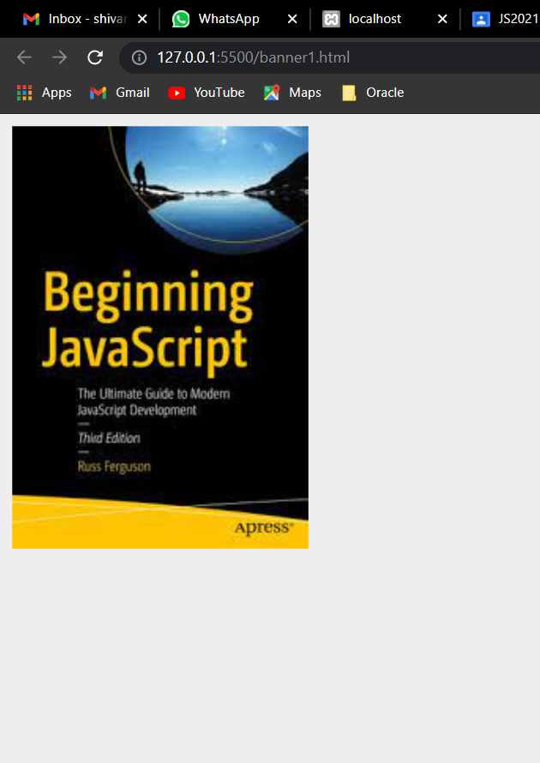

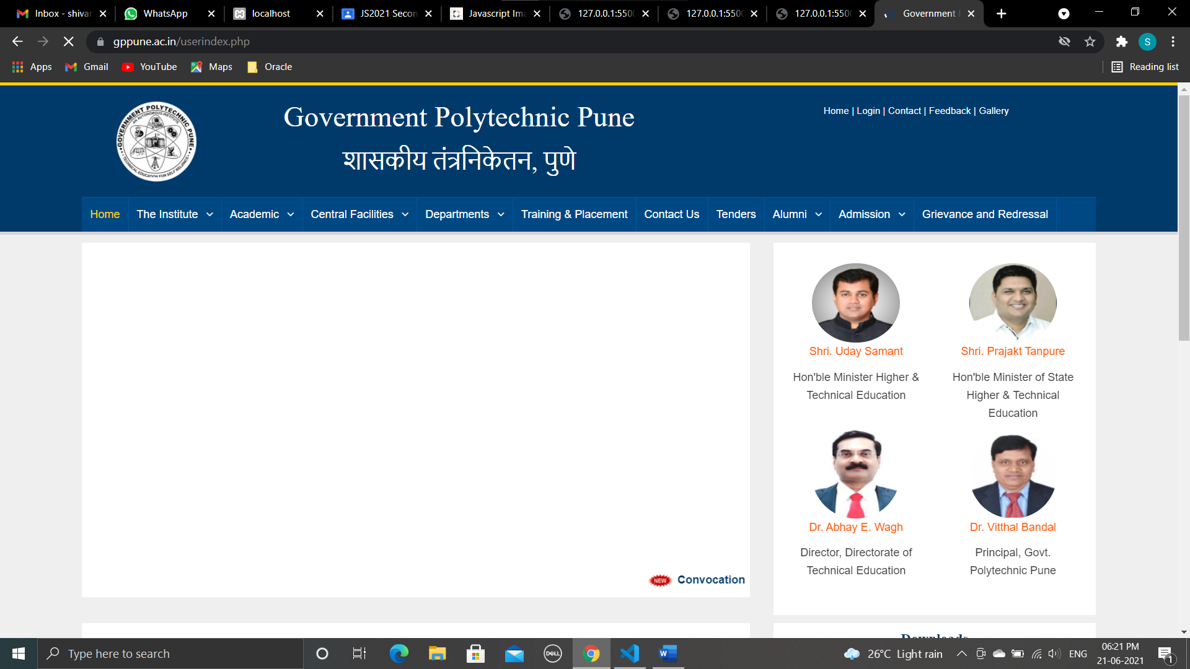

1. Program

<!-- Develop a JavaScript program to create a slideshow with the group of four images, also simulate the next and previous transition between slides in your JavaScript.-->

<html>

<head>

<title>Image slideshow</title>

<script>

var images = ["js.jpg", "ds.jpg", "oop.jpg", "books.jpg"];

var count = 0;

function previousImage() {

if (count != 0)

count--;

var id = document.getElementById("iamgeID");

id.src = "images/" + images[count];

}

function nextImage() {

if (count != 3)

count++;

var id = document.getElementById("iamgeID");

id.src = "images/" + images[count];

}

</script>

</head>

<body>

<center>

<img id="iamgeID" src="images/books.jpg" width="30%" height="75%" />

<br/>

<hr>

<input type="button" value=" Prev Image" onclick="previousImage()" />

<input type="button" value="Next Image" onclick="nextImage()" />

</center>

</body>

</html>

**Output :**

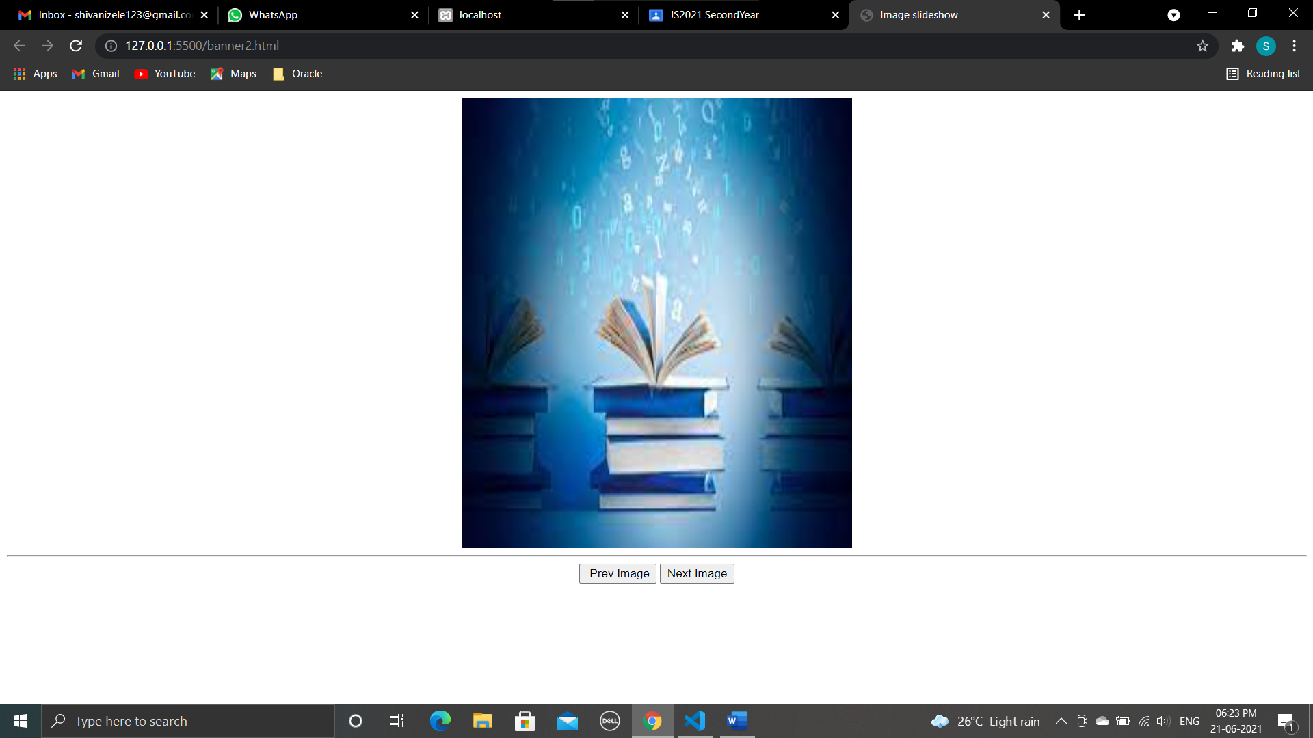

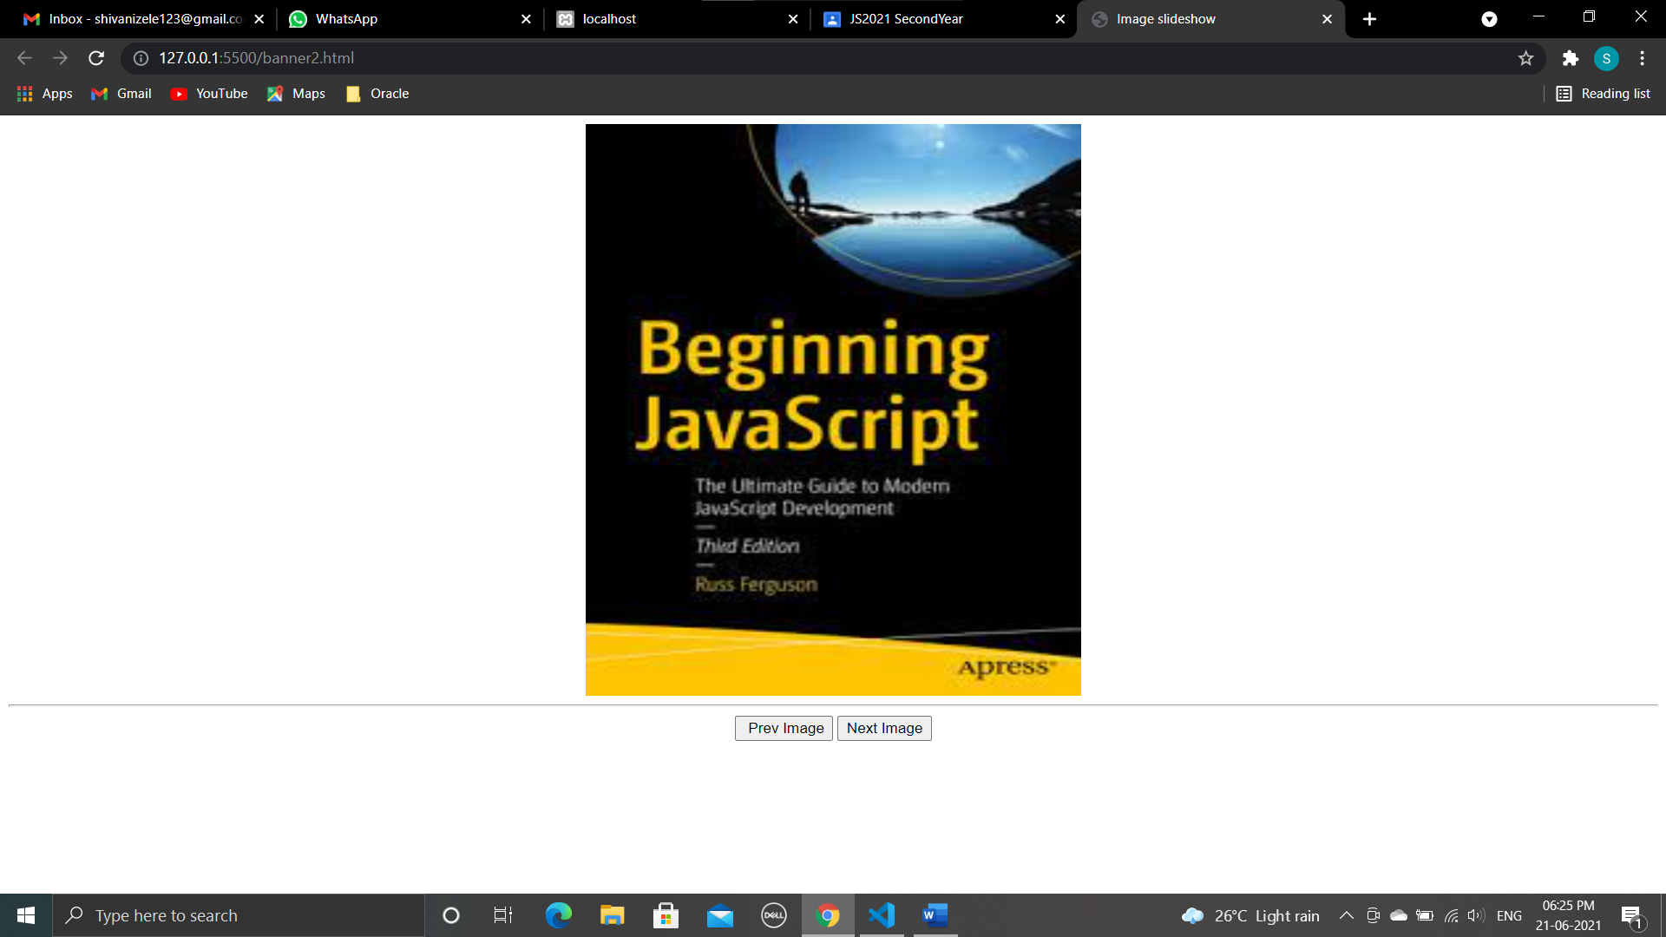

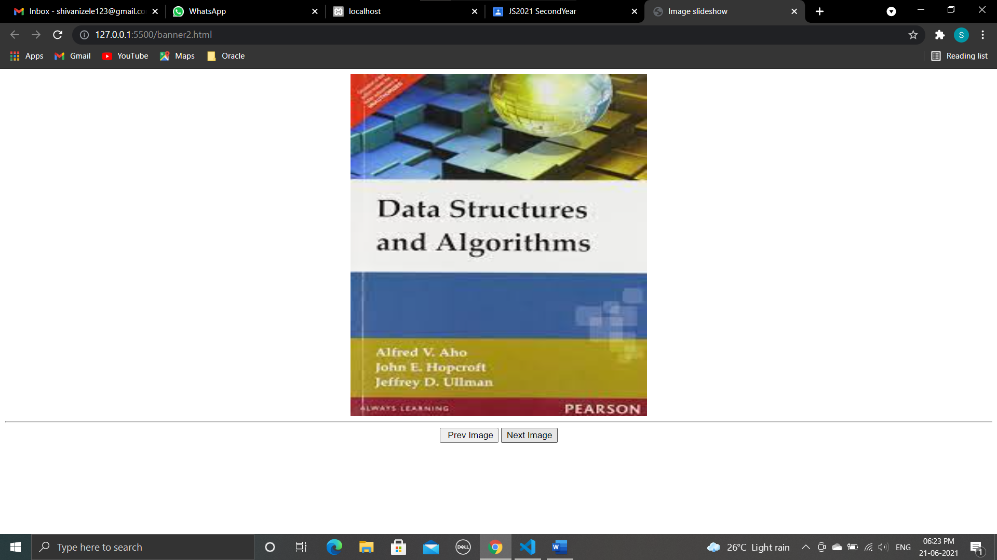

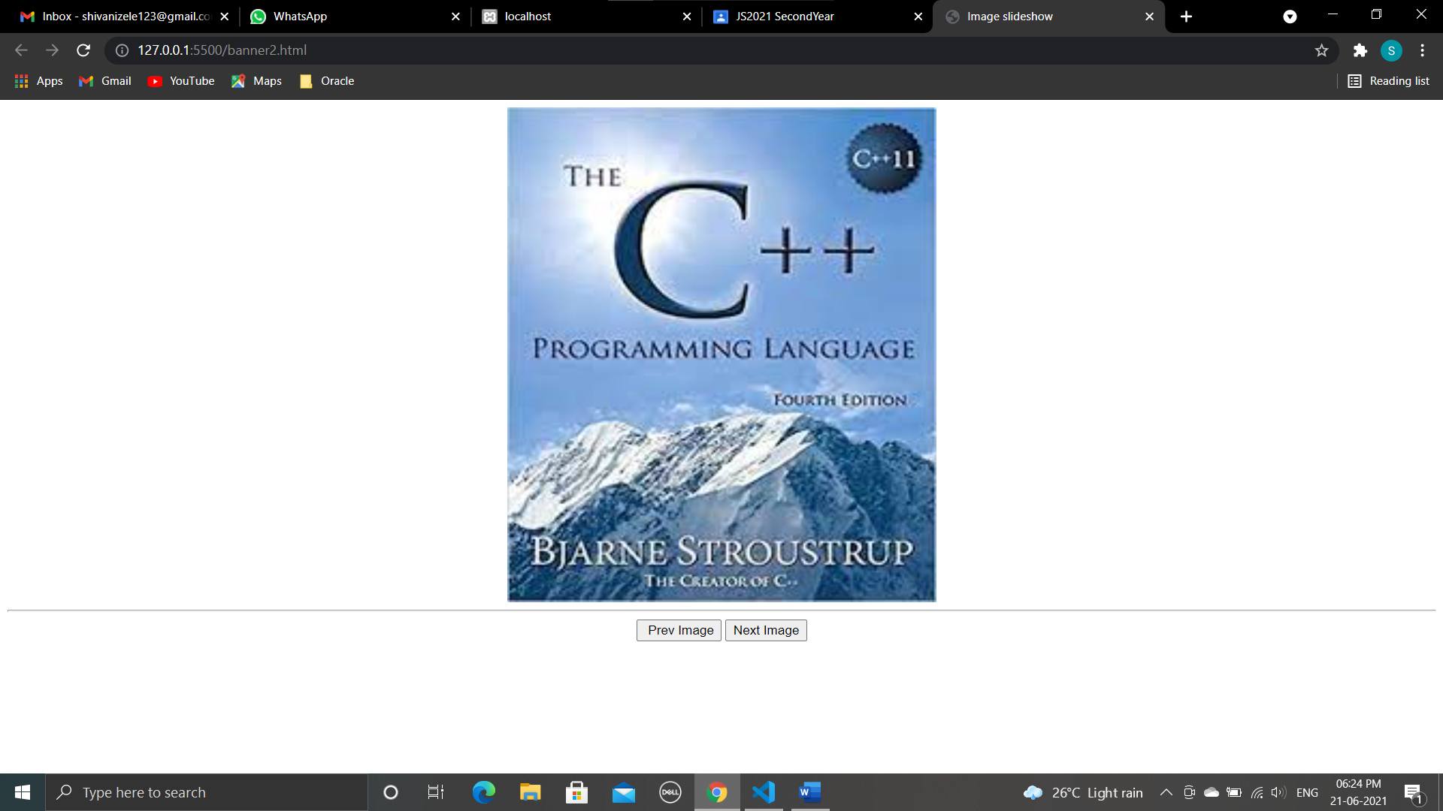

1. **Program**

<html>

<head>

<script language="Javascript">

MyBanners = new Array("js.jpg", "ds.jpg", "oop.jpg", "books.jpg")

banner = 0

function ShowBanners() {

if (document.images) {

banner++

if (banner == MyBanners.length) {

banner = 0

}

document.ChangeBanner.src = MyBanners[banner]

setTimeout("ShowBanners()", 5000)

}

}

</script>

<body onload="ShowBanners()">

<center>

<img src="js.jpg" width="500" height="600" name="ChangeBanner" />

</center>

</body>

</html>

**Output :**

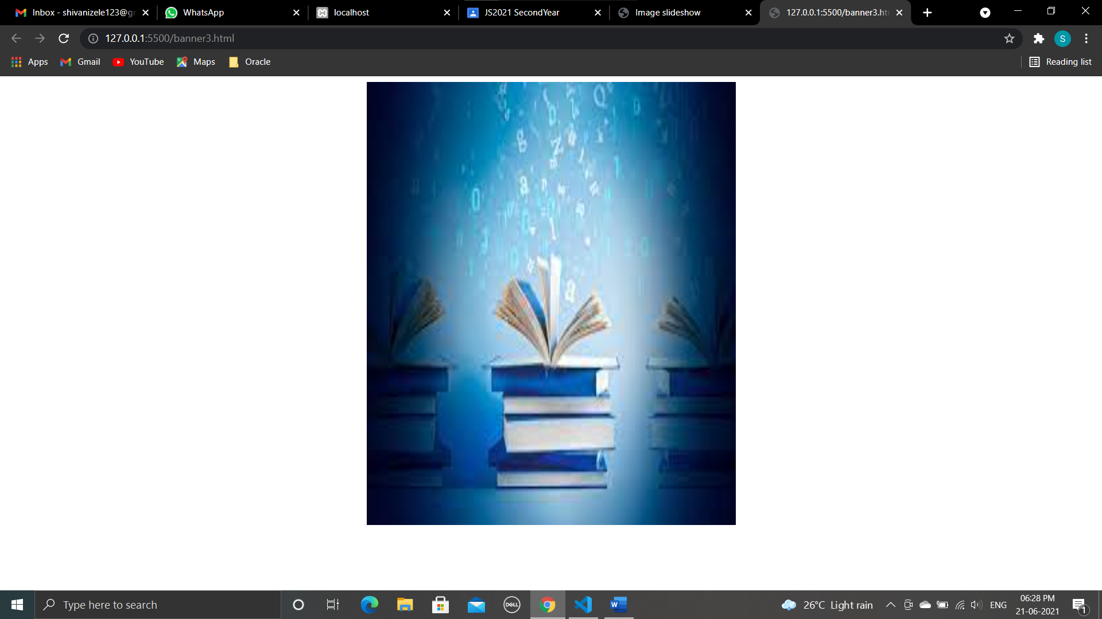

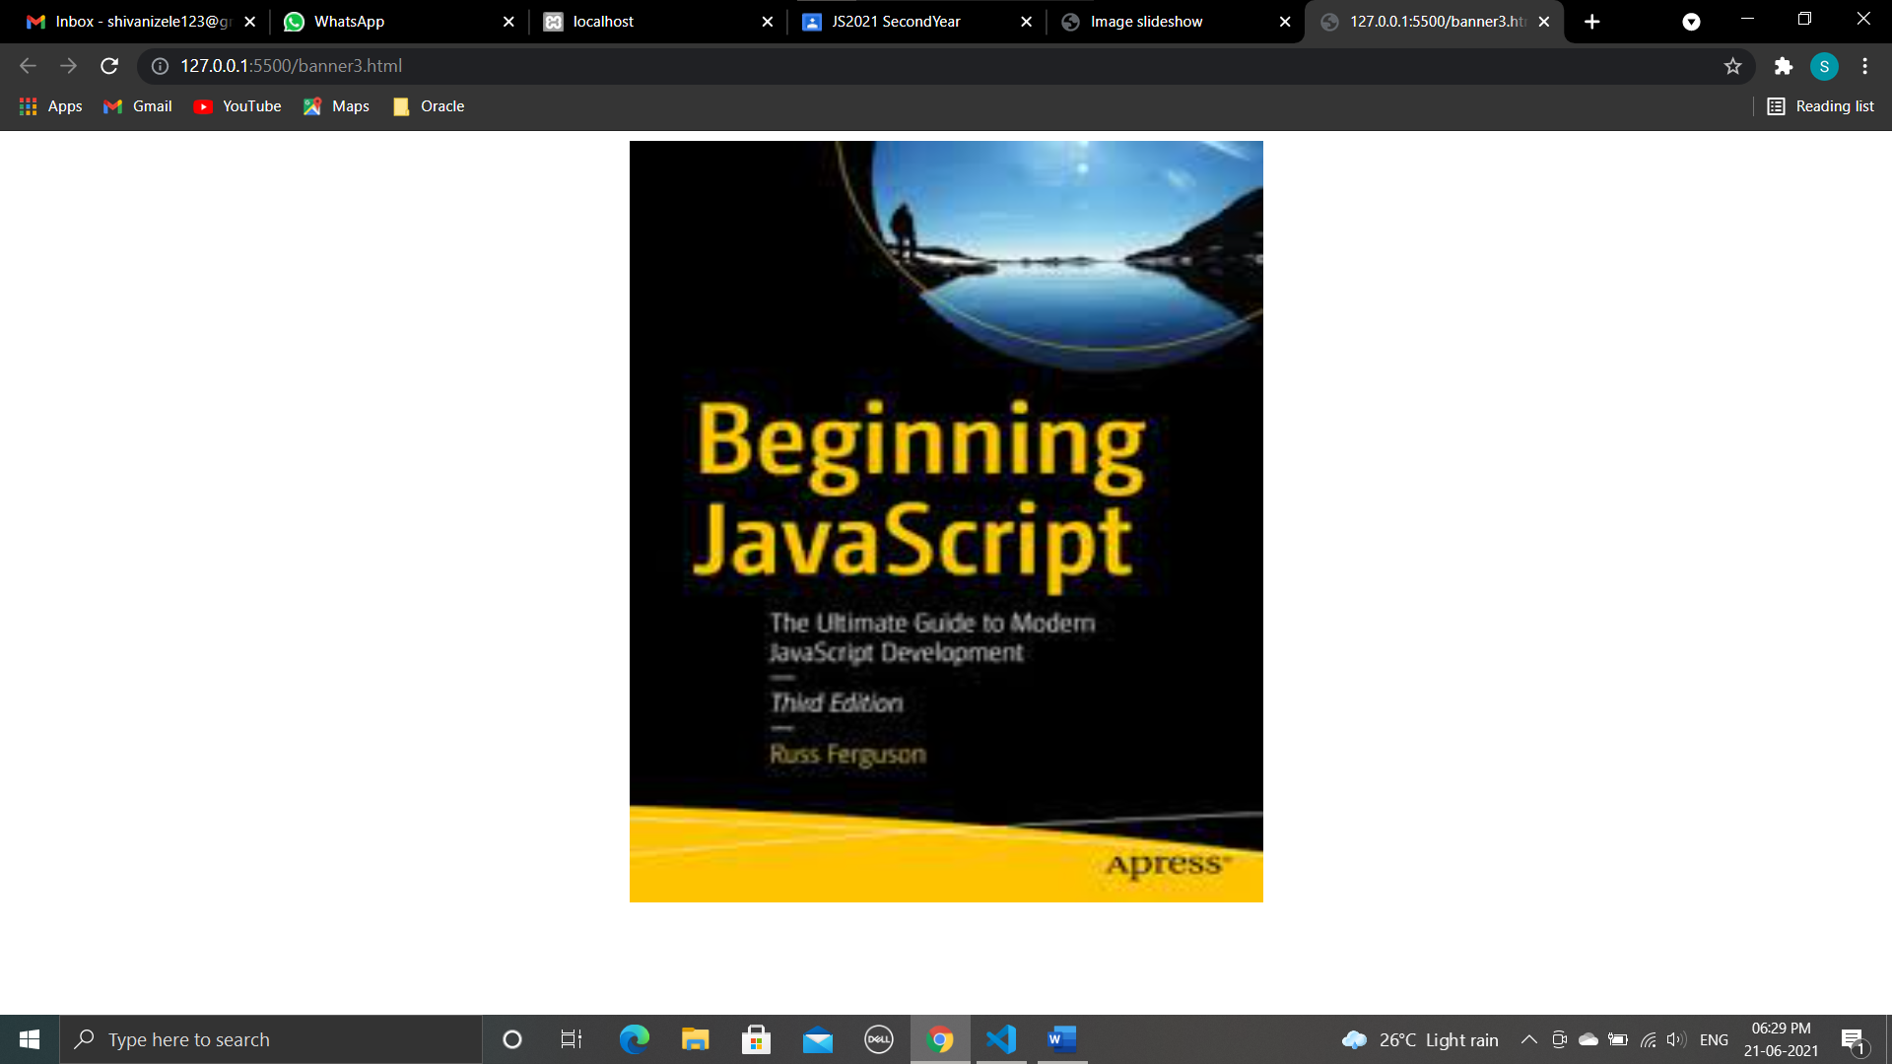

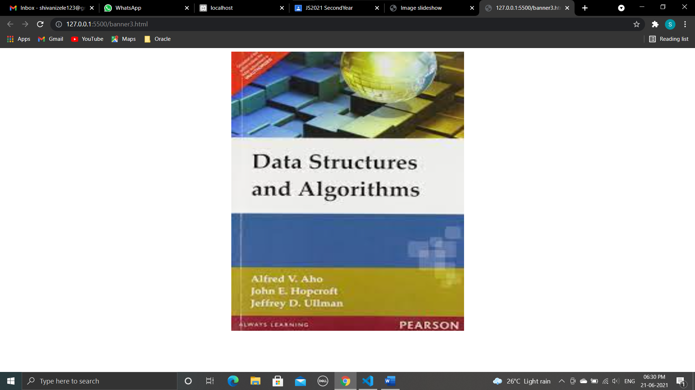

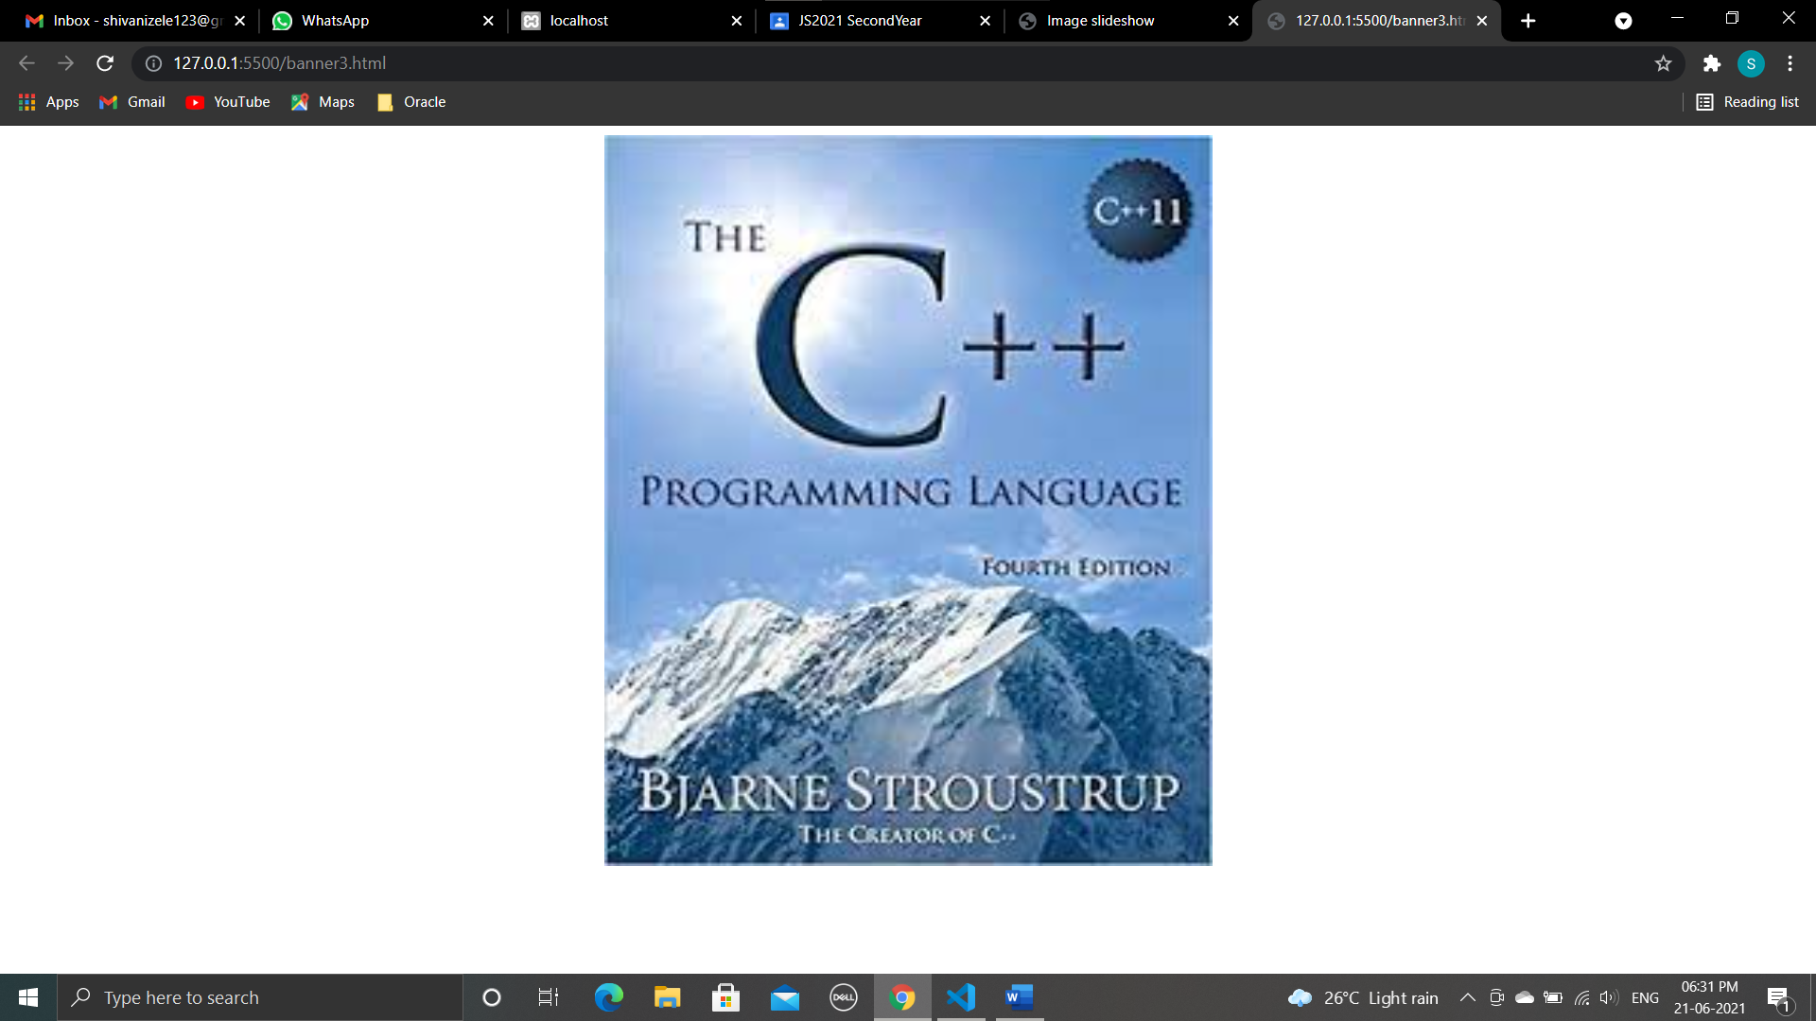

1. **Program**

<html>

<head>

<title>JavaScript Status Bar</title>

</head>

<body>

<a href="https://gppune.ac.in/userindex.php" onMouseOver="window.status='GP pune';return true" onMouseOut="window.status='';return true">

Government polytechnic pune

</a>

</body>

</html>

Output :

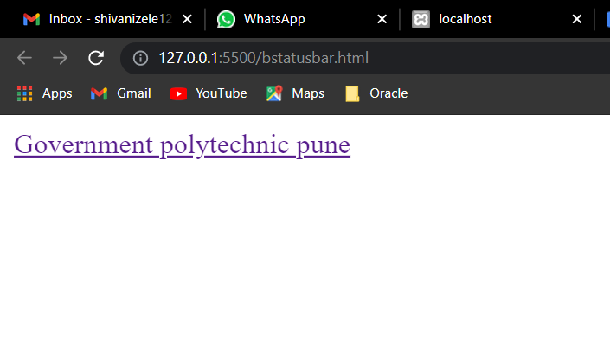

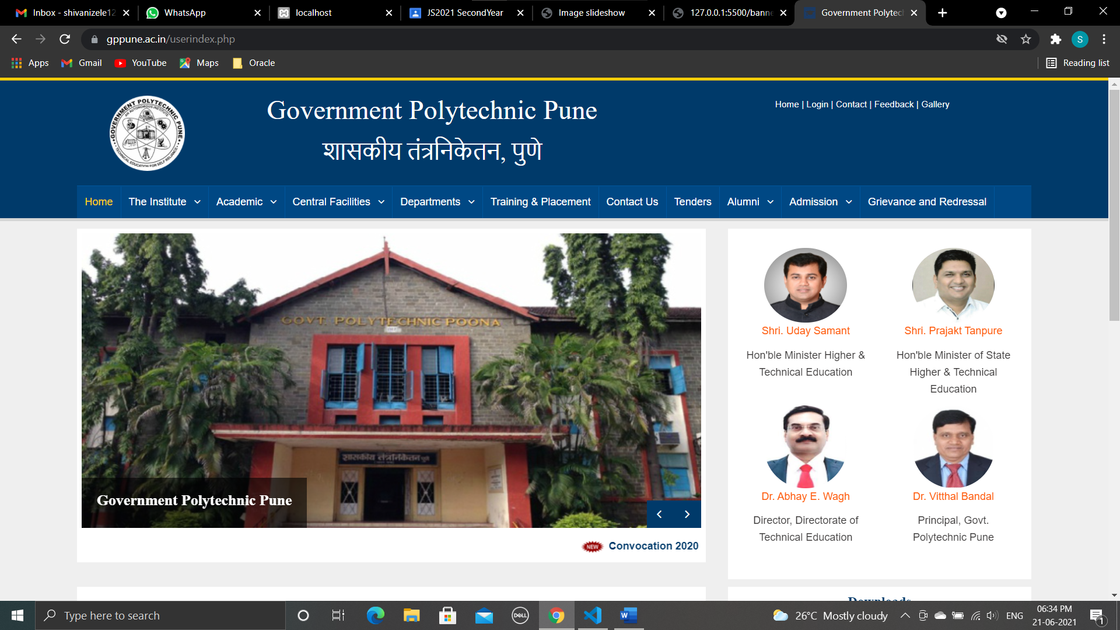

**Conclusion :**

**We have studied Programs for implementing Banners, Slideshow Programs for implementing Status bars and Web**

**Page Protection.**

**Assignment 14**

**AIM :** Write a JavaScript program to display the current day and time in the following format. Sample Output : Today is : Tuesday. Current time is : 10 PM : 30 : 38

Write a JavaScript program to get the current date.

1. program to display the current day and time in the following format. Sample Output : Today is : Tuesday. Current time is : 10 PM : 30 : 38

<html>

<head>

<title>Javascript current date and time program</title>

</head>

<body>

<script>

var today = new Date();

var day = today.getDay();

var daylist = ["Sunday", "Monday", "Tuesday", "Wednesday ", "Thursday", "Friday", "Saturday"]

document.write("Today is : " + daylist[day] + ".");

document.write("<br/>");

var hour = today.getHours();

var minute = today.getMinutes();

var second = today.getSeconds();

var prepand = (hour >= 12) ? "PM" : "AM";

hour = (hour >= 12) ? hour - 12 : hour;

if (hour === 0 && prepand == 'PM') {

if (minute === 0 && second === 0) {

hour = 12;

prepand = 'Noon'

} else {

hour = 12;

prepand = 'PM';

}

}

if (hour === 0 && prepand === 'AM'); {

if (minute === 0 && second === 0) {

hour = 12;

prepand = 'AM'

}

}

document.write("current time : " + hour + prepand + " : " + minute + " : " + second)

</script>

</body>

</html>

Output :

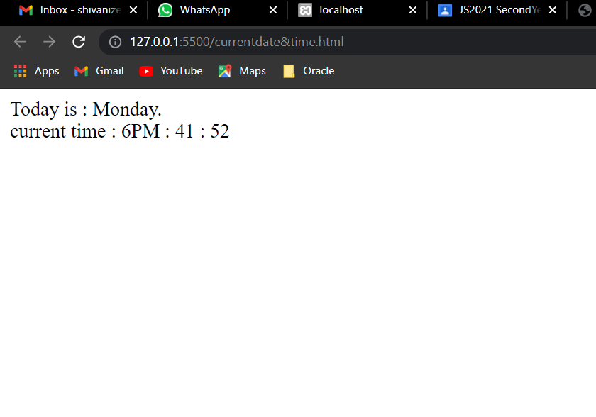

1. Write a JavaScript program to get the current date.

<html>

<head>

<title>

Get current date

</title>

</head>

<body>

<script>

var curday = function(sp) {

today = new Date();

var dd = today.getDate();

var mm = today.getMonth() + 1; //As January is 0.

var yyyy = today.getFullYear();

if (dd < 10) dd = '0' + dd;

if (mm < 10) mm = '0' + mm;

return (mm + sp + dd + sp + yyyy);

};

document.write("The curent date is : " + curday('/'));

</script>

</body>

</html>

Output :

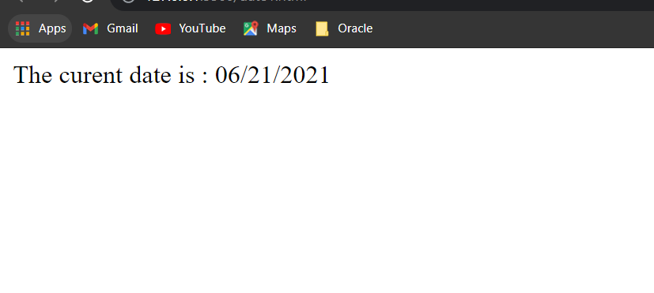

1. Program

<!DOCTYPE html>

<html>

<head>

<title>Javascript</title>

</head>

<style>

.beauty {

text-align: center;

margin-top: 100px;

}

.button {

background-color: #008000;

}

</style>

<body class="beauty">

<h2>JavaScript program to display current Date and Time </h2>

<button type="button" class="button" onclick="document.getElementById('demo').innerHTML = Date()">

Click me to display Date and Time.</button>

<p id="demo"></p>

</body>

</html>

Output:

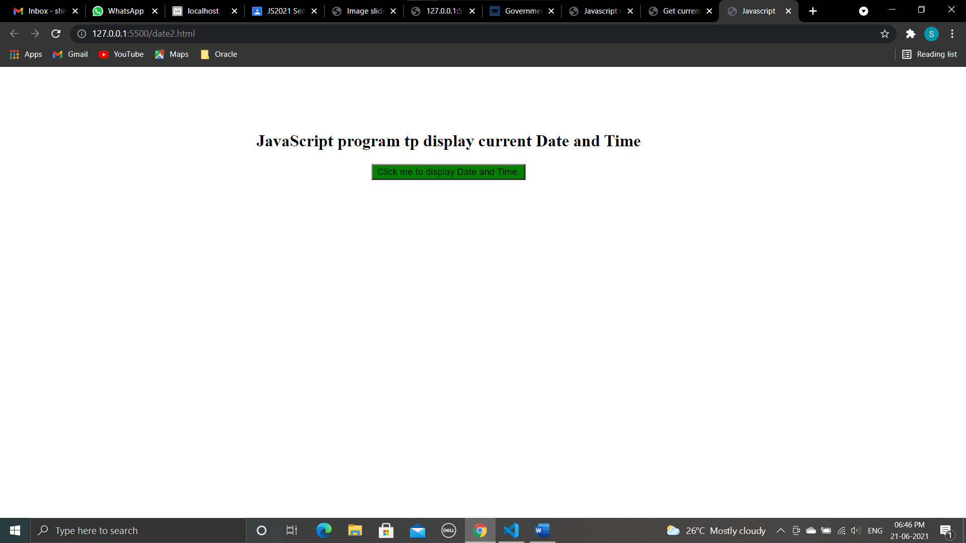

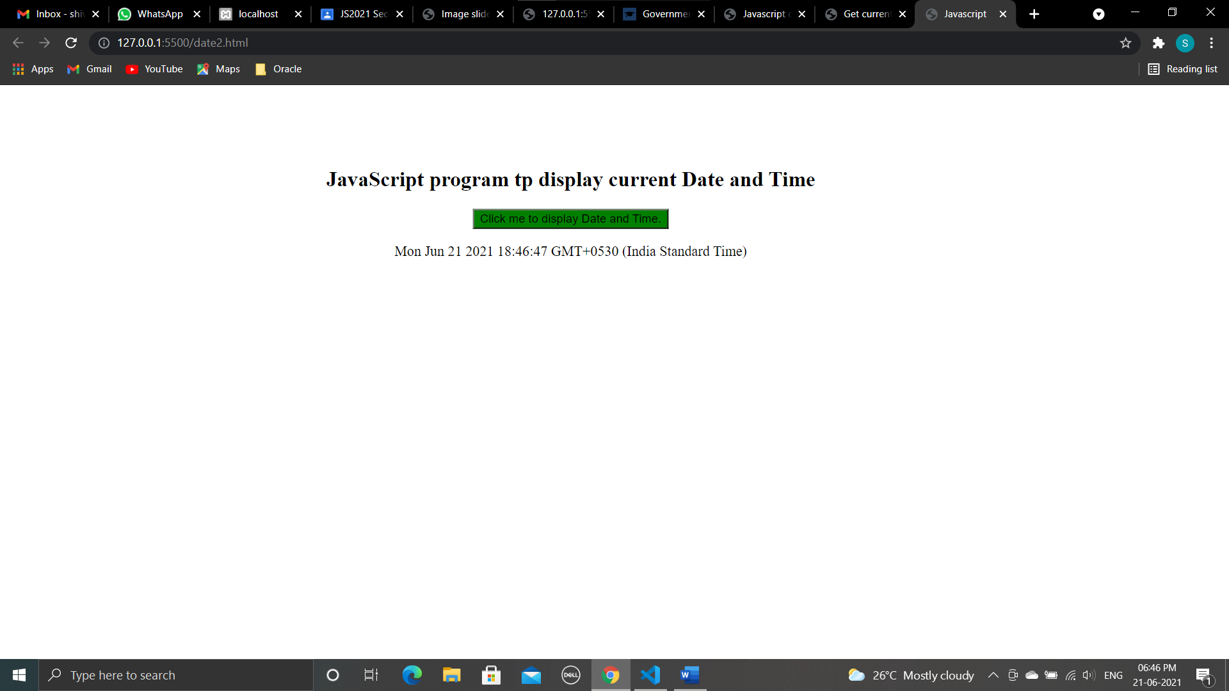

­­­­­­­­­­­­­­­­­­­­­­­­­­

___________________________________________________________

**Conclusion :**

We have studied a JavaScript program to display the current day and time in the following format. Sample Output : Today is : Tuesday. Current time is : 10 PM : 30 : 38 and program to get the current date.

________________________________________________________________

**Assignment : 15**

Aim : Writing code demonstrating XMLHttpRequest

1, Program

<!DOCTYPE html>

<html lang="en">

<head>

<meta charset="utf-8">

<title>JavaScript Ajax GET Demo</title>

<script>

function displayFullName() {

// Creating the XMLHttpRequest object

var request = new XMLHttpRequest();

// Instantiating the request object

request.open("GET", "/examples/php/greet.php?fname=John&lname=Clark");

// Defining event listener for readystatechange event

request.onreadystatechange = function() {

// Check if the request is compete and was successful

if (this.readyState === 4 && this.status === 200) {

// Inserting the response from server into an HTML element

document.getElementById("result").innerHTML = this.responseText;

}

};

// Sending the request to the server

request.send();

}

</script>

</head>

<body>

<div id="result">

<p>Content of the result DIV box will be replaced by the server response</p>

</div>

<button type="button" onclick="displayFullName()">Display Full Name</button>

</body>

</html>

Greet.php

<?php

if(isset($_GET["fname"]) && isset($_GET["lname"])) {

$fname = htmlspecialchars($_GET["fname"]);

$lname = htmlspecialchars($_GET["lname"]);

// Creating full name by joining first and last name

$fullname = $fname . " " . $lname;

// Displaying a welcome message

echo "Hello, $fullname! Welcome to our website.";

} else {

echo "Hi there! Welcome to our website.";

}

?>

Output :

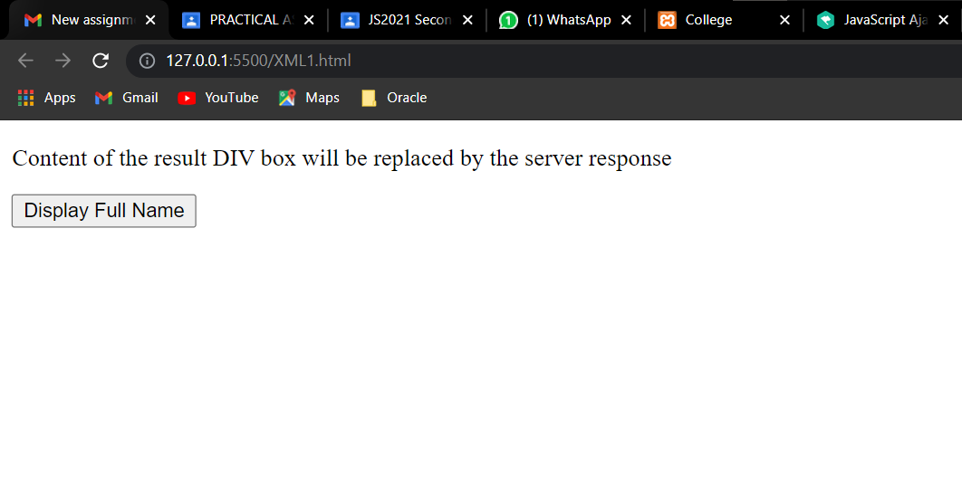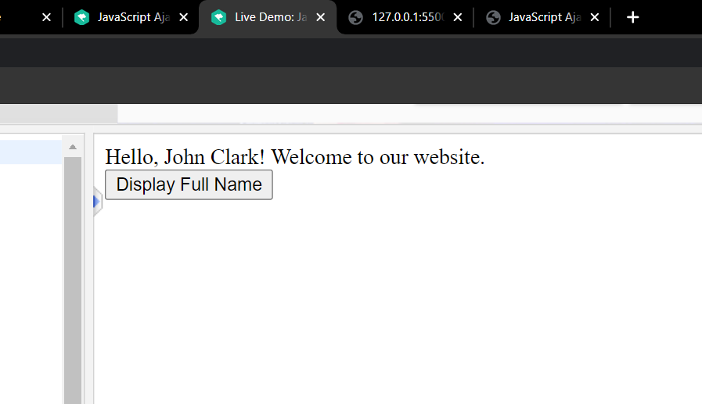

1. Program

<!DOCTYPE html>

<html lang="en">

<head>

<meta charset="utf-8">

<title>JavaScript Ajax POST Demo</title>

<script>

function postComment() {

// Creating the XMLHttpRequest object

var request = new XMLHttpRequest();

// Instantiating the request object

request.open("POST", "confirmation.php");

// Defining event listener for readystatechange event

request.onreadystatechange = function() {

// Check if the request is compete and was successful

if (this.readyState === 4 && this.status === 200) {

// Inserting the response from server into an HTML element

document.getElementById("result").innerHTML = this.responseText;

}

};

// Retrieving the form data

var myForm = document.getElementById("myForm");

var formData = new FormData(myForm);

// Sending the request to the server

request.send(formData);

}

</script>

</head>

<body>

<form id="myForm">

<label>Name:</label>

<div><input type="text" name="name"></div>

<br>

<label>Comment:</label>

<div><textarea name="comment"></textarea></div>

<p><button type="button" onclick="postComment()">Post Comment</button></p>

</form>

<div id="result">

<p>Content of the result DIV box will be replaced by the server response</p>

</div>

</body>

</html>

Confirmation.php

<?php

if($_SERVER["REQUEST_METHOD"] == "POST") {

$name = htmlspecialchars(trim($_POST["name"]));

$comment = htmlspecialchars(trim($_POST["comment"]));

// Check if form fields values are empty

if(!empty($name) && !empty($comment)) {

echo "<p>Hi, <b>$name</b>. Your comment has been received successfully.<p>";

echo "<p>Here's the comment that you've entered: <b>$comment</b></p>";

} else {

echo "<p>Please fill all the fields in the form!</p>";

}

} else {

echo "<p>Something went wrong. Please try again.</p>";

}

?>

Output:

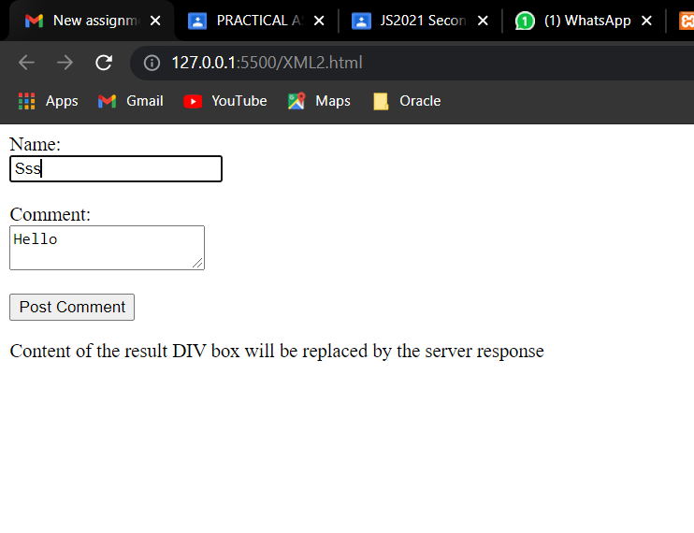

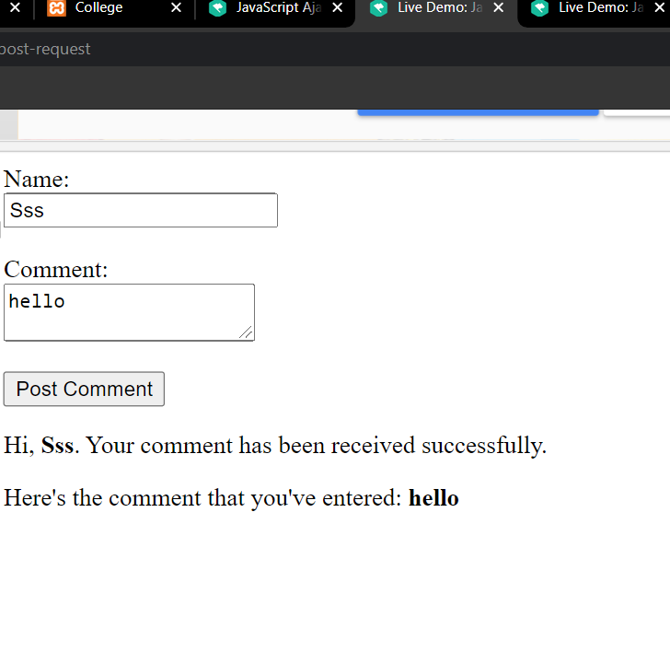

**____________________________________________________**

**Conclusion :**

We have studied code to code demonstrating XMLHttpRequest.

____________________________________________________